1. Residue-by-residue RMSD calculations

Residue-by-residue RMSD calculation is carried by first performing a structural alignment followed by a direct rms calculation on the alignment structure for each residues. By-residue RMSD calculations are carried for 3GLS (apo-SIRT3), 4FVT(SIRT3:carba-NAD:ac-peptide) and 4JSR (SIRT3:ELT-11 inhibitor) with reference to 4BVG (SIRT3:Intermediate).

By comparing to the crystal structures, the flexible loop region can be identified as between residue 155 and 174. For intermediate loop building, residue 156-169 was often chosen as a trade-off between the length of the loop and the completeness of flexible region, because 3JSR suggest that the -turn can form with the inclusion of residue 156-169 that will allow the proper interaction of PHE157 and ARG158 with substrates. Longer chain (residue 156-172) is also use in the modeling of 4FVT when constraints are applied.

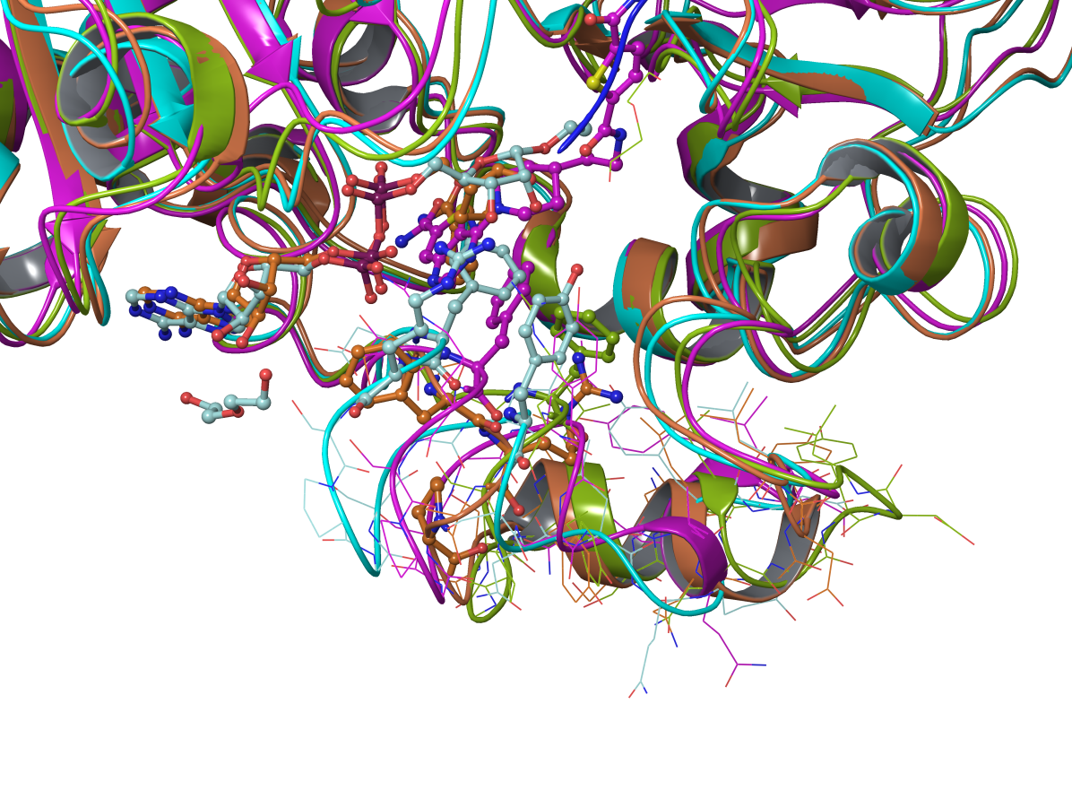

4BVG: light blue

4FVT: orange

3JSR: purple

3GLS: green

RC: Please clarify: “because 3JSR suggest that the -turn can form with the inclusion of residue 156-169 that will allow the proper interaction of PHE157 and ARG158 with substrates.” How does inclusion of residues up to 169 facilitate interaction of residues 157 and 158? Where is the alpha turn located?