Beta-lacatamase Redesign – Library Transformation and Sequencing
Chaoran Jing
12-17-2013

Objectives
- After obtaining the plasmid library from Zhen, I need to transform the plasmids into E.coli (BL21) cells.
- Before screening the library with growth assay, I need to sequence several colonies to make sure the library is correctly constructed.

Methods
- BL21 cells were obtained from Life Technologies. Heat shock transformations were performed following the manual.
- Plasmid preparation was performed using Qiagen Mini-prep kit.
- Sanger sequencing was performed by Genewiz.
- General sequence editing and translation is by using software Serial Cloner.
- Multiple DNA sequence alignment is by using software ApE.
- Pairwise DNA sequence alignment and protein sequence alignment are by using online tool Clustal Omega. (ApE is good at visualizing the result but its algorithm is not good as Clustal Omega.)

Results
Heat shock transformation (12/10/13 – 12/11/13)
The plasmid library was transformed into BL21 cells by heat shock methods. After transformation, cells were plated at various densities on agar plates with 50mg/mL Kanamycin. In Figure 1 below, ‘straight’ means 100 μL cell culture from the transformation was plated on agar plate without dilution; ‘d100’ means the original cell culture was diluted by 1:100 and 100 μL diluted culture was plated. On the left bottom plate the cells were transformed with wt P99 plasmid, as a control.
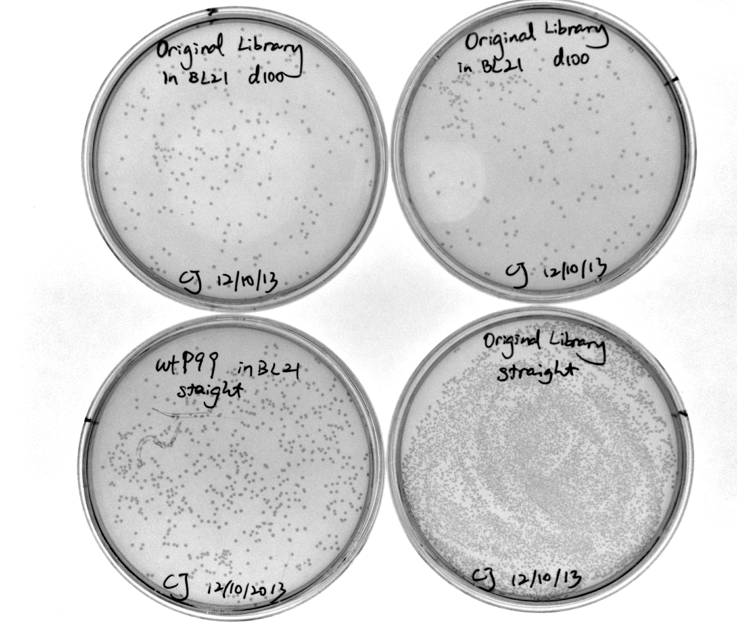
Figure 1. Library transformation.

Plasmid preparation (12/12/13)
I picked up 11 single colonies (named A1 – A11) from agar plate with library, 1 colony from wt P99 plate to inoculate 5mL cultures. Then I did mini-prep to extract 50 μL plasmid with average concentration of ~40 ng/μL. These plasmid solutions were sent to Genewiz for sequencing using T7 primer.
Note: the 40 ng/μL is lower than expected. Usually I can collect >100 ng/μL plasmids using mini-prep. The low concentration may be attributed to the fact that pET-26(b)+ is a low copy number vector. The recommended concentration for sequencing is 80 ng/μL. Low concentration may result in low S/N.
Sequencing results returned on 12/16/13.

Sequence analysis (12/16/13 – 12/17/13)
I first aligned the synthesized wt P99 DNA sequence with the naturally occurring wt P99 gene (from GenBank). Below is a snapshot of the result:
As we can see, these two sequences do not align perfectly. The mismatches are due to different codon usage. So I know that the BlueHeron company did not use the natural P99 gene as template when doing reverse translation. I’m not sure whether they did codon optimization or not. (In E.coli, some codon are preferred than others during translation, even through they are degenerate. If the codon is not optimized, the synthesized gene may not be expressed efficiently.) However, Zhen reported that wt P99 showed high activity against cephalothin. So I don’t worry too much about the expression of this synthetic P99 gene.

I also translated both synthetic and natural wt P99 genes and aligned the protein sequences:
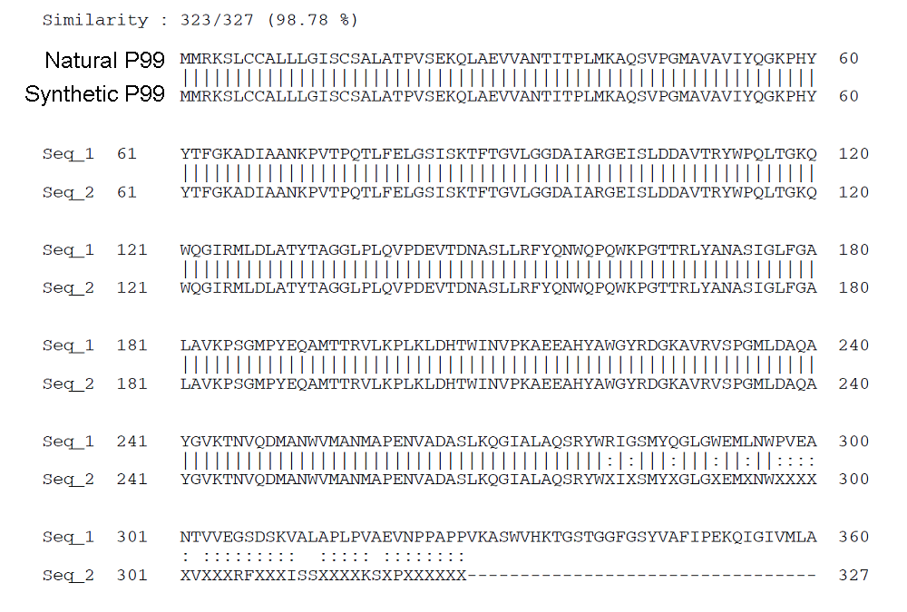
So the synthetic wt P99 protein sequence aligned quite well with the natural P99 protein. Note that after 250 aa (corresponding to ~750 bp), the sequencing signal gets weaker and weaker, leaving some errors and a lot of uncertain sequences (denoted as X). This phenomenon is common in Sanger sequencing.

Since the synthetic wt P99 DNA is different from the natural P99 gene, for the following sequence alignment I only use the synthetic P99 DNA as reference.

Then I aligned the mutant sequence with the wt P99. The library is designed with 4 mutations at L139, Y241, S238 and N346, respectively. In terms of DNA sequence, I expected to see mutations at 415-417 bp and 740-742 bp. The latter two mutations are too far away from the start codon and therefore can not be observed in current sequencing results.
Note: I trimmed the raw sequencing data, deleting all the sequence before start codon. Now the bp numbering should exactly match the original design.

It is a surprise to see that the mutations were not observed at where they should be.

Mutation expected for L139, corresponding to 415-417 bp. It was actually observed at 434-436 bp:
(In following figures the first sequence is the wt P99, followed by 11 mutant sequences A1 – A11. ‘N’ stands for uncertain base. Mismatches are highlighted in red.)
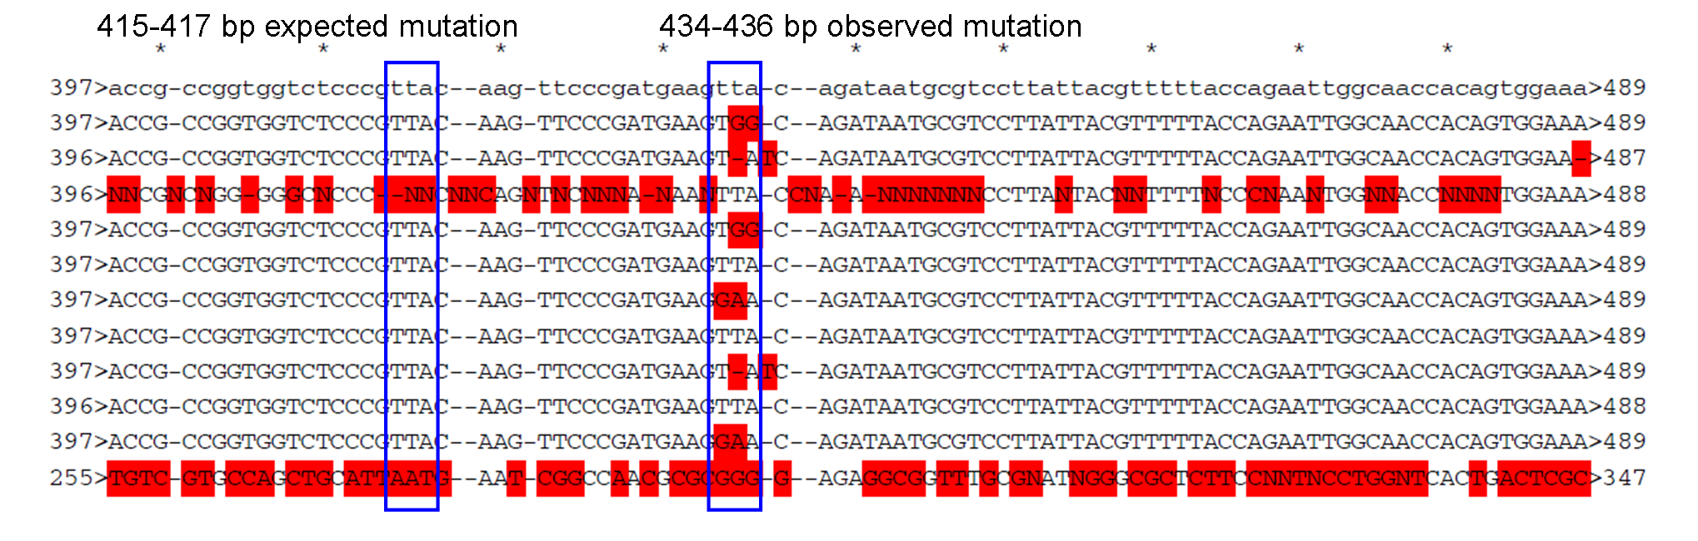

Mutation expected for Y241, corresponding to 721-723 bp. It was actually observed at 740-742 bp:
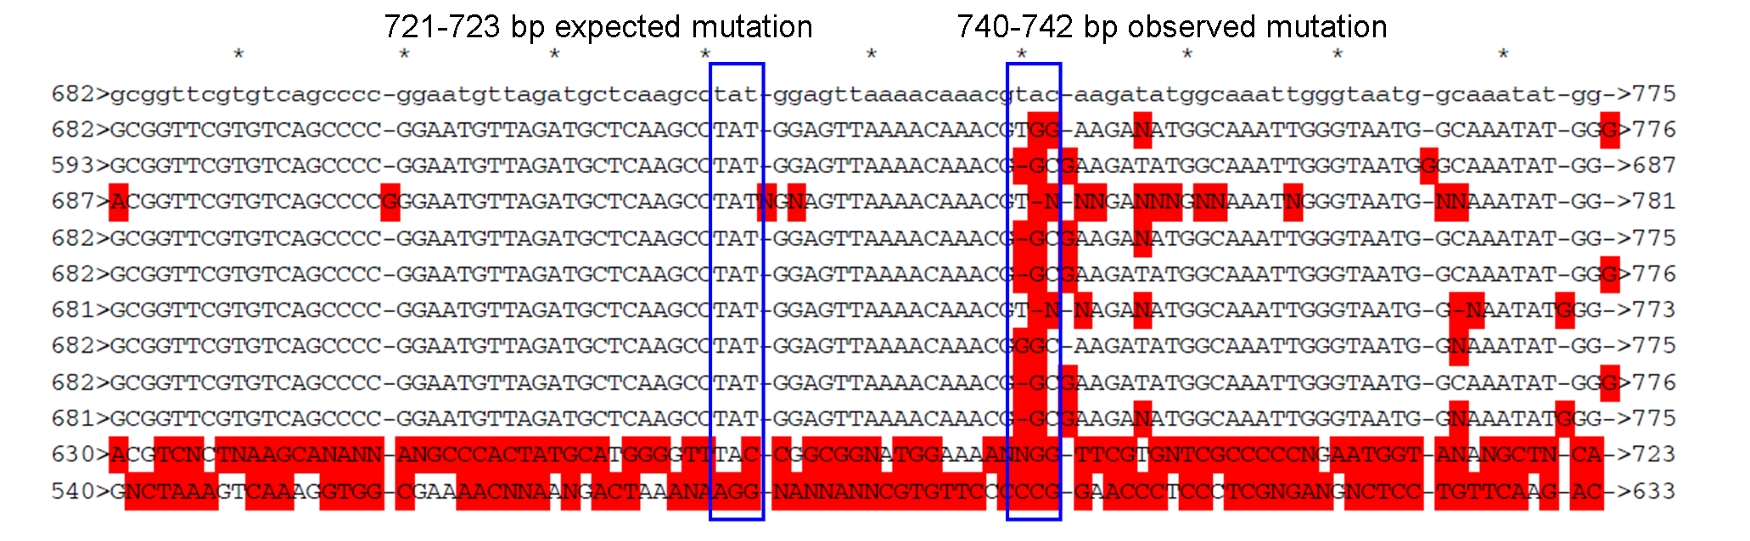
Note: the last trace (A11) is messy because the S/N in sequencing is very poor. We can omit it. The mismatch in the second sequence from bottom (A10) is due to poor algorithm of the ApE program. We don’t need to worry about it.

Besides this systematic mistake on the mutation position, I also observed that mutant A2, A3, A9 have some random frame shift (kind of common in library construction). A11 shows poor signal in sequencing. So in the following protein alignment I did not include these 4 sequences.

I translated the wt P99 along with 7 mutants, namely A1, A4 – A8, and A10 and did multiple protein sequence alignment. Consistent to the DNA alignment results, the mutations did not occur at the designed positions.

We expected to see L139 mutated into Y, L, E, W. Now we see V145 and T146 mutated into GT, VA, VT and VS.
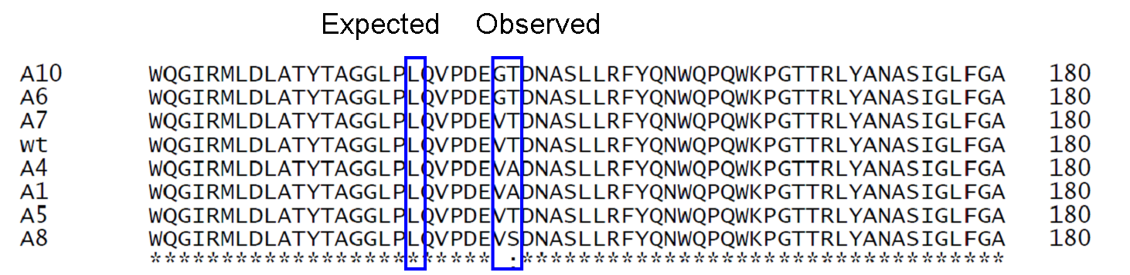

We expected to see Y241 mutated into A, Y, G, W. Now we observe V247 and Q248 mutated into GQ, GE, VE.
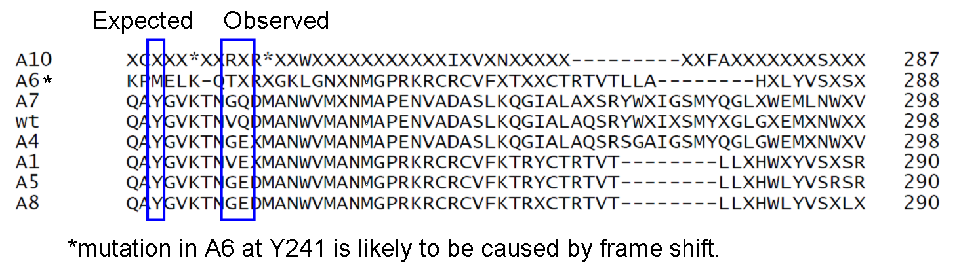

Conclusions
- The wt P99 gene encodes an active enzyme with correct sequence. (I need to do another round of sequencing to see the C-termini, to be 100% sure it is correct.)
- For both L139 and Y241, the observed mutations were shifted 19 bp downstream, compared to the designed positions. As a result, the mutations in protein sequences were shifted 6-7 aa downstream, affecting two amino acids instead of one as designed.
- It is very likely that the same shift also affect the other two mutations.
- Zhen reported that ‘no mutant shows higher beta-lactamase activity than the wt one’. I suppose that’s partly due to the fact that the library is not correctly constructed.

