*NB: Energy decomposition based on per-residue proves to be problematic for complexes studied by Ping as stated earlier. I will try to figure it out once I get time. I believe that it needs to be run using Amber 12 to fix the issue.*

Per-residue based E-interaction analysis based on MM/PBSA and MM/GBSA calculations for product complex with 4FVT loop

|  |  |  |  |  |  |  |  |  |  |  |
| --- | --- | --- | --- | --- | --- | --- | --- | --- | --- | --- |
| **RES ID**  **OPEN** | **vdw** | **Ele** | **Polar Solv** | **Non-polar solv** | **GBSA** | **vdw** | **Ele** | **Polar Solv** | **Non-polar solv** | **PBSA** |
| THR200 | -1.55 | -14.89 | 9.09 | -0.09 | -7.44 | -1.55 | -14.89 | 10.58 | 0.00 | -5.86 |
| SER201 | -1.40 | -11.42 | 8.87 | -0.33 | -4.29 | -1.40 | -11.42 | 8.38 | 0.00 | -4.45 |
| GLY25 | -0.55 | -7.01 | 3.56 | 0.00 | -4.00 | -0.55 | -7.01 | 4.91 | 0.00 | -2.65 |
| ALA26 | -1.45 | -6.57 | 4.61 | -0.22 | -3.63 | -1.45 | -6.57 | 5.26 | 0.00 | -2.77 |
| ASN224 | -1.84 | -1.99 | 0.43 | -0.09 | -3.50 | -1.84 | -1.99 | 2.20 | 0.00 | -1.63 |
| GLN108 | -1.91 | -2.21 | 1.50 | -0.18 | -2.79 | -1.91 | -2.21 | 2.21 | 0.00 | -1.91 |
| ARG225 | -3.26 | -30.51 | 31.54 | -0.32 | -2.56 | -3.26 | -30.51 | 30.19 | 0.00 | -3.59 |
| GLY27 | -2.01 | -2.91 | 2.68 | -0.15 | -2.39 | -2.01 | -2.91 | 3.25 | 0.00 | -1.67 |
| LYS280 | -0.73 | -42.73 | 42.93 | -0.10 | -0.64 | -0.73 | -42.73 | 40.13 | 0.00 | -3.33 |
| VAL246 | -0.68 | -2.90 | 1.78 | -0.05 | -1.86 | -0.68 | -2.90 | 1.88 | 0.00 | -1.71 |
| ASP245 | -0.69 | 18.36 | -19.36 | -0.04 | -1.74 | -0.69 | 18.36 | -18.35 | 0.00 | -0.68 |
| VAL204 | -1.10 | -0.85 | 0.47 | -0.14 | -1.62 | -1.10 | -0.85 | 1.04 | 0.00 | -0.91 |
| VAL24 | -0.17 | -0.30 | -0.78 | 0.00 | -1.25 | -0.17 | -0.30 | 0.24 | 0.00 | -0.23 |
| **Total** |  |  |  |  | **-37.72** |  |  |  |  | **-31.39** |

The crucial interactions are shown below (Open loop).

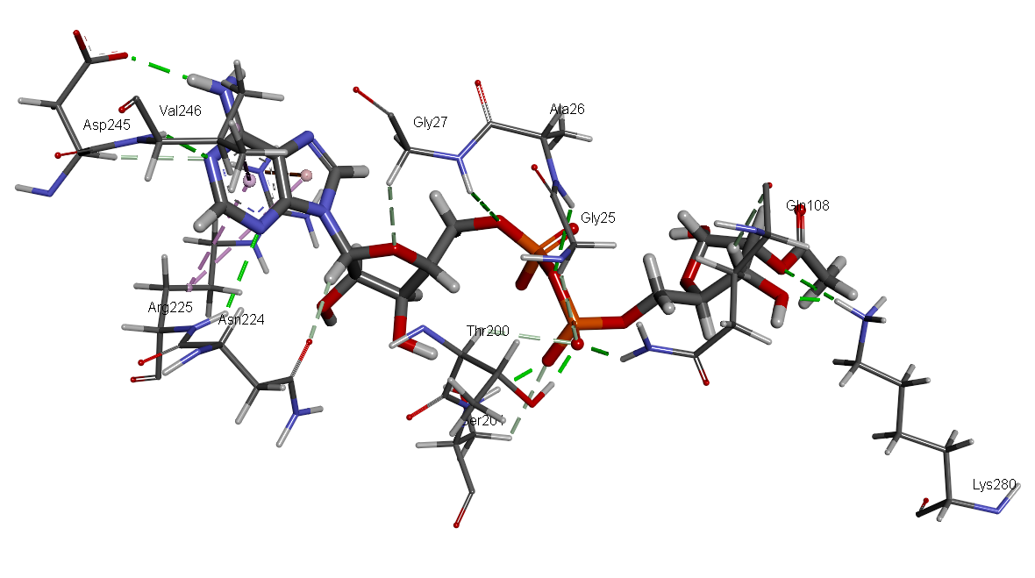

Per-residue based E-interaction analysis based on MM/PBSA and MM/GBSA calculations for product complex with 4BVG loop

|  |  |  |
| --- | --- | --- |
| **RESID (Closed)** | **GBSA** | **PBSA** |
| ARG 158 | -18.712 | -23.747 |
| PHE 157 | -8.797 | -7.913 |
| THR 320 | -7.853 | -6.798 |
| SER 321 | -6.546 | -8.369 |
| ALA 146 | -4.561 | -4.011 |
| GLY 145 | -4.547 | -3.613 |
| ASN 344 | -3.801 | -1.704 |
| GLN 228 | -3.283 | -2.681 |
| ARG 345 | -3.262 | -4.475 |
| GLY 368 | -2.656 | -2.12 |
| HIE 248 | -2.407 | -3.319 |
| VAL 366 | -2.012 | -1.668 |
| THR 150 | -1.906 | -2.134 |
| Total | -70.343 | -72.552 |

*Detailed per-residue energy decomposition analysis*

|  |  |  |  |  |  |  |  |  |  |  |  |
| --- | --- | --- | --- | --- | --- | --- | --- | --- | --- | --- | --- |
| **RES ID**  **(Closed)** | **vdw** | | **Ele** | **Polar Solv** | **Non-polar solv** | **PBSA** | **vdw** | **Ele** | **Polar Solv** | **Non-polar solv** | **GBSA** |
| ARG 158 | | -1.38 | -82.98 | 60.61 | 0.00 | -23.75 | -1.38 | -82.98 | 65.85 | -0.21 | -18.71 |
| PHE 157 | | -3.05 | -10.58 | 5.72 | 0.00 | -7.91 | -3.05 | -10.58 | 5.03 | -0.19 | -8.80 |
| THR 320 | | -1.46 | -15.31 | 9.97 | 0.00 | -6.80 | -1.46 | -15.31 | 8.98 | -0.07 | -7.85 |
| SER 321 | | -3.33 | -33.43 | 32.28 | 0.00 | -4.48 | -0.99 | -15.83 | 10.45 | -0.17 | -6.55 |
| ALA 146 | | -1.07 | -7.36 | 4.42 | 0.00 | -4.01 | -1.07 | -7.36 | 3.97 | -0.10 | -4.56 |
| GLY 145 | | -0.64 | -7.15 | 4.17 | 0.00 | -3.61 | -0.64 | -7.15 | 3.24 | 0.00 | -4.55 |
| ASN 344 | | -1.36 | -3.51 | 1.55 | 0.00 | -3.32 | -1.67 | -2.80 | 0.78 | -0.11 | -3.80 |
| GLN 228 | | -1.96 | -2.91 | 2.19 | 0.00 | -2.68 | -1.96 | -2.91 | 1.70 | -0.11 | -3.28 |
| ARG 345 | | -0.48 | -5.49 | 3.84 | 0.00 | -2.13 | -3.33 | -33.43 | 33.81 | -0.32 | -3.26 |
| GLY 368 | | -2.05 | -3.14 | 3.07 | 0.00 | -2.12 | -2.05 | -3.14 | 2.65 | -0.12 | -2.66 |
| HIE 248 | | -1.09 | -1.63 | 0.84 | 0.00 | -1.88 | -1.36 | -3.51 | 2.59 | -0.13 | -2.41 |
| VAL 366 | | -0.35 | -3.30 | 1.79 | 0.00 | -1.87 | -0.72 | -2.73 | 1.50 | -0.06 | -2.01 |
| THR 150 | | -1.67 | -2.80 | 2.77 | 0.00 | -1.70 | -0.48 | -5.49 | 4.20 | -0.13 | -1.91 |

The crucial interactions are shown below (Closed loop).

