C-pocket inhibitors studied experimentally:

1. Galli U, Mesenzani O, Coppo C, Sorba G, Canonico PL, et al. (2012) Identification of a sirtuin 3 inhibitor that displays selectivity over sirtuin 1 and 2. Eur J Med Chem 55: 58–66

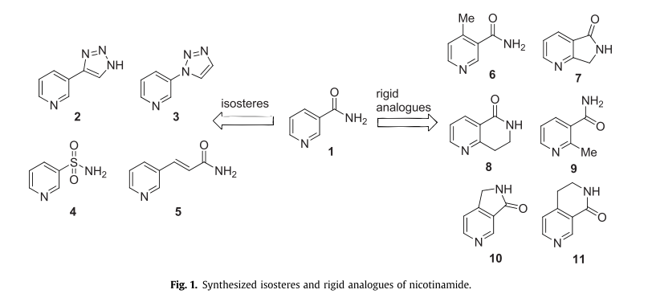

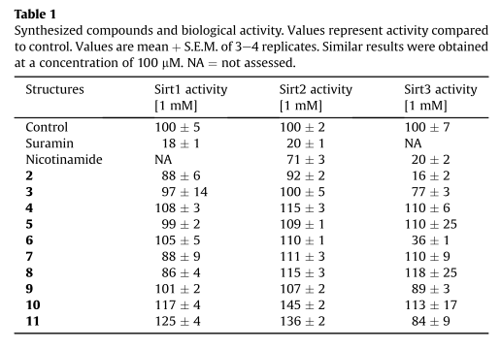

It was found that compound 2 and 5 were relatively potent with IC50 of 38 and 23 M respectively.

I have carried out Glide XP docking and MM-GBSA calculations on these compounds.

1. Jackson MD, Schmidt MT, Oppenheimer NJ, Denu JM (2003) Mechanism of nicotinamide inhibition and transglycosidation by Sir2 histone/protein deacetylases. J Biol Chem 278: 50985–50998.

I have also included the compounds from the above reference in the docking study.

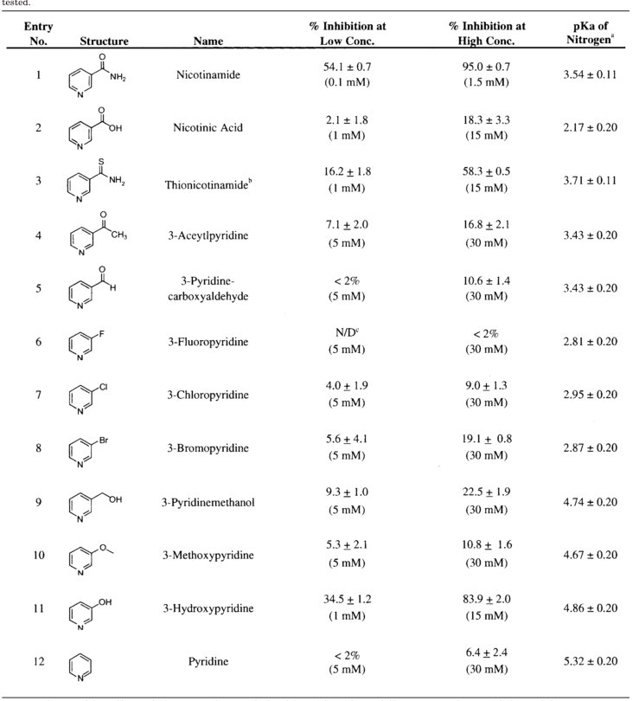

For MD and MM-GBSA calculations, I have carried out long simulations using the newly constructed Sir2TM ternary structure (after loop refinement with Prime). And the overall RMSD is small, < 1.5 Angstrom, but refined loop still show some degree of fluctuation, especially after 20ns. (the b-factor increase as the simulation time increase.)

Residue number B-factor (for 36ns simulation)

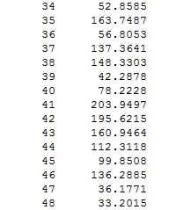

The MD/MM-GBSA results also showed some changed after longer simulation

The following are MM-GBSA values every 2ns

MM-GBSA (every 2 ns) STD

