**DATE: 3/3/2016**

**Demonstration of conformational rearrangement in sirtuins following NAM cleavage**

…As indicated above, there is a precedent for preferential binding of ligands to sirtuin-ADPR complexes (Ex-527 ref). These complexes are stabilized by cofactor binding loop - ligand interactions that occur only in the presence of ADPR, due to the fact that the flexible loop is ordered only in presence of ADPR binding. Hence it is plausible that the intermediate complex can bind more tightly to the ligand than the peptide complex through such flexible loop interactions. Tighter binding to the intermediate complex compared to substrate complex is possible due to the fact that a substantial conformational rearrangement of sirtuin loops occurs universally upon NAM cleavage.

Instead of competition with respect to NAM for binding, selective stabilization of the intermediate through preferential binding to structural features unique to the intermediate can activate sirtuins

* The sequence alignment (see SI) and discussion of loop conformational changes across sirtuins (below) are important to show the generality of the proposed mechanism of activation (similar biophysical properties required for multiple sirtuins)
* Focus on SIRT3, but may show one structure of Sir2Tm, and indicate issues with missing loop segment (to be addressed in subsequent papers)
* Residue-by-residue RMSD calculations

SIRT3:

* A flexible binding loop ILE154-GLU177 with ILE154-TYR165 having the potential to interact with substrates (NAD+, Intermediates, etc.)
* The loop conformation highly depends on the substrate bound.
* Upon conversion to intermediate (4BVG), or binding to thioimidate intermediate (3GLT), or products with Ex-527 inhibitor (4BVH), the helix unwinds and PHE157 rotate and the phenyl ring occupies part of the C pocket, TYR165 from unwound helix also comes closer to interact with intermediate with intermediate is formed. These structures often feature an a-turn in SER159-GLY163.
* Due to new contacts with ADPR after intermediate formation, it is possible that binding affinity increases after loop conformational change, but destabilization of NAM binding and proper positioning of catalytic residues may be more important

Residue-by-residue RMSD calculation is carried out by first performing a structural alignment followed by a direct rms calculation on the alignment structure for each residue. By-residue RMSD calculations are carried for 3GLS (apo-SIRT3), 4FVT(SIRT3:carba-NAD:ac-peptide) and 4JSR (SIRT3:ELT-11 inhibitor) with reference to 4BVG (SIRT3:Intermediate).

For SIRT3, by comparing to the crystal structures, the flexible loop region can be identified as lying between residue 155 and 174. For intermediate loop building, residue 156-169 was often chosen as a trade-off between the length of the loop and the completeness of flexible region, because 3JSR suggests that the alpha-turn can form with the inclusion of residue 156-169 that will allow the proper interaction of PHE157 and ARG158 with substrates. Longer chain (residue 156-172) is also use in the modeling of 4FVT when constraints are applied.

The RMSD plot shows 4FVT, 3JSR, 3GLS with reference to 4BVG is similar at residue 169. And if you inspect the loop structure above, you will see both 4BVG (light blue) and 3JSR (purple) both feature the alpha-turn (shown in figure above). With the formation of alpha-turn, the PHE157 is positioned toward the C-pocket and ARG158 stays above the C-pocket.

* + Szczepankiewicz BG, Dai H, Koppetsch KJ, Qian D, Jiang F, et al. (2012) Synthesis of carba-NAD and the structures of its ternary complexes with SIRT3 and SIRT5. J Org Chem 77: 7319–7329.
  + Gertz M, Fischer F et al (2013) Ex-527 inhibits Sirtuins by exploiting their unique NAD+-dependent deacetylation mechanism. Proc Natl Acad Sci U S A 110: E2772–E2781.

Sir2TM:

* PHE33 is found to critical for blocking NAM exchange as seen from ySir2-F274N and crystal structure with thioimidate intermediate (3D81). F33A is more sensitive to NAM inhibition.
  + Armstrong, C.M., Kaeberlein, M., Imai, S.I., and Guarente, L. (2002). Mutations in Saccharomyces cerevisiae gene SIR2 can have differential effects on in vivo silencing phenotypes and in vitro histone deacetylation activity. Mol. Biol. Cell 13, 1427–1438.
  + Hawse WF, Hoff KG, Fatkins DG, Daines A, Zubkova O V, et al. (2008) Structural insights into intermediate steps in the Sir2 deacetylation reaction. Structure 16: 1368–1377.
* Computational studies of the loop conformational change have not previously been carried out. The closest prior study comprised QM/MM simulations of stage 2 of catalysis (starting from intermediate complex). Here, the initial intermediate loop conformation was not created from the X-ray crystal structure as ARG34-SER44 were not resolved. The SIRT3 structures above do not have this problem.
  + Shi Y, Zhou Y, Wang S, Zhang Y (2013) Sirtuin Deacetylation Mechanism and Catalytic Role of the Dynamic Cofactor Binding Loop. J Phys Chem Lett 4: 491–495.

Using 2H59 as reference structure, the RMSD of CA atoms is plotted as follows. Will add comments from short report on Sir2TM loops – see Report_on_SIRT2TM

**The raw data for the plot shown below is located at**

**C:\Users\plin\Documents\MD_works\by-residue_RMSDs.xlsx**

**I find that the data in the file matches the data presented in the summary document**

**Suggestion: Since, we have the raw data; I can get it plotted using gnu plot or R for generating a better picture.**

**The raw data for this plot is located at**

**C:\Users\plin\Documents\MD_works\by-residue_RMSDs_2H4F_3D81.xlsx**

**Data matches**

residue 33

residue 47

**Figure. Residue-by-residue RMSD of cofactor binding loops in ternary and intermediate complexes, A) SIRT3 and B) Sir2Tm.**

**Suggestion: Since, we have the raw data; I can get it plotted using gnu plot or R for generating a better picture.**

1) Finalize these Figs, combine RMSD fig for SIRT3 w/below; Sir2TM will then go in SI. May need to remake them based on MD average RMSDs. Do both.

**This can be done because I have located the xls data sheet for the two plots.**

2) Add SIRT3 structure alignment w loops (3d if possible) to main text.

Main task here is to clarify this figure. May zoom in on ligands, with annotation of contacts and distances; in that case, may only put close-up in text, with whole loop depicted only in SI.

Again, Sir2Tm may go in SI w/mention in main text.

See task001.doc-task003.doc

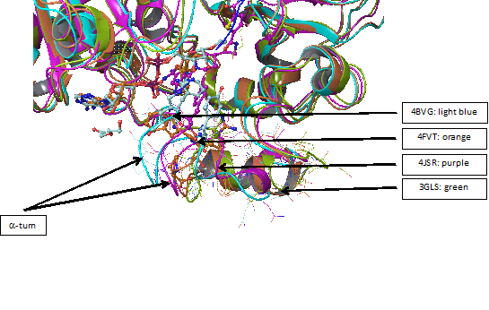

Suggestion: Since, we know the PDD ids used for generating the figure; I can get a better image generated using Pymol (POV ray rendered image), more focused on showing the conformational heterogeneity of the cofactor binding loop. I am not sure, if we need to have the side chains displayed?

**Figure. Structure alignment of ternary and intermediate SIRT3 complexes highlighting conformational differences in cofactor binding loops.**

**The files task001.doc-task003.doc is under**

**C:\Users\plin\Documents\SIRT\ task001.docx**

**C:\Users\plin\Documents\SIRT\ task002.docx**

**C:\Users\plin\Documents\SIRT\ task003.docx**

**-------------------------------------------------------------------------------------------------------------------------**

**Details pertaining to how the structural alignment (shown in the above figure) was carried out are document briefly in**

**C:\Users\plin\Documents\SIRT\** **task002.docx**

**If a new structure alignment needs to be done or the figure needs to be recreated, it can be done based on the PDB entry ids and the protocol, contained in the summary document (task002.docx)**

Then, make analogous figure based on MD averages based on same xtal structure instead (preferred; SIRT3 only). We will subsequently decide which one to use for SIRT3. For Sir2Tm, crystallographic structures will be used (SI) due to issues with loop preparation protocol that will not be discussed in this paper.

**One such figure showing the structural alignment of an MD averaged (SIRT3/Ac-ACS2/NAD+) structure with respect to crystal (pdb id: 4FVT) structure is contained in**

**C:\Users\plin\Documents\SIRT\SIRT3_Struct_Align_Figures_MD_vs_Cryst_v2.docx**

**Another figure showing the structural alignment of an MD averaged (Sir2TM/Ac-p53/NAD+) ternary complex with respect to crystal (pdb id: 2H4F) structure is contained in**

**C:\Users\plin\Documents\SIR \Sir2TM_Struct_Align_Figures_MD_vs_Cryst_v2.docx**

**REMARK: Although I don’t find any explicit mention of how structural alignment was carried out, but looking at some of the files and images contained under “C:\Users\plin\Documents”, I could sense that they should have been generated using Schrodinger.**

See Sidechain prediction validation set 1 PL RC.doc on side chain optimization. Data are in 4FVT-INT-NAM…-DATA.xls and 4FVT-INT-NAM…-ref-4BVG.xls

**Found the raw data for side chain RMSD prediction and prime energy results to be contained in**

**C:\Users\plin\Documents\MD_works\4FVT-INT-NAM-set1 /4FVT-INT-NAM-s155-178-set1-DATA.xlsx**

**\C:\Users\plin\Documents\MD_works\4FVT-INT-NAM-set1\with_reference_to_4BVG \4FVT-INT-NAM-set1-ref-4BVG.xlsx**

See tasks_2.2-2.4_report_updated.doc on loop substitution and structure preparation

**Found the raw data under**

**C:\Users\plin\Documents\SIRT\ tasks_2.2-2.4_report_updated.docx**

**It contains data related to loop modelling staring from crystal structure (PDB id 4FVT), which is an ternary complex(SIRT3/INT/NAM complex )**

**Molecular Dynamics**

MD simulations have been carried out on SIRT3/INT/NAM complex prepared from 4FVT with and without loop replacement that is taken from residue 155-178 of 4BVG.

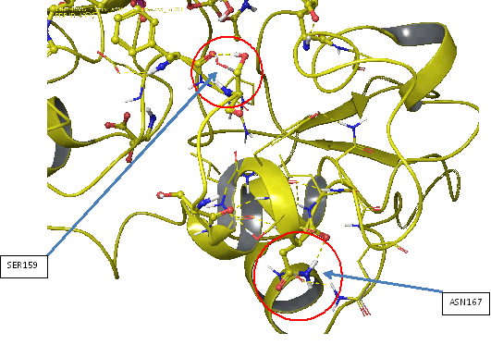

**Suggestion: This figure can be recreated with a better image quality. The H bonds have to be displayed in a different contrasting color (ideally black or red). The thickness of the H bonding interaction dots needs to be increased. If needed, I can generate a new figure using Pymol.**

**Figure.** **Comparison of** **SIRT3 complexes with cofactor binding loop modeled based on coordinates from ternary and intermediate complexes, respectively, after side chain optimization and molecular dynamics.** The structure depicted is an MD average**.** SIRT3/INT/NAM prepared from 4FVT w/ loop (res 155-178) replacement from 4BVG and side chain optimization; the native 4FVT structure after MD is aligned for comparison.

This figure can be recreated. The MD average structure used for the creation of the above figure is present in

**C:\Users\plin\Documents\MD_works \4FVT_isoNAM_v1_last10_ave.pdb**

- Prepare corresponding SIRT3 loop residue B factor fig from MD data, send to SI

**I see that computed B-factors for various SIRT3 complexes based on MD simulations are contained in**

**C:\Users\plin\Documents\MD_works \Flexible_Loop_Bfactor_Summary.xlsx**

**MM-GB(PB)SA**

The trajectories were further analyzed using MM-GB(PB)SA calculations with NAM as the ligand. Although the energies fluctuate over the course of the MD trajectory, the average energy shows clearly that with the loop substitution, the overall energy is lower and the binding affinity increases. The loop structures are well-maintained with respect to the starting structures in both cases.

* Conformational changes between ternary and intermediate (following NAM cleavage) complexes can be associated with significant energy gaps despite the fact that the binding modes of NAM moiety of NAD+ and NAM are similar (hence preventing effective competitive inhibition of base exchange) as described above.

Preliminary results exhibit consistency between GB and PB solvent

The most stable Phe conformation for INT:NAM complex appears to be with Phe partly in C pocket, but in different conformation from that in INT complex.

**MM/GB(PB)SA data table shown below is contained in**

**C:\Users\plin\Documents\SIRT\ MD simulations on SIRT3 complexes.docx.**

**The data shown in the table here matches the raw data contained in the file (MD simulations on SIRT3 complexes.docx)**

|  |  |  |  |  |  |  |  |
| --- | --- | --- | --- | --- | --- | --- | --- |
|  |  | SIRT3/INT/NAM prepared from 4FVT | | | SIRT3/INT/NAM prepared from 4FVT w/ loop (res 155-178) replacement from 4BVG | | |
| **time** | **Eng** | **Average** | **Std. Dev.** | **Std. Err. of Mean** | **Average** | **Std. Dev.** | **Std. Err. of Mean** |
| 2-4 ns | MM-GBSA(Complex) | -7145.44 | 50.57 | 3.57 | -7230.03 | 50.98 | 3.60 |
| 2-4 ns | MM-GBSA(receptor) | -7049.49 | 50.55 | 3.57 | -7131.85 | 50.92 | 3.59 |
| 2-4 ns | MM-GBSA(ligand) | -76.00 | 2.36 | 0.17 | -75.65 | 2.54 | 0.18 |
| 2-4 ns | MM-GBSA(binding) | -19.95 | 1.83 | 0.13 | -22.53 | 1.95 | 0.14 |
| 2-4 ns | MM-PBSA(Complex) | -5870.75 | 55.89 | 3.94 | -5914.04 | 54.19 | 3.82 |
| 2-4 ns | MM-PBSA(receptor) | -5794.44 | 56.35 | 3.97 | -5833.11 | 53.73 | 3.79 |
| 2-4 ns | MM-PBSA(ligand) | -73.05 | 2.35 | 0.17 | -72.80 | 2.53 | 0.18 |
| 2-4 ns | MM-PBSA(binding) | -3.25 | 3.92 | 0.28 | -8.12 | 3.57 | 0.25 |
| 4-6 ns | MM-GBSA(Complex) | -7149.60 | 49.39 | 3.48 | -7201.11 | 45.91 | 3.24 |
| 4-6 ns | MM-GBSA(receptor) | -7052.94 | 49.52 | 3.49 | -7103.24 | 46.11 | 3.25 |
| 4-6 ns | MM-GBSA(ligand) | -76.20 | 2.65 | 0.19 | -75.81 | 2.58 | 0.18 |
| 4-6 ns | MM-GBSA(binding) | -20.45 | 2.11 | 0.15 | -22.06 | 2.06 | 0.15 |
| 4-6 ns | MM-PBSA(Complex) | -5884.68 | 51.98 | 3.67 | -5895.39 | 51.61 | 3.64 |
| 4-6 ns | MM-PBSA(receptor) | -5806.29 | 52.11 | 3.68 | -5815.61 | 51.58 | 3.64 |
| 4-6 ns | MM-PBSA(ligand) | -73.25 | 2.67 | 0.19 | -72.91 | 2.55 | 0.18 |
| 4-6 ns | MM-PBSA(binding) | -5.14 | 3.40 | 0.24 | -6.88 | 4.01 | 0.28 |
| 6-8 ns | MM-GBSA(Complex) | -7151.85 | 54.34 | 3.83 | -7183.75 | 47.38 | 3.34 |
| 6-8 ns | MM-GBSA(receptor) | -7055.55 | 54.51 | 3.84 | -7085.51 | 47.20 | 3.33 |
| 6-8 ns | MM-GBSA(ligand) | -75.92 | 2.61 | 0.18 | -75.99 | 2.42 | 0.17 |
| 6-8 ns | MM-GBSA(binding) | -20.37 | 1.96 | 0.14 | -22.25 | 1.71 | 0.12 |
| 6-8 ns | MM-PBSA(Complex) | -5870.18 | 59.74 | 4.21 | -5875.60 | 51.64 | 3.64 |
| 6-8 ns | MM-PBSA(receptor) | -5794.27 | 59.69 | 4.21 | -5795.97 | 51.49 | 3.63 |
| 6-8 ns | MM-PBSA(ligand) | -72.98 | 2.58 | 0.18 | -73.02 | 2.39 | 0.17 |
| 6-8 ns | MM-PBSA(binding) | -2.93 | 3.20 | 0.23 | -6.62 | 3.66 | 0.26 |
| 8-10 ns | MM-GBSA(Complex) | -7153.39 | 48.88 | 3.45 | -7195.55 | 48.90 | 3.45 |
| 8-10 ns | MM-GBSA(receptor) | -7056.99 | 48.80 | 3.44 | -7097.05 | 48.84 | 3.44 |
| 8-10 ns | MM-GBSA(ligand) | -75.98 | 2.49 | 0.18 | -76.07 | 2.55 | 0.18 |
| 8-10 ns | MM-GBSA(binding) | -20.42 | 1.66 | 0.12 | -22.43 | 1.87 | 0.13 |
| 8-10 ns | MM-PBSA(Complex) | -5885.39 | 50.81 | 3.58 | -5908.01 | 54.54 | 3.85 |
| 8-10 ns | MM-PBSA(receptor) | -5807.87 | 51.04 | 3.60 | -5827.36 | 54.18 | 3.82 |
| 8-10 ns | MM-PBSA(ligand) | -72.98 | 2.46 | 0.17 | -73.05 | 2.54 | 0.18 |
| 8-10 ns | MM-PBSA(binding) | -4.54 | 3.54 | 0.25 | -7.60 | 3.63 | 0.26 |
|  |  |  |  |  |  |  |  |
| 2-12 ns | MM-GBSA(Complex) | -7146.48 | 50.31 | 3.55 | -7203.58 | 48.73 | 3.44 |
| 2-12 ns | MM-GBSA(receptor) | -7050.17 | 50.35 | 3.55 | -7105.13 | 48.62 | 3.43 |
| 2-12 ns | MM-GBSA(ligand) | -75.99 | 2.54 | 0.18 | -75.95 | 2.51 | 0.18 |
| 2-12 ns | MM-GBSA(binding) | -20.33 | 1.86 | 0.13 | -22.50 | 1.87 | 0.13 |
| 2-12 ns | MM-PBSA(Complex) | -5873.69 | 54.91 | 3.87 | -5901.23 | 53.32 | 3.76 |
| 2-12 ns | MM-PBSA(receptor) | -5796.70 | 55.08 | 3.89 | -5820.47 | 52.96 | 3.74 |
| 2-12 ns | MM-PBSA(ligand) | -73.03 | 2.53 | 0.18 | -73.02 | 2.49 | 0.18 |
| 2-12 ns | MM-PBSA(binding) | -3.96 | 3.51 | 0.25 | -7.73 | 3.67 | 0.26 |

Show only 2-12 ns in paper(in style of PLOS 2014 paper). **-** SIRT3/INT/NAM (native loop); -SIRT3/INT/NAM (substituted loop: from 4BVG). Write standard dev as +/- in same column. Remaining rows should be sent to SI. Specify def of std error of mean: in terms of 25 ps intervals? Verify that these simulations used an equilibration phase of only 2 ns (sampling phase of 10 ns).

**Suggestion: Completely agree with your comment. We need to report only ∆G computed form an equilibrated trajectory. So, a single ensemble averaged number (∆G) accompanied by +/- SD would suffice for the main paper. However, if you feel the need to show convergence in the supplementary section, then I can use these numbers for estimating convergence (Block averaging) and error propagation.**

See MD simulations on SIRT3 complexes.doc.

**You asked me to add this data for the second simulation here.**

|  |  |  |  |  |  |  |  |
| --- | --- | --- | --- | --- | --- | --- | --- |
|  |  | 4BVG w/NAM and loop replacement | | | 4BVG with NAM placement | | |
| **time** | **Eng** | **Average** | **Std. Dev.** | **Std. Err. of Mean** | **Average2** | **Std. Dev.5** | **Std. Err. of Mean6** |
| 2-4 ns | MM-GBSA(Complex) | -7432.84 | 50.68 | 3.57 | -7464.74 | 51.08 | 3.60 |
| 2-4 ns | MM-GBSA(receptor) | -7339.14 | 50.98 | 3.60 | -7370.14 | 51.00 | 3.60 |
| 2-4 ns | MM-GBSA(ligand) | -75.67 | 2.54 | 0.18 | -75.67 | 2.40 | 0.17 |
| 2-4 ns | MM-GBSA(binding) | -18.03 | 1.81 | 0.13 | -18.93 | 2.20 | 0.16 |
| 2-4 ns | MM-PBSA(Complex) | -6127.56 | 57.23 | 4.04 | -6128.43 | 52.74 | 3.72 |
| 2-4 ns | MM-PBSA(receptor) | -6054.95 | 56.71 | 4.00 | -6048.63 | 53.02 | 3.74 |
| 2-4 ns | MM-PBSA(ligand) | -72.60 | 2.50 | 0.18 | -72.65 |  |  |
| 2-4 ns | MM-PBSA(binding) | -0.02 | 4.55 | 0.32 | -7.15 |  |  |
| 4-6 ns | MM-GBSA(Complex) | -7417.88 | 49.62 | 3.50 | -7419.88 | 50.52 | 3.56 |
| 4-6 ns | MM-GBSA(receptor) | -7324.78 | 49.76 | 3.51 | -7323.77 | 50.32 | 3.55 |
| 4-6 ns | MM-GBSA(ligand) | -75.65 | 2.51 | 0.18 | -75.92 | 2.44 | 0.17 |
| 4-6 ns | MM-GBSA(binding) | -17.44 | 1.85 | 0.13 | -20.18 | 1.96 | 0.14 |
| 4-6 ns | MM-PBSA(Complex) | -6116.08 | 60.73 | 4.28 | -6085.57 | 55.37 | 3.91 |
| 4-6 ns | MM-PBSA(receptor) | -6044.37 | 60.22 | 4.25 | -6008.62 | 55.26 | 3.90 |
| 4-6 ns | MM-PBSA(ligand) | -72.67 | 2.50 | 0.18 | -72.89 | 2.42 | 0.17 |
| 4-6 ns | MM-PBSA(binding) | 0.96 | 4.00 | 0.28 | -4.06 | 3.54 | 0.25 |
| 6-8 ns | MM-GBSA(Complex) | -7431.85 | 52.10 | 3.67 | -7485.77 | 50.38 | 3.55 |
| 6-8 ns | MM-GBSA(receptor) | -7338.70 | 51.76 | 3.65 | -7388.92 | 50.21 | 3.54 |
| 6-8 ns | MM-GBSA(ligand) | -75.65 | 2.50 | 0.18 | -75.81 | 2.47 | 0.17 |
| 6-8 ns | MM-GBSA(binding) | -17.50 | 2.02 | 0.14 | -21.03 | 1.57 | 0.11 |
| 6-8 ns | MM-PBSA(Complex) | -6162.60 | 59.01 | 4.16 | -6139.09 | 56.28 | 3.97 |
| 6-8 ns | MM-PBSA(receptor) | -6089.22 | 58.39 | 4.12 | -6063.15 | 56.34 | 3.97 |
| 6-8 ns | MM-PBSA(ligand) | -72.59 | 2.48 | 0.18 | -72.79 | 2.48 | 0.17 |
| 6-8 ns | MM-PBSA(binding) | -0.80 | 3.11 | 0.22 | -3.15 | 3.20 | 0.23 |
| 8-10 ns | MM-GBSA(Complex) | -7434.14 | 45.86 | 3.23 | -7492.73 | 45.21 | 3.19 |
| 8-10 ns | MM-GBSA(receptor) | -7341.21 | 46.18 | 3.26 | -7395.78 | 44.79 | 3.16 |
| 8-10 ns | MM-GBSA(ligand) | -75.53 | 2.86 | 0.20 | -75.98 | 2.60 | 0.18 |
| 8-10 ns | MM-GBSA(binding) | -17.40 | 2.03 | 0.14 | -20.97 | 1.57 | 0.11 |
| 8-10 ns | MM-PBSA(Complex) | -6176.31 | 48.02 | 3.39 | -6155.15 | 48.74 | 3.44 |
| 8-10 ns | MM-PBSA(receptor) | -6104.37 | 48.35 | 3.41 | -6078.98 | 48.73 | 3.44 |
| 8-10 ns | MM-PBSA(ligand) | -72.45 | 2.80 | 0.20 | -72.97 | 2.60 | 0.18 |
| 8-10 ns | MM-PBSA(binding) | 0.51 | 3.07 | 0.22 | -3.20 | 3.51 | 0.25 |
| 10-12 ns | MM-GBSA(Complex) | -7457.50 | 50.78 | 3.59 | -7476.44 | 49.70 | 3.51 |
| 10-12 ns | MM-GBSA(receptor) | -7363.65 | 50.44 | 3.57 | -7383.50 | 49.95 | 3.53 |
| 10-12 ns | MM-GBSA(ligand) | -75.91 | 2.26 | 0.16 | -75.92 | 2.39 | 0.17 |
| 10-12 ns | MM-GBSA(binding) | -17.93 | 1.93 | 0.14 | -17.02 | 2.56 | 0.18 |
| 10-12 ns | MM-PBSA(Complex) | -6189.51 | 55.40 | 3.92 | -6152.64 | 53.05 | 3.75 |
| 10-12 ns | MM-PBSA(receptor) | -6116.29 | 55.13 | 3.90 | -6076.08 | 53.31 | 3.77 |
| 10-12 ns | MM-PBSA(ligand) | -72.83 | 2.27 | 0.16 | -72.95 | 2.36 | 0.17 |
| 10-12 ns | MM-PBSA(binding) | -0.39 | 2.95 | 0.21 | -3.61 | 4.20 | 0.30 |
|  |  |  |  |  |  |  |  |
| 2-12 ns | MM-GBSA(Complex) | -7434.84 | 49.81 | 3.51 | -7467.91 | 49.38 | 3.48 |
| 2-12 ns | MM-GBSA(receptor) | -7341.50 | 49.82 | 3.52 | -7372.42 | 49.25 | 3.48 |
| 2-12 ns | MM-GBSA(ligand) | -75.68 | 2.53 | 0.18 | -75.86 | 2.46 | 0.17 |
| 2-12 ns | MM-GBSA(binding) | -17.66 | 1.93 | 0.14 | -19.63 | 1.97 | 0.14 |
| 2-12 ns | MM-PBSA(Complex) | -6154.41 | 56.08 | 3.96 | -6132.18 | 53.24 | 3.76 |
| 2-12 ns | MM-PBSA(receptor) | -6081.84 | 55.76 | 3.93 | -6055.09 | 53.33 | 3.76 |
| 2-12 ns | MM-PBSA(ligand) | -72.63 | 2.51 | 0.18 | -72.85 | 1.97 | 0.14 |
| 2-12 ns | MM-PBSA(binding) | 0.05 | 3.54 | 0.25 | -4.23 | 2.89 | 0.20 |

**The raw data file is located at**

**C:\Users\plin\Documents\SIRT\MM-GBPBSA_for_SIRT3complexes.xlsx.**

**The number stated here are consistent with the raw data.**

**(Although you asked me to have a look at this data, I find that you have commented above that this simulation “data is less stable”, henceforth will not be used for the paper.)**

Prepare a Figure depicting MM-GBSA and MM-PBSA trajectories (line plots of energies vs time):

**Figure. Molecular dynamics trajectories for SIRT3 complexes after structure preparation. A)** MM-GBSA and PBSA energies vs simulation time for SIRT3/INT/NAM prepared from 4FVT w/ loop (res 155-178) replacement from 4FVT; **B)** MM-GBSA and PBSA energies vs simulation time for SIRT3/INT/NAM prepared from 4FVT

**(I couldn’t locate any plot pertaining to this. I presume this plot has not been generated)**

3) Add the methods for the above (to SI if needed); includes loop substitution, side chain opt, NAM placement, MD simulation, MM-GB(PB)SA scoring (latter two from previous PLOS paper). Also sequence alignment below. See short reports for some details. Configuration files for MD and PLOS 2014 paper will have further details on MD methods if needed.

**Computational SI**

**The alignments figures are contained under**

**C:\Users\plin\Documents\SIRT \alignment2_v3.pdf**

**C:\Users\plin\Documents\SIRT \alignment2.docx (data matches)**

* **Structure-based sequence alignment**

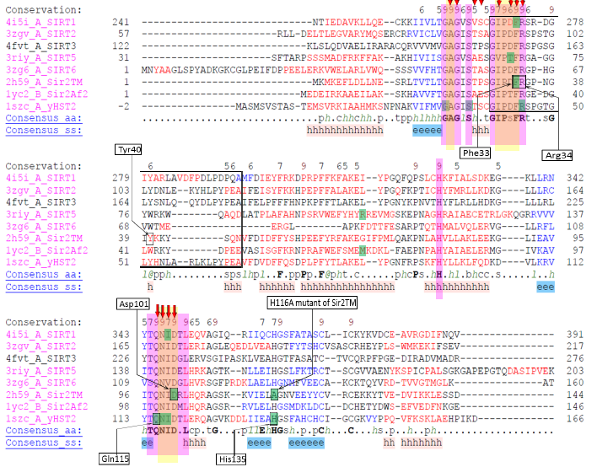

Helix in the binding loop in 4FVT (SIRT3) ranges from GLY163-TYR171, b-turn in 2H59 (Sir2TM) ranges from GLY35-GLY38 and is shown in the red rectangle.

**REMARK: Although I don’t find any explicit mention of how sequence alignment was**

**carried out; but looking at raw data files and images contained under**

**“C:\Users\plin\Documents\SIRT”, I see that they have been generated using PROMALS3D.**

**So this data could be reproduced if we need a better alignment picture .**

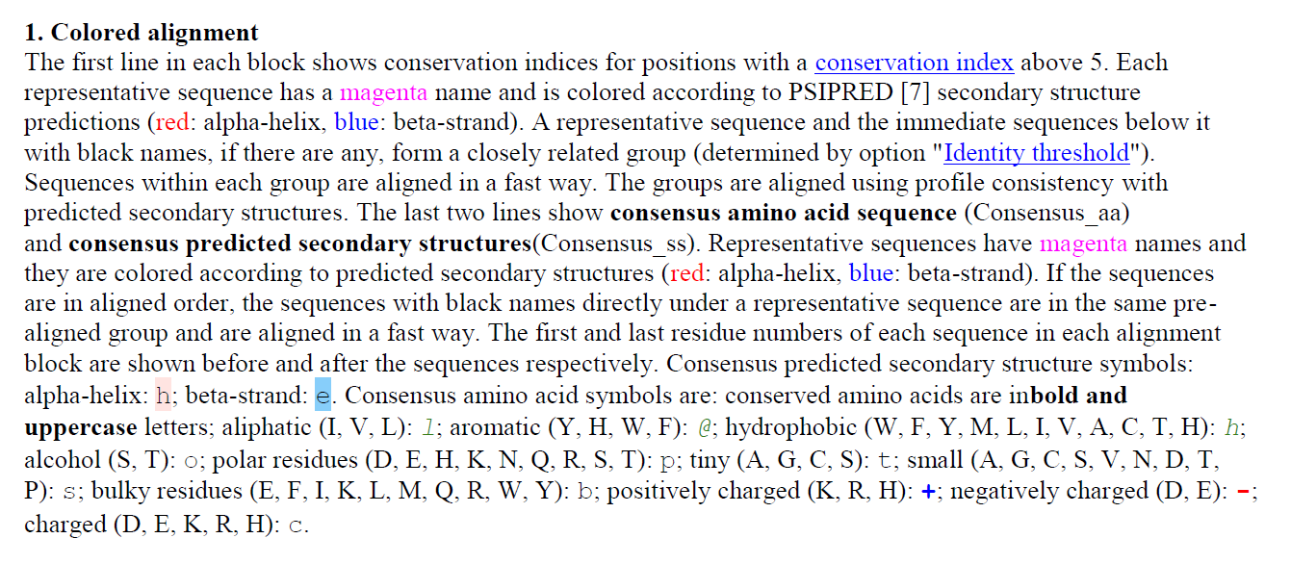

**Figure. Sirtuin sequence alignment highlighting flexible cofactor binding loop and conserved residues important in binding and catalysis**

-Sequence alignment – finalize and send to SI. Make sure annotations are defined and clear. See Alignment_mutation table insert

**I found the “Alignment_mutation table insert” document under**

**C:\Users\plin\Documents \Alignment_mutation table insert_02.06.2015.pptx**

-Sir2Tm Figs above – send to SI

**Figure.** **Residue B factors from molecular dynamics for SIRT3 cofactor binding loops modeled based on coordinates from ternary and intermediate complexes, respectively, after side chain optimization.**

**I see that computed B-factors values are for various SIRT3 complexes computed from MD simulations are contained in**

**C:\Users\plin\Documents\MD_works \Flexible_Loop_Bfactor_Summary.xlsx**

**We can use this data to plot the graph.**

-SIRT3 loop residue B factor fig – send to SI

**The B factor values are contained in**

**C:\Users\plin\Documents\MD_works \Flexible_Loop_Bfactor_Summary.xlsx**

**We can use this data to plot the graph.**