Date: 3/16/2016

Task 1:

Mapping the remaining raw data files relevant to the information contained KT documents.

Status: Almost done, few more data on loop modelling needs to be mapped. Back to this work, since the rest of the task is complete.

-----------------------------------------------------------------------------------------------------------------

Task 2:

Create new B factor plots based on the MD data contained in

C:\Users\plin\Documents\MD_works \Flexible_Loop_Bfactor_Summary.xlsx

Two plots needs to be created.

**Status: Completed**

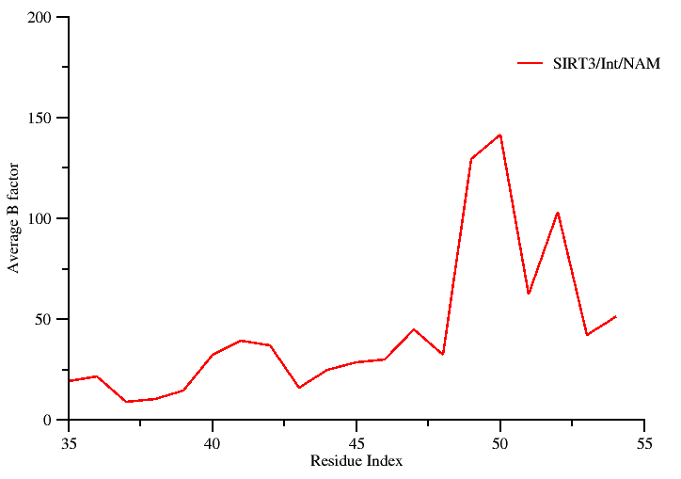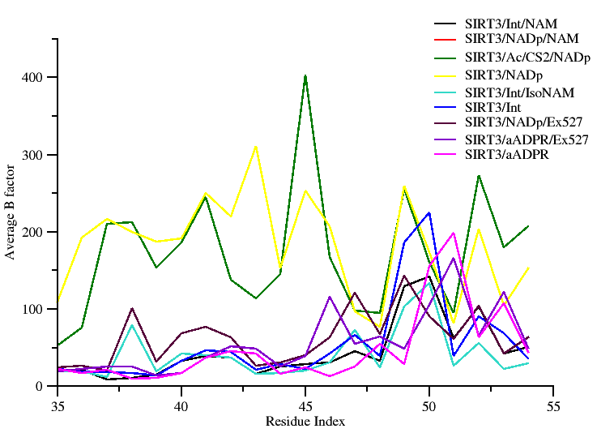

RSK: This figure was not present in Plin’s document. Hence, figure legend was not available.

Fig ------: Plot showing simulated B-factor values for the Cα atoms belonging to the co-factor binding loop region of SIRT3/Int/NAM complex.

**Comments:**

RSK: Not sure which plot you specifically need. So I created two plots here. I can always change the color of the plot, easily because I have them saved in .agr format.

Source of data: Raw data used for generating the above plot is contained in: C:\Users\plin\Documents\MD_works\Flexible_Loop_Bfactor_Summary.xlsx

---------------------------------------------------------------------------------------------------------------

Task 3:

Perform a structure based sequence alignment using PROMALS3D to recreate the figure presented in Pling’s summary document.

The following PDB ids 4I5I, 3ZGV, 4FVT, 3RIY, 3ZG6, 2H59, 1YC2, and 1SZC will be considered for alignment and highlight regions containing the conserved residues critical for catalysis and their mutations.

**Status: Completed**

RC: -- Task 3: is PROMALS3D what Ping used?

If so, please indicate some of the differences between the new alignment/presentation and the old one.

E.g., this might include focusing on a particular region.

RSK: Looking at the image and also digging through the files located in (user/plin), I do see that Plin has some html result files generated using PROMALS3D. Further looking at the style of the data, I am confident that the alignment output must have been obtained using the PROMALS3D.

Looking at the footnote below that alignment image, I see that the whole point in having the sequence-structure alignment was to highlight residue conservation in the loop region (showing the short helix) and the beta turn region. However, the image contains the entire sequence space, which looks to be slightly cluttered.

Hence, my suggestion is to use the alignment information provided by PROMALS3D and then filter the aligned region of interest and then proceed to create a sequence logo image to highlight the degree of conservation. Alternatively, a simple solution would be to edit the PROMALS3D image and the crop it to focus only on the region of interest.

RC: Regarding the sequence alignments and annotations of catalytically important residues in other figures: please get the table from Guan on the roles of these residues and include some version of this at the end of the document so it is self-contained and so the captions can later be revised to include some mention of the roles of these residues if desired.  
This should also be available on the wiki.

RSK: I have added a summary note based on Plin’s document. Also, I have revised the figure incorporating such information’s which I picked up form literatures.

Basically from a review article titles “*Structural basis for sirtuin function: What we know and what we don’t*” which appeared in BBA.

RC: Regarding caption for sequence alignment, I didn't see a draft of the condensed/revised version of the original caption that Ping apparently borrowed from the sequence alignment program.

RSK: A condensed and revised version of the figure legend has now been incorporated.

**Option A (new revised figure)**

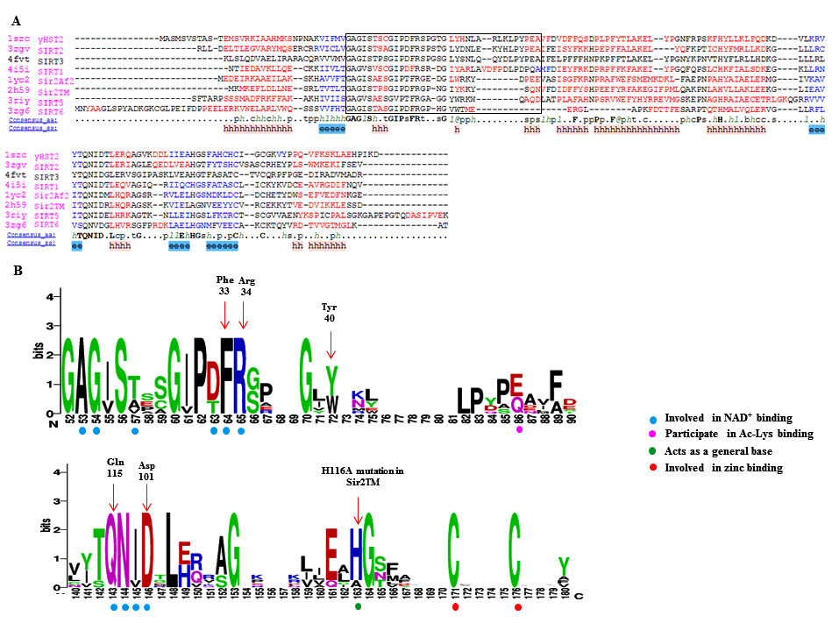

**RSK: figure legend revised appropriately based on your comments.**

**Fig ……. :** Panel A shows a PROMALS3D sequence alignment of sirtuin proteins.  Residues shown in the alignment are colored according to their predicted secondary structure elements (red: α-helix, blue: β-strand). The black box indicates the boundaries of the co-factor binding loop region. The consensus sequence (consensus_aa) and the consensus predicted secondary structure (consensus_aa) are shown at the bottom of the alignment. Consensus amino acid symbols are represented by: conserved amino acids are in bold and uppercase letters; aliphatic (I, V, L): l; aromatic (Y, H, W, F): @; hydrophobic (W, F, Y, M, L, I, V, A, C, T, H): h; alcohol (S, T): o; polar residues (D, E, H, K, N, Q, R, S, T): p; tiny (A, G, C, S): t; small (A, G, C, S, V, N, D, T, P): s; bulky residues (E, F, I, K, L, M, Q, R, W, Y): b; positively charged (K, R, H): +; negatively charged (D, E): −; charged (D, E, K, R, H): c. The global consensus predicted secondary structure are represented by alpha helix (h) and beta strand (e).

Panel B shows a portion of sequence logo that corresponds to co-factor binding loop region and other key residues of the catalytic core region. Here, the relative height of the letters indicates amino acid frequency at that position. Residues important for co-factor, substrate binding and catalysis are highlighted using colored circles. Amino acids residues in the logos are colored according to their chemical properties (neutral polar – green, basic – blue, acidic – red and hydrophobic – black).

**Summary on the role of the highlighted residues: (Taken form Plin’s document)**

Phe 33 in ySir2

* Plays a critical role both in the initial reaction steps
* Its orientation is likely to be a key mediator of the nicotinamide exchange reaction

His 116 in Sir2Tm

* Catalytically Important residue
* H116D and H116Y mutation decrease deacylation rates in vivo and in vitro
* His acts as a general base to deprotonate one of the ribose oxygens.

Asp 101 in Sir2Tm

* The D101N mutation would lead to the disruption of key hydrogen bonds in the nicotinamide binding pocket and the change of the binding conformation of NAD+.

Gln 115 in Sir2Af1

* Enzymatic activity is severely affected by mutations
* Located at the floor of the NAD binding pocket

**Option B (Old figure)** 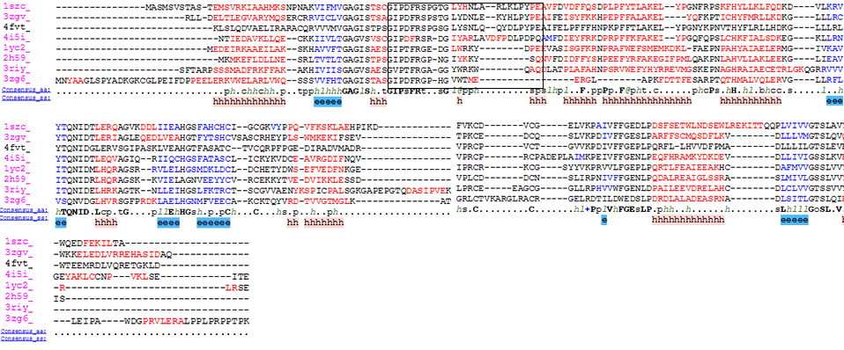

**Raw data: data source not required. I completely recreated it using the PDB entries mentioned in the previous figure prepared by Plin prepared. I crosschecked and the alignment does matches with the earlier figure.**

**---------------------------------------------------------------------------------------------------------------------**

Task 4:

Pymol rendering showing the conformational heterogeneity of the cofactor binding loop (with and without the side chains displayed). The following PDB ids will be used to carry out a structural alignment. (4BVG, 4FVT, 4JSR, and 3GLS).

**Status : Completed**

RC: -- Task 4: Structure alignment from pdbs. Yes, SIRT3 is the priority. I believe there was also a note about Sir2Tm in the Supporting Info. We should bear in mind that using 4 structures might lead to clutter. I believe the priorities were 4BVG and 4FVT? We can consider the others as well possibly for alternate versions of the Fig but with a plan.

RSK: I get your point. I will go ahead and prepare a session file with all four PDB entries. However, for generating image I will use only 4BVG and 4FVT in the display. Since, I will have everything saved in a pymol session file, we can always open the session file and juggle between the PDB entries, as required. A pymol session file will mitigate the need to create a quality rendering each time when required

Option A (4BVG and 4FVT alone used for the display) old figure

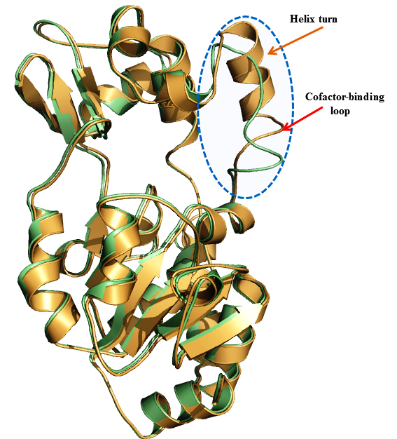

Option B (All PDB ids used)old figure

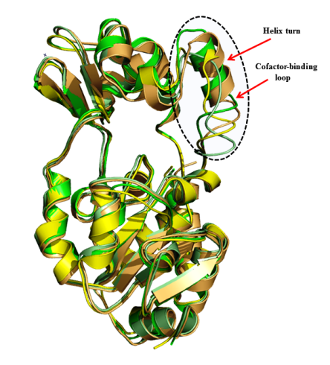

RC: For task 4, you mentioned we can easily edit displays for alternate versions. Zooming in closer to the loop may be desirable in one version.

RSK: Image has been revised; a new figure has been created to address this comment.

RC: Are we still doing a version with side chains displayed?

RSK: Yes, It has been incorporated in the revised image. To prevent cluttering I have displayed only the side chains for the key residue (Phe of the cofactor binding loop) and the substrate (Acetylated Lysine). See fig Option B.

Revisions undertaken: I have created a revised figure based on your comments. The co-factor binding loop is now zoomed in. The key residue (Phe) and the substrate (Ac-Lys) are highlighted and their sidechains display is turned on. In addition, I have also ensured that important subsites and the channel are also highlighted. See the revised figure in page 8: Option B (Revised figure)

Option A: Without side chains (old figure)

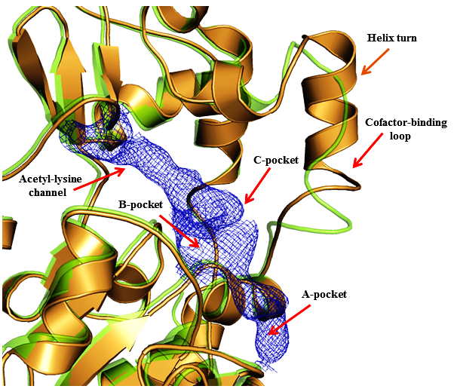

**Figure. Structure alignment of ternary and intermediate SIRT3 complexes highlighting conformational differences in cofactor binding loops. (as per Plin’s document)**

**RSK: I revised the figure legend (old)**

Figure XXXXX: Superposition of Sirt3 native intermediate (4BVG - Green) and Sirt3 ternary complex (4FVT - Orange) showing different conformations of the co-factor binding loop. Individual subsites of the active site are highlighted.

**Option B (Revised figure) new**

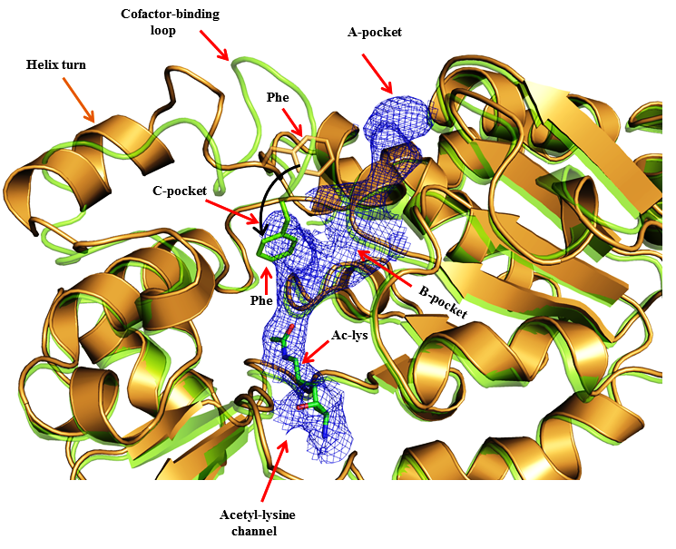

RSK: I also revised the figure legend appropriately to reflect the changes.

Figure XXXXX: Superposition of Sirt3 native intermediate (4BVG - Green) and Sirt3 ternary complex (4FVT - Orange) showing difference in the conformations of the cofactor binding loop and the position of the Phe residue. Individual subsites are highlighted and the movement of Phe residue is indicated by black arrows

**-------------------------------------------------------------------------------------------------------------------------------**

Task 5:

A new figure showing the comparison of SIRT3 complexes with cofactor binding loop modeled based on coordinates from ternary and intermediate complexes.

RC: Task 5: This is from MD data, right?

RSK: Yes, that’s right. It’s the MD averaged structure. I have located the pdb file of the MD averaged structure. ***However, the FOOT NOTE for the image provided by Plin in the original summary document says that “the native 4FVT structure after MD is aligned for comparison”. But looking at the image, I see the image to contain only one structure.* This needs to be reconciled. I think that 4FVT_isoNAM_v1_mds_avg10ps.pdb (native 4FVT simulation average structure) is the structure which Pling is alluding to.**

RC: Regarding task 2, we may have the structures match those that will be included in the MD average Fig. We could start with that, following which I will consider further and advise

C:\Users\plin\Documents\MD_works\MD_4BVG_4FVT/Int_fused_4FVT_4BVG.pdb

Remark: I find that Pling in his summary has stated that “*The most stable Phe conformation for INT:NAM complex appears to be with Phe partly in C pocket, but in different conformation from that in INT complex”.* However, looking at the figure, which I created (below), I see that the Phe side chain is oriented towards the B pocket in lieu of the C pocket. I am not sure about this statement.

Old figure

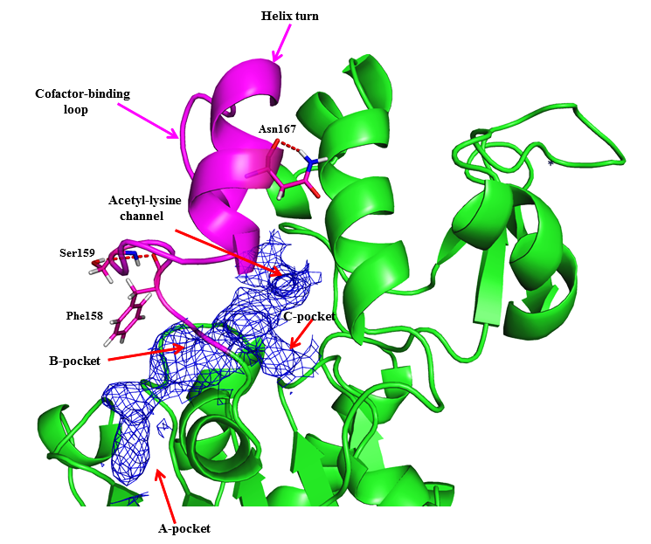

**Caption**

**Figure.** **Comparison of** **SIRT3 complexes with cofactor binding loop modeled based on coordinates from ternary and intermediate complexes, respectively, after side chain optimization and molecular dynamics.** The structure depicted is an MD average**.** SIRT3/INT/NAM prepared from 4FVT w/ loop (res 155-178) replacement from 4BVG and side chain optimization; the native 4FVT structure after MD is aligned for comparison.

Revised Caption:

Fig : MD averaged structure of Sirt3 complex, showing the cofactor binding loop (magenta) modeled based on the coordinates from ternary and intermediate complex.

RC: I am not sure that we are on the same page regarding the MD average figure. See the proposed caption, which mentions that the two loop conformations after MD are to be compared.  
I only see a single purple loop in the figure provided. Is that the INT or ternary conformation of the loop?  
Perhaps this is related to the potential issue you had referred to in a previous posting.

RSK: Yes, that’s what I referred to. It has been fixed in the revised figure.

RC: In this figure, I'm not sure that using different colors for the loops adds to clarity. Perhaps a different rendering or other approach could be considered.

RSK: Okay, will remove the colors for the loop. This issue has been fixed in the revised version.

RC: Regarding the B/C pocket issue for Phe: I noted that the different figs provide varying perspectives on the active site. It may be easier to observe the difference in Phe conformation between the INT complex (shown in green in  
Figure XXXXX: Superposition of Sirt3 native intermediate) and in INT:NAM complex if the figures used the same perspective.

RSK: I had ensured consistency. The revised figures have the same perspective.

RC: What structures did you use for the latest version of this figure (R2 revision)? The intention was to use the MD averages from 4FVT simulations with and without loop replacement from  
4BVG. Is that what you used or did you use a simulation based on 4BVG protein structure for the intermediate?

RSK: **In the revised figure I used an MD average structure (last 10ps) of 4FVT_isoNAM.pdb ( 4FVT-IsoNAM- with loop modelled from 4BVG) superimposed onto native 4FVT structure  
  
I think that I will have to revise this figure using the 4FVT having NAM instead of iso NAM ( ie, 4FVT-NAM- with loop modeled from 4BVG), because I see that is what you require. I think that now we are on the same page on the how the figure should be created. If not let please me know.**

RC: In the figure based on pdb structures, you showed the substrate. In this case would it compromise clarity?

RSK: You mean the Acy-Lys. I will create another one without out the substrate.  
RC: By "In this case" I meant the MD average figure. It is lacking the substrates.  
RSK: Okay got it. Will create two versions of the figure w/wo substrate. You can choose the one with better clarity.

REVISED FINAL OPTION A

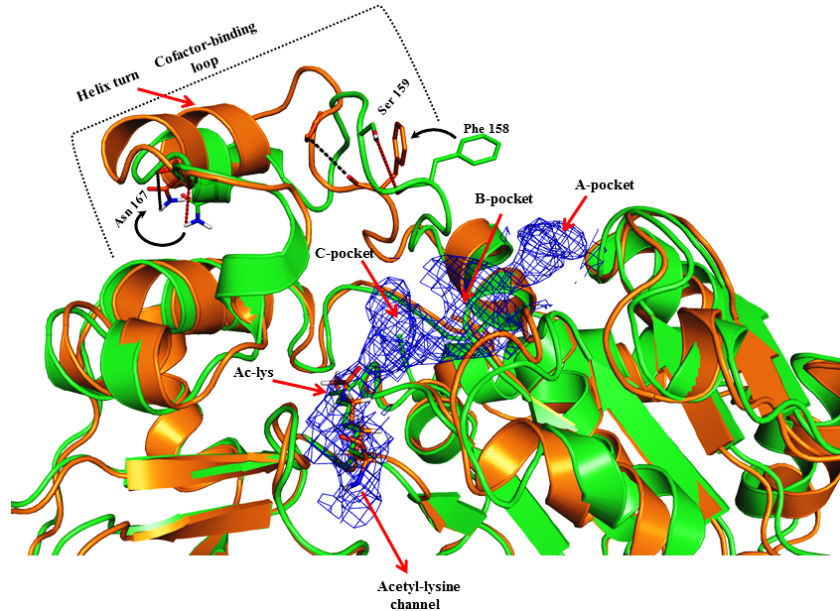

Revised figure **with substrate**

Actual figure legend which Plin had in his document

**Figure.** **Comparison of** **SIRT3 complexes with cofactor binding loop modeled based on coordinates from ternary and intermediate complexes, respectively, after side chain optimization and molecular dynamics.** The structure depicted is an MD average**.** SIRT3/INT/NAM prepared from 4FVT w/ loop (res 155-178) replacement from 4BVG and side chain optimization; the native 4FVT structure after MD is aligned for comparison.

RSK: Revised figure legend

Fig ---- : SIRT3 native ternary complex (4FVT - Green) superimposed onto SIRT3 intermediate complex (Orange) prepared from 4FVT with the cofactor binding loop residues (155-178) replaced from 4BVG structure. Structures shown in figure are MD averaged structures. Differences in the conformations of the cofactor binding loop and the position of the Phe residue are highlighted.

REVISED FINAL OPTION B

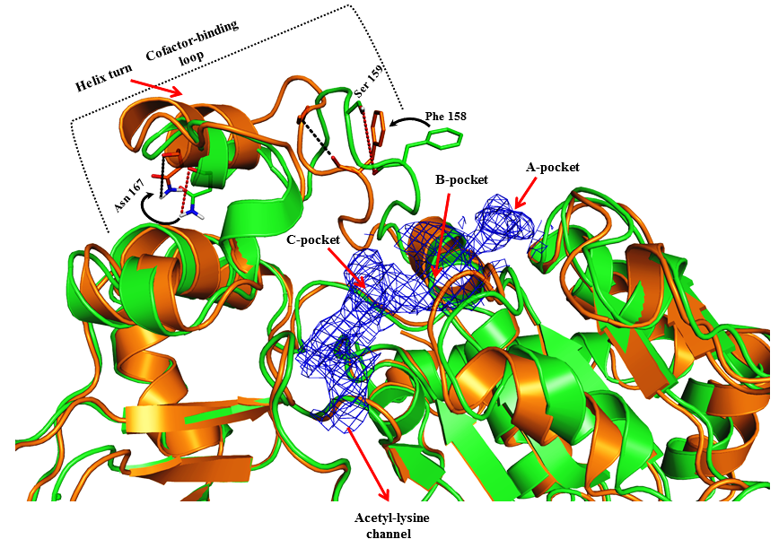

Revised figure **without substrate**

Fig ---- : SIRT3 native ternary complex (4FVT - Green) superimposed onto SIRT3 intermediate complex (Orange) prepared from 4FVT with the cofactor binding loop residues (155-178) replaced from 4BVG structure. Structures shown in the figure are MD averaged structures. Differences in the conformations of the cofactor binding loop and the position of the Phe residue are highlighted.

Data source: The MD average structured of 4FVT is located at C:\Users\plin\Documents\MD_works\ 4FVT_v1_fixed2_mds_last10ps.pdb

The MD average structured of 4FVT with loop residues replaced from 4BVG is located at

C:\Users\plin\Documents\MD_works\ 4FVT_NAM_fixed_v1_mds_avg10ps

-----------------------------------------------------------------------------------------------------------------

RC: Also, there were RMSD plots in one Fig that is later to be merged with either 4 or 5. Are we planning to use the old versions?

RSK: I will have to recreate one so that it match publication quality image standard and for consistency with the other plots. I have appended this item to the task list as item no 8.

**Status: Completed**

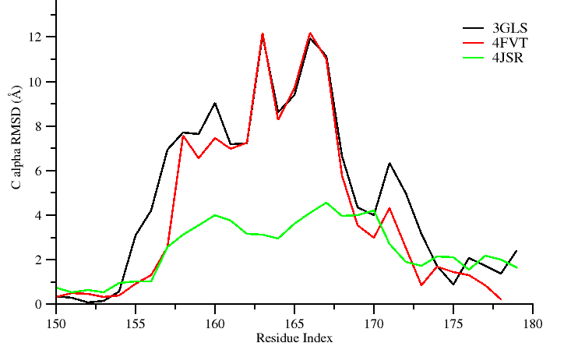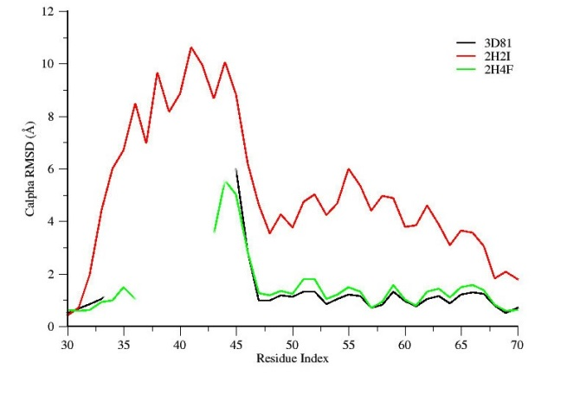

**Legend**

**Figure. Residue-by-residue RMSD of cofactor binding loops in ternary and intermediate complexes, A) SIRT3 and B) Sir2Tm.**

RSK:

Revised figure legend.

Figure ----: Comparison of average per-residue RMSD values for the cofactor binding loop region in ternary and intermediate complexes.

Data source: The raw data used for the plot is located at

C:\Users\plin\Documents\MD_works\by-residue_RMSDs.xlsx

-----------------------------------------------------------------------------------------------------------------

Task 6: Recreate new MM/GBSA and MM/PBSA tables similar to the previous PLOS ONE 2014 paper, reporting only binding energy values computed between 2-12 ns time scale. Two such tables need to be created.

**Status: completed**

**Table ….. : Calculated binding energies using MM-PBSA and MM-GBSA. Energy values are reported in kcal/mol.**

|  |  |  |
| --- | --- | --- |
| Energy Components | SIRT3/INT/NAM prepared from 4FVT | SIRT3/INT/NAM prepared from 4FVT with loop (res 155-178) replaced from 4BVG |
| MM-GBSA (Complex) | -7146.48 ± 3.55 | -7201.58 ± 3.44 |
| MM-GBSA (Receptor) | -7050.17 ± 3.55 | -7105.13 ± 3.43 |
| MM-GBSA (Ligand) | -75.99 ± 0.18 | -75.95 ± 0.18 |
| **MM-GBSA (ΔGBind )** | **-20.33 ± 0.13** | **-22.50 ± 0.13** |
| MM-PBSA (Complex) | -5873.69 ± 3.87 | -5901.23 ± 3.76 |
| MM-PBSA (Receptor) | -5796.70 ± 3.89 | -5820.47 ± 3.74 |
| MM-PBSA (Ligand) | -73.03 ± 0.18 | -73.02 ± 0.18 |
| **MM-PBSA ( ΔGBind )** | -**3.96** **± 0.25** | **-7.73 ± 0.26** |

**Data source:**

**The data used in this table is located at:**

**C:\Users\plin\Documents\SIRT\MM-GBPBSA_for_SIRT3complexes.xlsx.**

**REMARK: I see that you have commented to Plin that you need a table that’s similar to the PLOS 2014 paper. For that I would need the raw generated from the MMPBSA.py script. I tried to locate the raw .dat files obtained from the mmpbsa calculations in the gpu node, so that I could tabulate the energetic decomposition. I see that there are umpteen mmpbsa output files. Hence, I have written a shell script that will recursively go in to each directory and search for a .dat file and greps the value. (Will let you know if the script is able to locate a file having the exact ΔGBindvalues shown in the table).**

**---------------------------------------------------------------------------------------------------------------------**

RC: Should we list the raw data required for each task under the task?

RSK: Yes, I think that would help in maintaining a good documentation. I have added it as item no 7 to the task list.

Task 7:

RC: Add the location/path of the raw data used for completing the assigned task in “Task list1”

**Status: completed**.

**RSK: data source and path has been added now for each completed task.**

**--------------------------------------------------------------------------------------------------------------------**

Task 8: Replot the two RMSD plots contained in the KT document (manuscript computational section excerpts and task.doc)

**Status: completed (I have saved the plots in .agr format. In case if you need any modification, I can get it easily done (I will not have to redo the complete plotting again). Plot was generated using windows version of Xmgrace.**

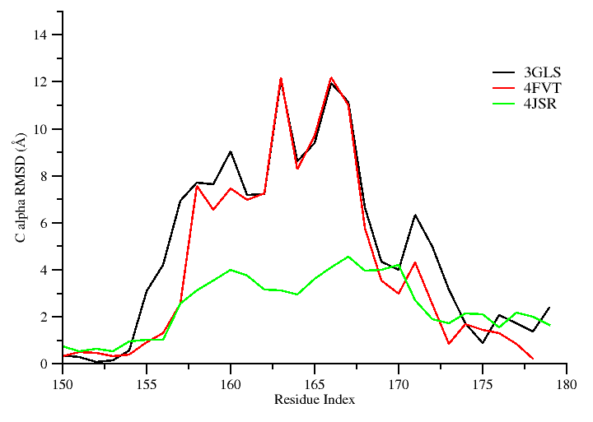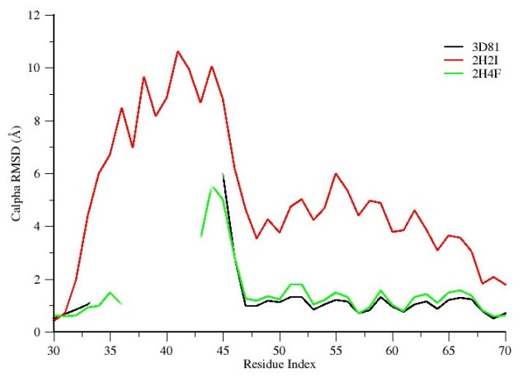

Figure ----: Comparison of average per-residue Cα RMSD values for the cofactor binding loop region in ternary and intermediate Sirt3 complexes.

-------------------------------------------------------------------------------------------------------------------