Date: 3/18/2016

Task 1:

Mapping the remaining raw data files relevant to the information contained KT documents.

Status: Almost done, few more data on loop modelling needs to be mapped.

-----------------------------------------------------------------------------------------------------------------

Task 2:

Create new B factor plots based on the MD data contained in

C:\Users\plin\Documents\MD_works \Flexible_Loop_Bfactor_Summary.xlsx

Two plots needs to be created.

**Status: Completed**

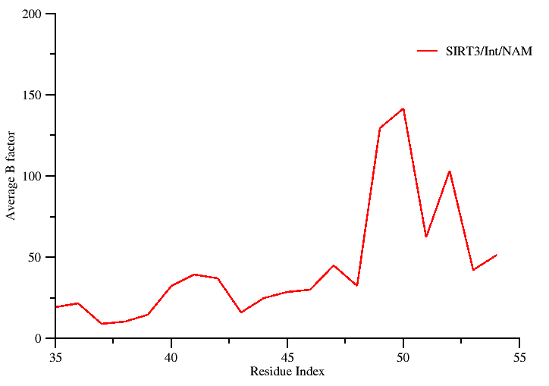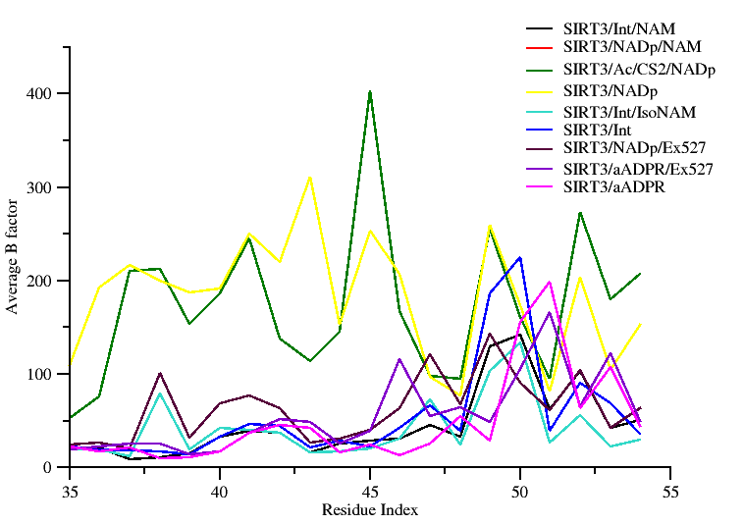

**Comments:**

RSK: Not sure which plot you specifically need. So I created two plots here. I can always change the color of the plot, easily because I have them saved in .agr format.

**Data source:** Raw data used for generating the above plot is contained in: C:\Users\plin\Documents\MD_works\Flexible_Loop_Bfactor_Summary.xlsx

---------------------------------------------------------------------------------------------------------------

Task 3:

Perform a structure based sequence alignment using PROMALS3D to recreate the figure presented in Plin’s summary document. The following PDB ids 4I5I, 3ZGV, 4FVT, 3RIY, 3ZG6, 2H59, 1YC2, and 1SZC will be considered for alignment and highlight regions containing the conserved residues critical for catalysis and their mutations.

**Revised figure**

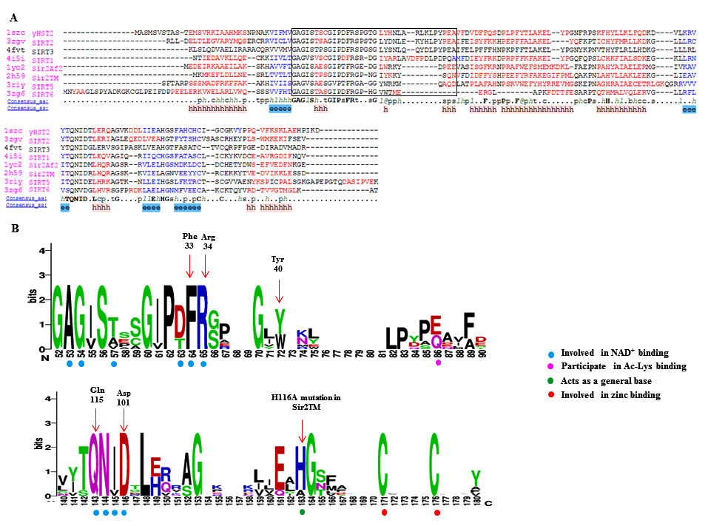

**Fig …….:** Panel A shows a PROMALS3D sequence alignment of sirtuin proteins.  Residues shown in the alignment are colored according to their predicted secondary structure elements (red: α-helix, blue: β-strand). The black box indicates the boundaries of the co-factor binding loop region. The consensus sequence (consensus_aa) and the consensus predicted secondary structure (consensus_aa) are shown at the bottom of the alignment. Consensus amino acid symbols are represented by: conserved amino acids are in bold and uppercase letters; aliphatic (I, V, L): l; aromatic (Y, H, W, F): @; hydrophobic (W, F, Y, M, L, I, V, A, C, T, H): h; alcohol (S, T): o; polar residues (D, E, H, K, N, Q, R, S, T): p; tiny (A, G, C, S): t; small (A, G, C, S, V, N, D, T, P): s; bulky residues (E, F, I, K, L, M, Q, R, W, Y): b; positively charged (K, R, H): +; negatively charged (D, E): −; charged (D, E, K, R, H): c. The global consensus predicted secondary structure are represented by alpha helix (h) and beta strand (e).

Panel B shows a portion of sequence logo that corresponds to co-factor binding loop region and other key residues of the catalytic core region. Here, the relative height of the letters indicates amino acid frequency at that position. Residues important for co-factor, substrate binding and catalysis are highlighted using colored circles. Amino acids residues in the logos are colored according to their chemical properties (neutral polar – green, basic – blue, acidic – red and hydrophobic – black).

**Summary on the role of the highlighted residues: (Adapted from Plin’s document)**

Phe 33 in ySir2

* Plays a critical role both in the initial reaction steps
* Its orientation is likely to be a key mediator of the nicotinamide exchange reaction

His 116 in Sir2Tm

* Catalytically Important residue
* H116D and H116Y mutation decrease deacylation rates in vivo and in vitro
* His acts as a general base to deprotonate one of the ribose oxygens.

Asp 101 in Sir2Tm

* The D101N mutation would lead to the disruption of key hydrogen bonds in the nicotinamide binding pocket and the change of the binding conformation of NAD+.

Gln 115 in Sir2Af1

* Enzymatic activity is severely affected by mutations
* Located at the floor of the NAD binding pocket

--------------------------------------------------------------------------------------------------------------------

Task 4:

Pymol rendering showing the conformational heterogeneity of the cofactor binding loop (with and without the side chains displayed). The following PDB ids will be used to carry out a structural alignment. (4BVG, 4FVT, 4JSR, and 3GLS).

**Status : Completed**

**Revised figure**

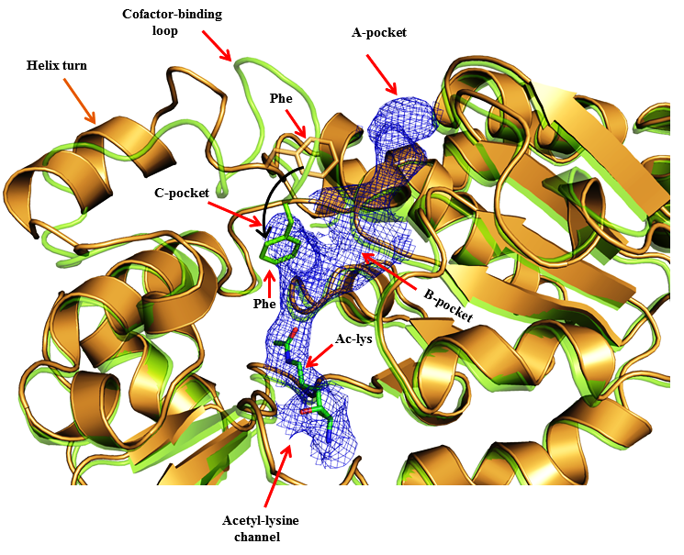

Figure XXXXX: Superposition of Sirt3 native intermediate (4BVG - Green) and Sirt3 ternary complex (4FVT - Orange) showing difference in the conformations of the cofactor binding loop and the position of the Phe residue. Individual subsites are highlighted and the movement of Phe residue is indicated by black arrows

**-------------------------------------------------------------------------------------------------------------------------------**

Task 5:

A new figure showing the comparison of SIRT3 complexes with cofactor binding loop modeled based on coordinates from ternary and intermediate complexes.

REVISED FINAL OPTION A

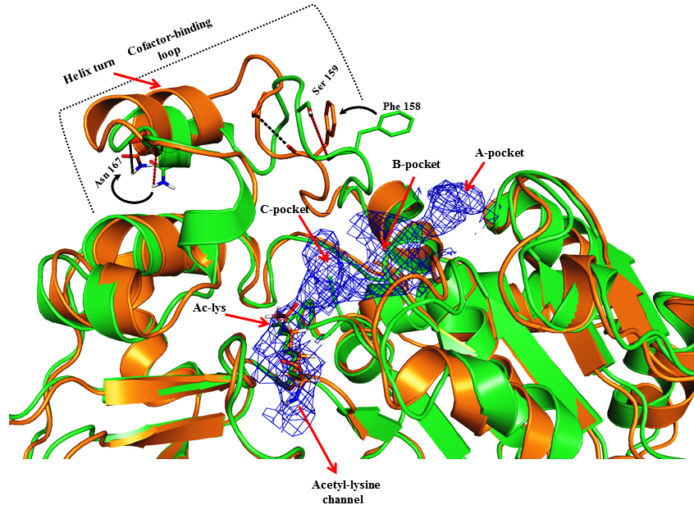

Revised figure **with substrate**

Fig ---- : SIRT3 native ternary complex (4FVT - Green) superimposed onto SIRT3 intermediate complex (Orange) prepared from 4FVT with the cofactor binding loop residues (155-178) replaced from 4BVG structure. Structures shown in figure are MD averaged structures. Differences in the conformation of the cofactor binding loop and the position of the Phe residue are highlighted.

REVISED FINAL OPTION B

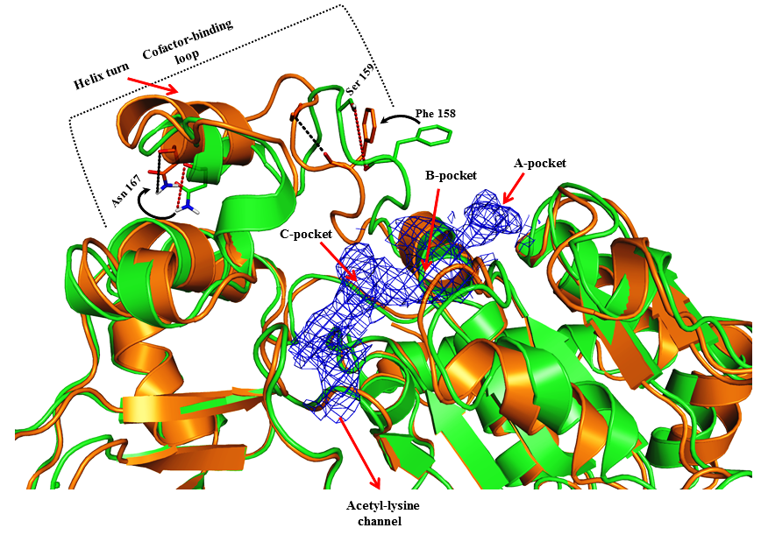

Revised figure **without substrate**

Fig ---- : SIRT3 native ternary complex (4FVT - Green) superimposed onto SIRT3 intermediate complex (Orange) prepared from 4FVT with the cofactor binding loop residues (155-178) replaced from 4BVG structure. Structures shown in the figure are MD averaged structures. Differences in the conformation of the cofactor binding loop and the position of the Phe residue are highlighted.

**Data source:** The MD average structured of 4FVT is located at C:\Users\plin\Documents\MD_works\ 4FVT_v1_fixed2_mds_last10ps.pdb

The MD average structured of 4FVT with loop residues replaced from 4BVG is located at

C:\Users\plin\Documents\MD_works\ 4FVT_NAM_fixed_v1_mds_avg10ps

-----------------------------------------------------------------------------------------------------------------

RC: Also, there were RMSD plots in one Fig that is later to be merged with either 4 or 5. Are we planning to use the old versions?

**Status: Completed**

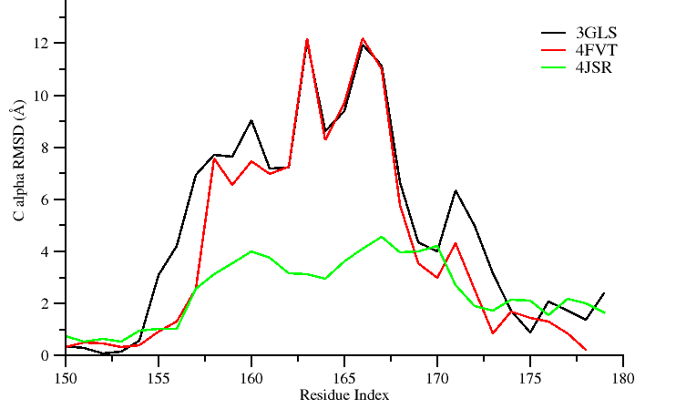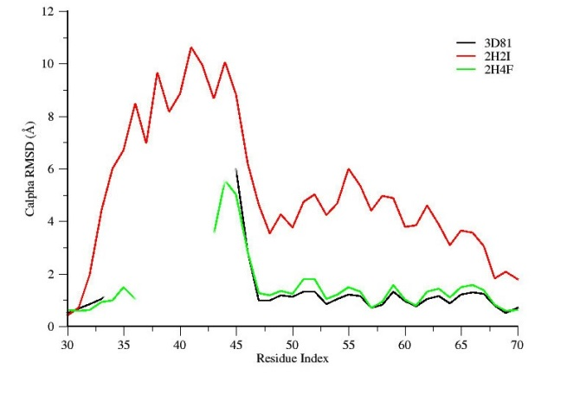

Figure ----: Comparison of average per-residue RMSD values for the cofactor binding loop region in ternary and intermediate complexes.

**Data source:** The raw data used for the plot is located at

C:\Users\plin\Documents\MD_works\by-residue_RMSDs.xlsx

-----------------------------------------------------------------------------------------------------------------

Task 6: Recreate new MM/GBSA and MM/PBSA tables similar to the previous PLOS ONE 2014 paper, reporting only binding energy values computed between 2-12 ns time scale. Two such tables need to be created.

**Status: completed**

**Table: Calculated binding energies using MM-PBSA and MM-GBSA. Energy values are reported in kcal/mol.**

|  |  |  |
| --- | --- | --- |
| Energy Components | SIRT3/INT/NAM prepared from 4FVT | SIRT3/INT/NAM prepared from 4FVT with loop (res 155-178) replaced from 4BVG |
| MM-GBSA (Complex) | -7146.48 ± 3.55 | -7201.58 ± 3.44 |
| MM-GBSA (Receptor) | -7050.17 ± 3.55 | -7105.13 ± 3.43 |
| MM-GBSA (Ligand) | -75.99 ± 0.18 | -75.95 ± 0.18 |
| **MM-GBSA (ΔGBind )** | **-20.33 ± 0.13** | **-22.50 ± 0.13** |
| MM-PBSA (Complex) | -5873.69 ± 3.87 | -5901.23 ± 3.76 |
| MM-PBSA (Receptor) | -5796.70 ± 3.89 | -5820.47 ± 3.74 |
| MM-PBSA (Ligand) | -73.03 ± 0.18 | -73.02 ± 0.18 |
| **MM-PBSA ( ΔGBind )** | -**3.96** **± 0.25** | **-7.73 ± 0.26** |

**Data source:**

**The data used in this table is located at:**

**C:\Users\plin\Documents\SIRT\MM-GBPBSA_for_SIRT3complexes.xlsx.**

**REMARK: I see that you have commented that you need a table that’s similar to the PLOS 2014 paper. For that I would need the raw generated from the MMPBSA.py script**

**I tried to locate the raw .dat files obtained from the mmpbsa calculations in the gpu node, so that I could tabulate the energetic decomposition. I see that there are umpteen mmpbsa output files. Hence, I have written a shell script that will recursively go in to each directory and search for a .dat file and greps the value. (Will let you know if the script is able to locate a file having the exact ΔGBindvalues shown in the table).**

**-----------------------------------------------------------------------------------------------------------------**

Task 7:

Add the location/path of the raw data used for completing the assigned task in “Task list1”

**Status: completed**

------------------------------------------------------------------------------------------------------------------

Task 8: Replot the two RMSD plots contained in the KT document (manuscript computational section excerpts and task.doc)

**Status: completed (I have saved the plots in .agr format. In case if you need any modification, I can get it easily done (I will not have to redo the complete plotting again). Plot was generated using windows version of Xmgrace.**

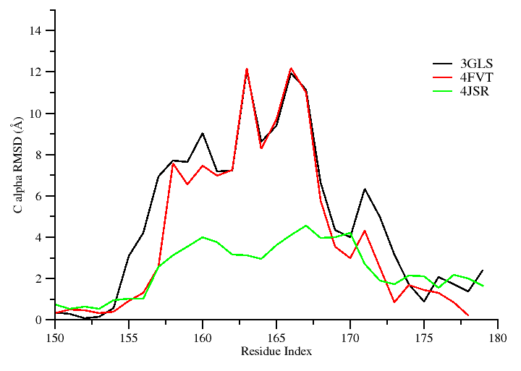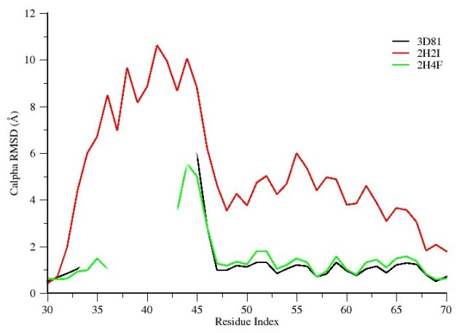

Figure ----: Comparison of average per-residue Cα RMSD values for the cofactor binding loop region in ternary and intermediate Sirt3 complexes.

**Data source:**

**The raw data for the plot shown below are located at**

**C:\Users\plin\Documents\MD_works\by-residue_RMSDs.xlsx**

**C:\Users\plin\Documents\MD_works\by-residue_RMSDs_2H4F_3D81.xlsx**

-------------------------------------------------------------------------------------------------------------------