RC (4/12/206)

1. re-introduce the missing figures from the current paper draft as per their positions in biorxiv (everything -except- experimental data figures).

RSK (4/20/2016): I have incorporated the figures into the main draft. This draft has been

upload to the wiki earlier (4/18/2016). However, I see that you have also commented yesterday (4/20/2016) on some missing figures. I will upload another revised version shortly incorporating the changes you had asked for.

RC (4/12/206)

1. prepare a working file (appendix/SI) which includes all the latest figures not included in

paper draft. We will organize this later.

RSK (4/20/2016): I have prepared a working file for SI and uploaded it to the wiki. Essentially it is a cleaned up version of our previous working document. The supplementary figs captions and legends are not numbered presently.

RC (4/12/206)  
c) clean up/merge the inserted computational figures as needed

RSK (4/20/2016): The figures the needs to be merged /cleaned up have been incorporated to the main draft. This draft has been uploaded to the wiki earlier (4/18/2016). Let me know if you do plan to merge any figures other that the one which you had indicated earlier (merged fig - see fig 6 in main draft).

RC (4/12/206)  
 d) add the new reference; check there are no missing refs

RSK (4/20/2016): I did add two references that were missing, but I missed incorporating the ELT inhibitor reference. I will add this in the revised version along with the other changes.

RC (4/12/206)

e) do a PNAS length check (use their online tool; assume extended online format)

RSK (4/21/2016): I did comment on this earlier on the wiki, but I see that you have reverted with your comments yesterday (4/20/2016). I will update you once I revise the manuscript as per your latest comments.

RC (4/12/206)  
f) The table on MM-GBSA energies should not highlight the binding affinities only, since the free energies of loop conformational changes are relevant. You may add a column or otherwise rework the table and its title to reflect this and report \Delta G for loop conformational change as well (in this sense it departs from previous tables).

RSK (4/20/2016): The table has been reorganized to reflect the focus is on the conformational free energy difference between Sirt3/Int/NAM with a 4BVG loop conformation over Sirt3/Int/NAM with a 4FVT loop conformation. I have added a new column that shows the conformational energy difference (ΔΔG (B → A)) and relative binding energy difference (ΔΔBE (B → A)). I presume that conformational energy and binding energy are the proper thermodynamic terminologies in the present context and not conformational free energy and binding free energy, because I see that energy terms Ping has calculated involves only the enthalpic component and ignores the entropy contribution. *Please correct me if my understanding is wrong.*

You also asked earlier if it would be possible to generate more data points by decreasing the time interval.

I am working on it. Firstly I am trying to reproduce Ping’s data in the table. (I will update you on this)

I have a small suggestion here since the focus has now shifted to conformational energies instead of binding energies and the whole point is to highlight the energy gap between the two different conformations. I think we can use an alternate figure like the one which I shown below (probability density distribution vs conformational energies of each snapshots in the trajectory – Just an illustrative figure).

**Option A**



One can compare the means of the probability density distribution to highlight the conformational energy difference (energy gap) between Sirt3/Int/NAM modelled using 4FVT and Sirt3/Int/NAM modelled from 4FVT but loop replaced from 4BVG. The relevant data necessary for this can be extracted by me by form the log file of the MM/PBSA and MM/GBSA calculations carried out Ping by writing perl scripts.

Such a plot could also potentially reduce the risk of reviewers racking up convergence issues from a time series plot (like the one below). Just a polite suggestion, let me know thoughts on it.

**Option B**

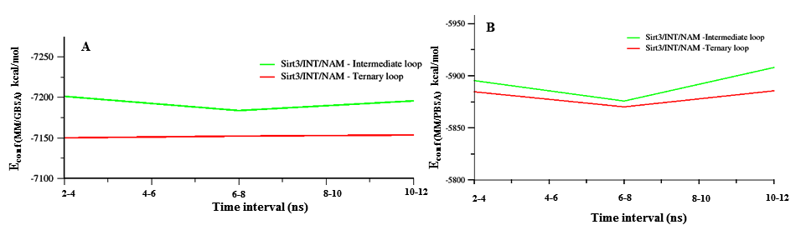  
RC (4/12/206)

(g) Regarding the figure "Fig ---- : Superposition of the time averaged MD structures of Sirt3/Peptide/NAD ternary complex (4FVT – orange) and Sirt3/Intermediate complex (4BVG – green). Differences in the conformations of the co-factor binding loop and the position of the Phe residue are highlighted. Individual subsites are highlighted."  
some follow up work is needed:  
- please add corresponding entries to the global/loop RMSD table and/or corresponding per-residue RMSD plots for these simulations with respect to xtal structures

RSK (4/20/2016): The necessary figures have been created.

Option A (combined plot of 4BVG and 4FVT)

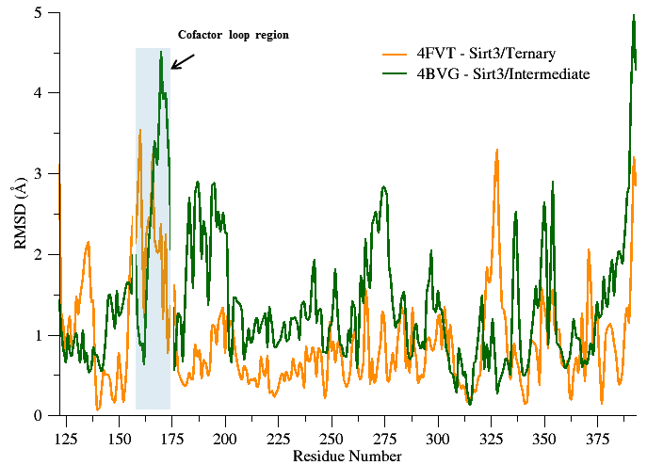

Fig SI – Per residue RMSD plot of the time average MD structure of Sirt3/Ternary and Sirt3/Intermediate complex calculated with respect to their crystal structure.

Option B (separate plots for 4BVG and 4FVT)

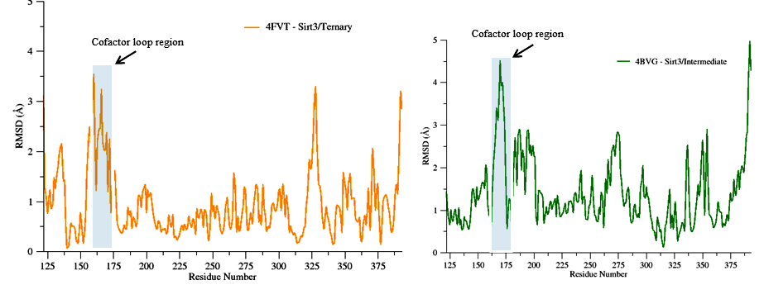

Fig SI – Per residue RMSD plot of the time average MD structure of Sirt3/Ternary and Sirt3/Intermediate complex calculated with respect to their crystal structure.

***Note: The colors used in the plot reflect the colors used in the structural alignment figure.***

RSK (4/20/2016): Global/loop RMSD table has been added to the RMSD table, shown below. The recent additions are highlighted in the table for ready reference.

SI Table ---:

|  |  |  |  |
| --- | --- | --- | --- |
| Complex | Global heavy atom RMSD | Co-factor loop RMSD | Substrate RMSD |
| 4FVT (ternary complex) – Xtal vs 4BVG ( native intermediate) Xtal | 0.5 Å | 4.0 Å | Matching atoms in NAD (0.8 Å)  Matching atoms in Acs2 peptide  (0.3 Å) |
| 4FVT (ternary complex) – Xtal  vs  4FVT (ternary complex) – MD averaged | 1.1Å | 2.2Å | Matching atoms in NAD (0.4Å)  Matching atoms in Acs2 peptide  (1 Å) |
| 4BVG (native intermediate) Xtal  vs  4BVG (native intermediate) MD averaged | 1.6Å | 1.8Å |  |
| 3GLS (apo Sirt3) – Xtal  vs  3GLS (apo Sirt3) – MD averaged | 1.1Å | 0.79Å |  |
| Sirt3/ADPR complex/NAM modelled from 4FVT (**MD average**)  vs  Sirt3/ADPR complex/NAM modelled from 4FVT but with loop replaced form 4BVG (**MD average**) | 2.2 Å | 5.9Å |  |
| 4FVT (ternary complex) – Xtal  vs  Sirt3/ADPR complex/NAM modelled from 4FVT (MD average) | 1.9Å | 3.9Å | Matching atoms in NAD part (0.62Å)  Matching atoms in Acs2 peptide part  ( 0.5Å) |
| 4FVT (ternary complex) – Xtal  vs  Sirt3/ADPR complex/NAM modelled from 4FVT but with loop replaced form 4BVG (MD average) | 1.1Å | 3.7Å | Matching atoms in NAD part (0.3Å)  Matching atoms in Acs2 peptide part  (0.7 Å) |
| 4BVG (native intermediate) Xtal  vs  Sirt3/ADPR complex/NAM modelled from 4FVT (MD average) | 2.0Å | 6.3Å | Matching atoms in NAD part (--.Å)  Matching atoms in Acs2 peptide part  ( 0.55Å) |
| 4BVG (native intermediate) Xtal  vs  Sirt3/ADPR complex/NAM modelled from 4FVT but with loop replaced form 4BVG (MD average) | 1.0Å | 1.4Å | Matching atoms in NAD part (--.Å)  Matching atoms in Acs2 peptide part  ( 0.Å) |

RC (4/12/206)- comparing to the B factor plots, comment on which loop segment displays the greatest flexibility vis-a-vis the structural motifs like helix,  
alpha turn.

RSK (4/20/2016): The plots are shown below. I have briefly commented on it based on my observation.

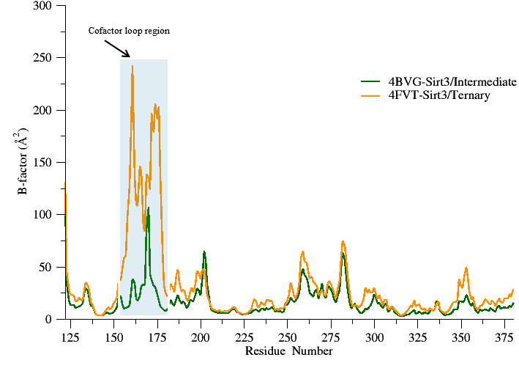

Fig SI – Simulated B factor values for Sirt3/Ternary and Sirt3/Intermediate complexes.

RSK (4/20/2016): (Comments) I see that the Simulated B factors computed form the MD trajectory shows that 4FVT (Sirt3/Ternary complex) in general displays enchanted flexibility. In particular the cofactor loop of 4FVT which has a short alpha helix display significant flexibility over 4BVG (ternary complex) which doesn’t have a short alpha helix. Secondly, the flexibility for the other structural regions (Rossmann-fold domain and the zinc-binding domain) is largely similar in both the complexes.

These findings are consistent with crystallographic findings

1. The Xtal structure of 4BVG and 4FVT differs only in the cofactor loop region (global RMSD is 0.5 Å and local RMSD for the cofactor loop region is 4 Å.
2. The reason being the unwinding of the helix seen in the intermediate complex (4BVG). This unwinding seems to be more localized in nature and doesn’t bring about changes elsewhere.
3. Plot of crystallographic B factor values also display a similar trend. ( A figure which I created for my earlier report is copied below for ready reference)

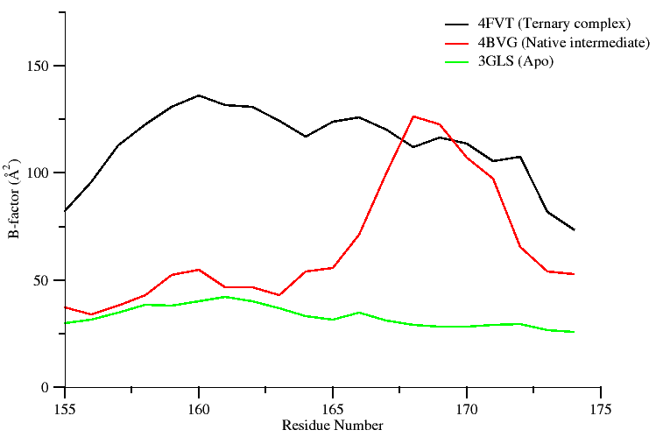

SI Fig ------: Plot showing crystallographic B-factor values of the Cα atoms belonging to the co-factor binding loop region of SIRT3 in different states. Residues (162-170) adapt a helix conformation when bound to co-factor.

RC (4/12/206)- Generate a figure analogous to "Time averaged MD structure of Sirt3: INT: NAM modeled using the 4BVG loop (Green) superimposed onto 4BVG Xtal structure (Global RMSD = 1 Å)", but for the apoprotein MD average and the 3GLS xtal structure instead.

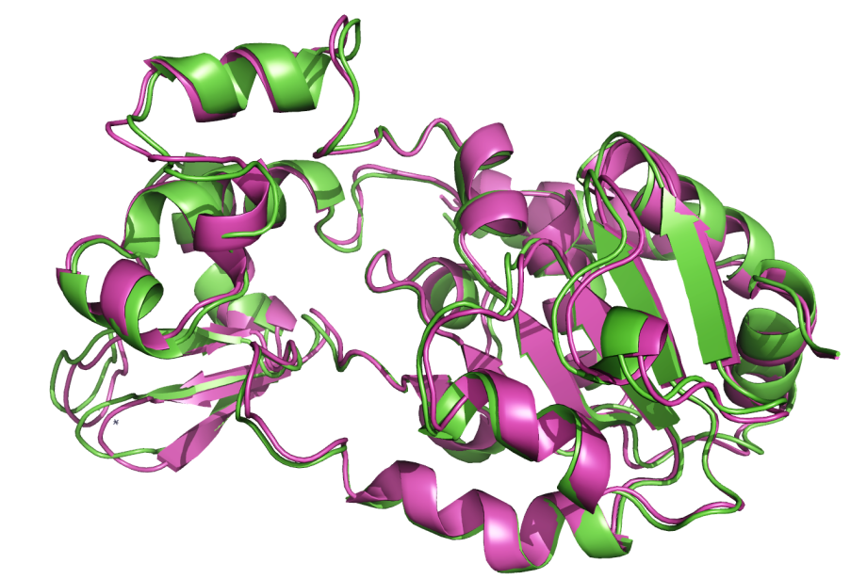

SI Fig ---: Time averaged MD structure of apo Sirt3 (Magenta) superimposed onto apo Sirt3 crystal structure 3GLS (Green). Global RMSD = 1.1 Å.

RC (4/12/206)- Related to the comment in the draft about verification that the apo loop conformation is similar to that in the ternary complex, verify that despite this conformational similarity in the xtal structures, the loop in ternary complex is more flexible (compared to the flexibility in both the INT and apo complexes) and that this apparent in the RMSDs of the MD averages to the respective xtal structures.

RSK (4/20/2016): It’s true that the loop conformation in Sirt3 apo is structurally close to Sirt3 ternary complex loop conformation. However, the crystallographic B factor values plotted (see fig above in page 7) shows that Sirt3 ternary *complex (4FVT)* ***exhibits enhanced flexibility in relation*** to Sirt3 apo crystal structure (3GLS) and Sirt3 intermediate complex (4BVG). **The same trend is also apparent** in the RMSD plot of the MD average structures computed with respect to their respective crystal structure.

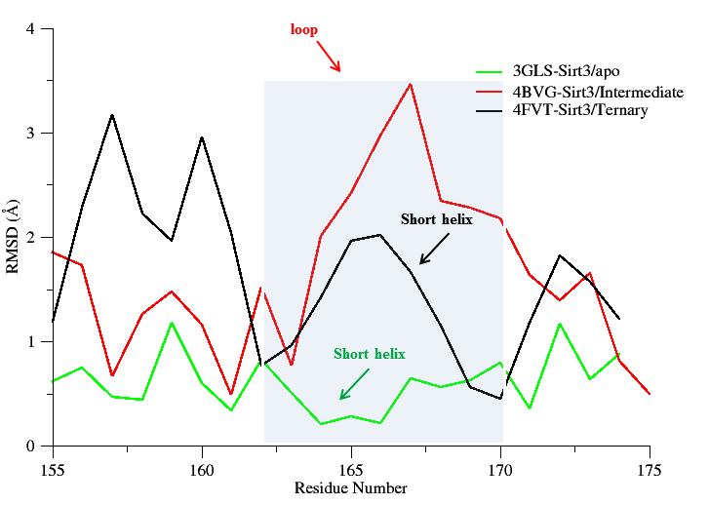

SI Fig ------: Per residue RMSD plot of the time average MD structure of Sirt3 apo, Sirt3/Ternary, and Sirt3/Intermediate complex calculated with respect to their crystal structure. Only those residues belonging to the cofactor loop region are shown in the plot for clarity. Residues (162-170) which constitute the short alpha helix region (highlighted in grey) of the cofactor loop region in Sirt3/apo and Sirt3/Ternary complex. In Sirt3/Intermediate complex an order to disorder transition results in the unwinding of the short helix.

RC (4/12/206)- g) add entry for the apoprotein MD average with respect to 3GLS to the global/loop RMSD table

RSK (4/20/2016): This data has been added to the revised table (see page 5 of the document for the revised table)

RC (4/12/206)- h) Color coding of structures in all figures must be consistent

RSK (4/20/2016): I have ensured the color coding is consistent for the figures.

RC (4/12/206)- i) Make a plot of B factors from the MD simulations of non-crystallographic complexes (e.g., INT:NAM complexes)

RSK (4/20/2016): I found the B factor data for these simulations has been generated by ping. Hence, I used the data generated by Ping to generate plots.

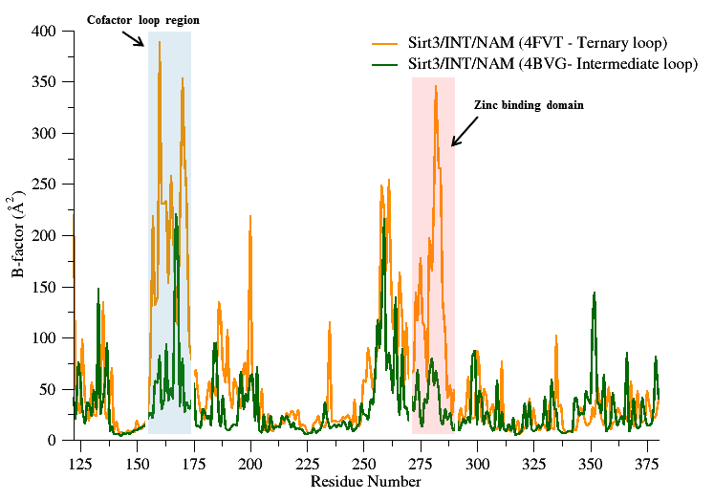

Fig SI -----: Simulated B factor values for Sirt3/Int/NAM complexes modeled based on a ternary loop conformation (4FVT) and an intermediate loop conformation (4BVG).

Remark: If we look at the structure we see enhanced flexibility around at the Zin binding domain for Sirt3/Int/NAM complex with a ternary loop (short alpha helix) conformation. On the contrary the thermal B fac values are relatively low for Sirt3/Int/NAM complex with an intermediate loop (loop) conformation.

RC (4/12/206)- Note that in the current working draft, we are assuming there will be no experimental data included.SI will be further edited after you complete these tasks, followed by Methods.

RSK (4/20/2016): Point taken.