**Cephalothin:** http://pubchem.ncbi.nlm.nih.gov/summary/summary.cgi?cid=6024

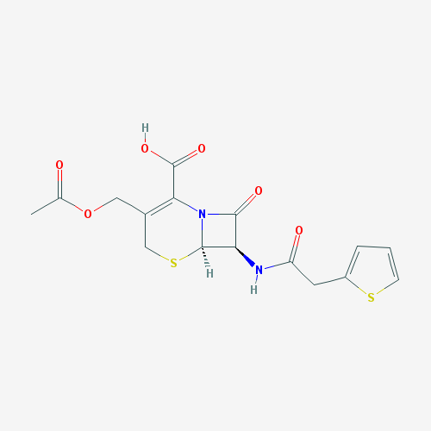

**Cephazolin**: http://pubchem.ncbi.nlm.nih.gov/summary/summary.cgi?cid=33255&loc=ec_rcs

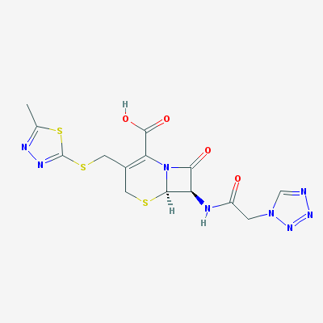

**Ampicillin**: http://pubchem.ncbi.nlm.nih.gov/summary/summary.cgi?cid=6249&loc=ec_rcs

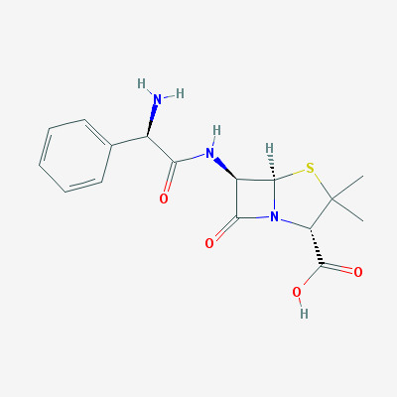

**Ceftazidime: http://pubchem.ncbi.nlm.nih.gov/summary/summary.cgi?cid=5481173&loc=ec_rcs**

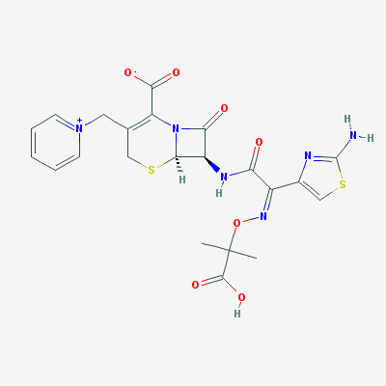

**Cefoxitin: http://pubchem.ncbi.nlm.nih.gov/summary/summary.cgi?cid=441199&loc=ec_rcs**

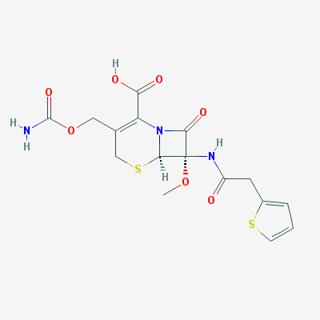

**Cefotaxime: http://pubchem.ncbi.nlm.nih.gov/summary/summary.cgi?cid=5742673&loc=ec_rcs**

