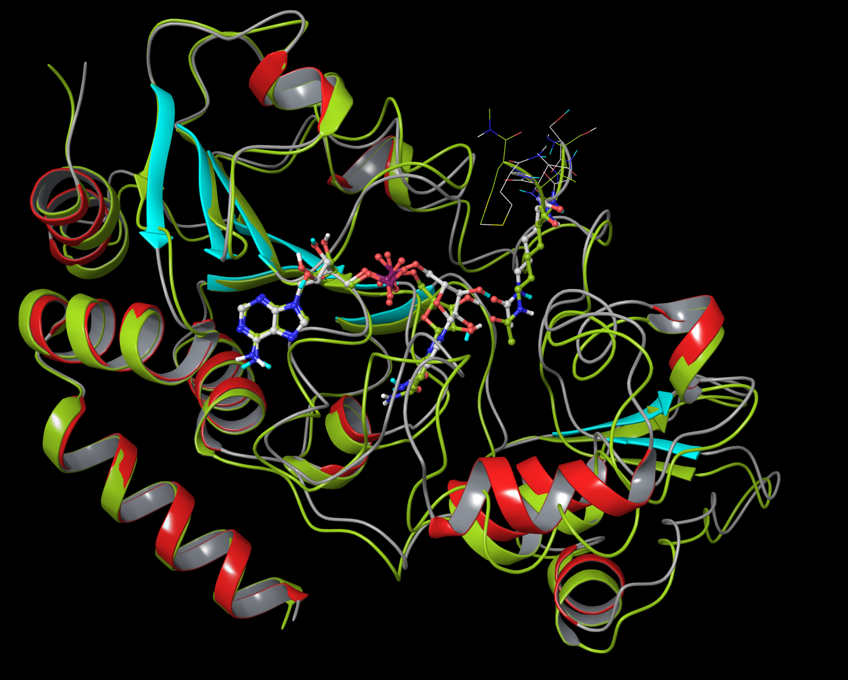
Figure 1: Alignment of ternary complex (SIRT3/Ac-ACS2/NAD+) from MD averaged structure (10 frames from last 10ps) with respect to crystal (pdbID:4FVT) structure. Ribbon representation of crystal structure is colored by secondary structure (sheets in cyan, helixes in red and coils in gray), MD averaged structure in lime green color. Carbon atoms in crystal structure are in white, and are in lime green for MD averaged structure. Alignment was made using residues 139-151, 313-378, which forms the stable A binding pocket in Rossmann fold domain (RMSD of backbone of these residues between crystal structure and MD averaged structure is 0.84 Angstrom). Such alignment allows better visualization of relative conformational changes. RMSD of NAD+ itself (heavy atoms only) after alignment between crystal structure and MD averaged structure is 0.56 Angstrom.
Ac-CS2: acetyl-Co-A synthase 2
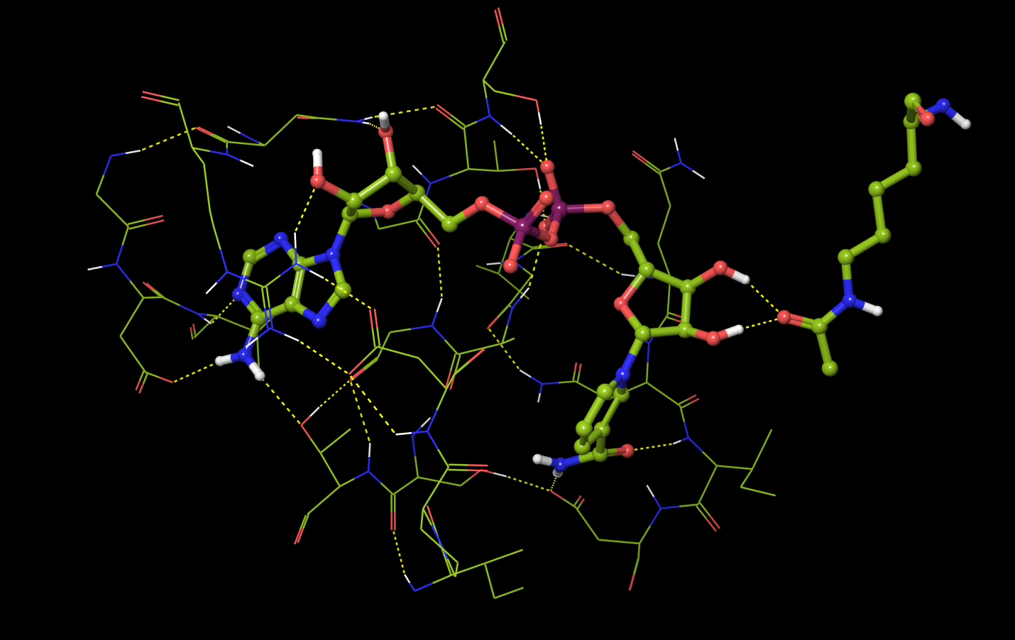
C Pocket
A Pocket
Figure 1a: Observation of A and C pockets from the MD averaged structure.

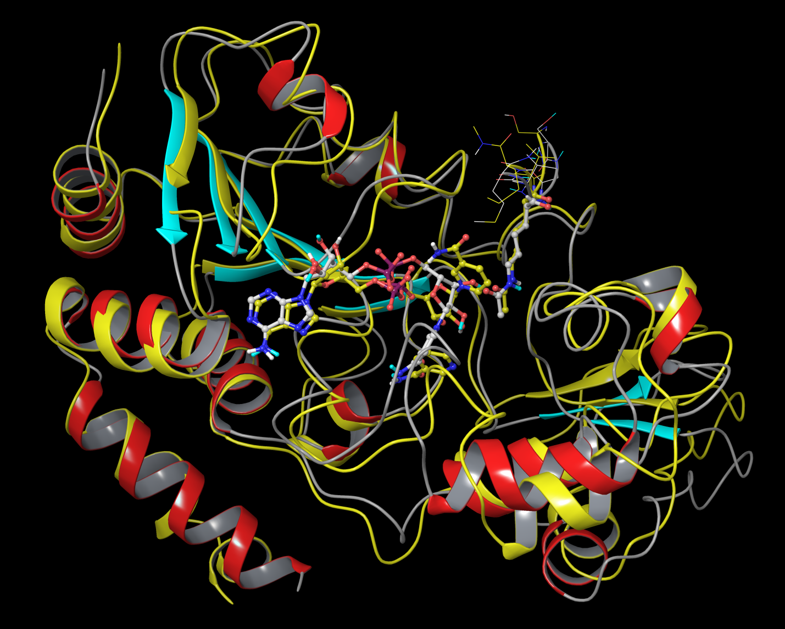
Figure 2: Alignment of complex (SIRT3/Ac-ACS2/NAD+/NAM) from MD averaged structure (10 frames from last 10ps) with respect to crystal (pdbID:4FVT) structure. Ribbon representation of crystal structure is colored by secondary structure (sheets in cyan, helixes in red and coils in gray), MD averaged structure in yellow color. Carbon atoms in crystal structure are in white, and are in yellow for MD averaged structure. Alignment was made using residues 139-151, 313-378, which forms the stable A binding pocket in Rossmann fold domain (RMSD of backbone of these residues between crystal structure and MD averaged structure is 0.74 Angstrom). RMSD of NAD+ itself (heavy atoms only) after alignment of MD averaged structure with respect to NAD+ from 1YC2:A is 3.38 Angstrom.

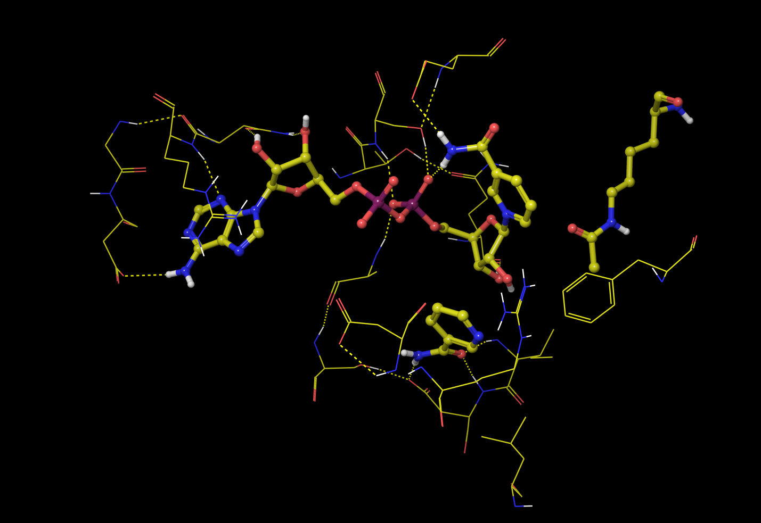
B Pocket
C Pocket
A Pocket
Figure 2a: Observation of A, B and C pockets from the MD averaged structure.

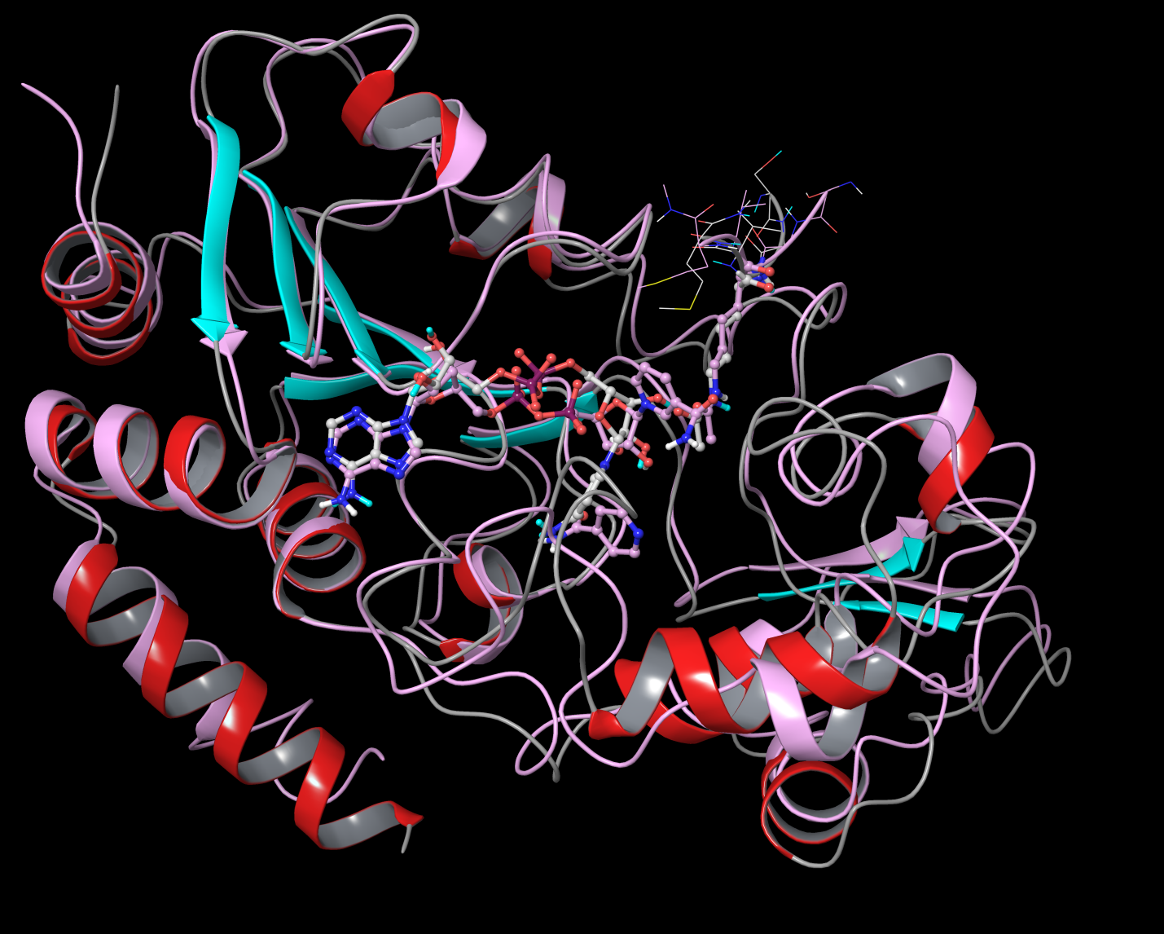
Figure 3: Alignment of complex (SIRT3/Ac-ACS2/NAD+/isoNAM) from MD averaged structure (10 frames from last 10ps) with respect to crystal (pdbID:4FVT) structure. Ribbon representation of crystal structure is colored by secondary structure (sheets in cyan, helixes in red and coils in gray), MD averaged structure in plum color. Carbon atoms in crystal structure are in white, and are in plum for MD averaged structure. Alignment was made using residues 139-151, 313-378, which forms the stable A binding pocket in Rossmann fold domain (RMSD of backbone of these residues between crystal structure and MD averaged structure is 0.70 Angstrom). RMSD of NAD+ itself (heavy atoms only) after alignment of MD averaged structure with respect to NAD+ from 1YC2:A is 2.88 Angstrom.

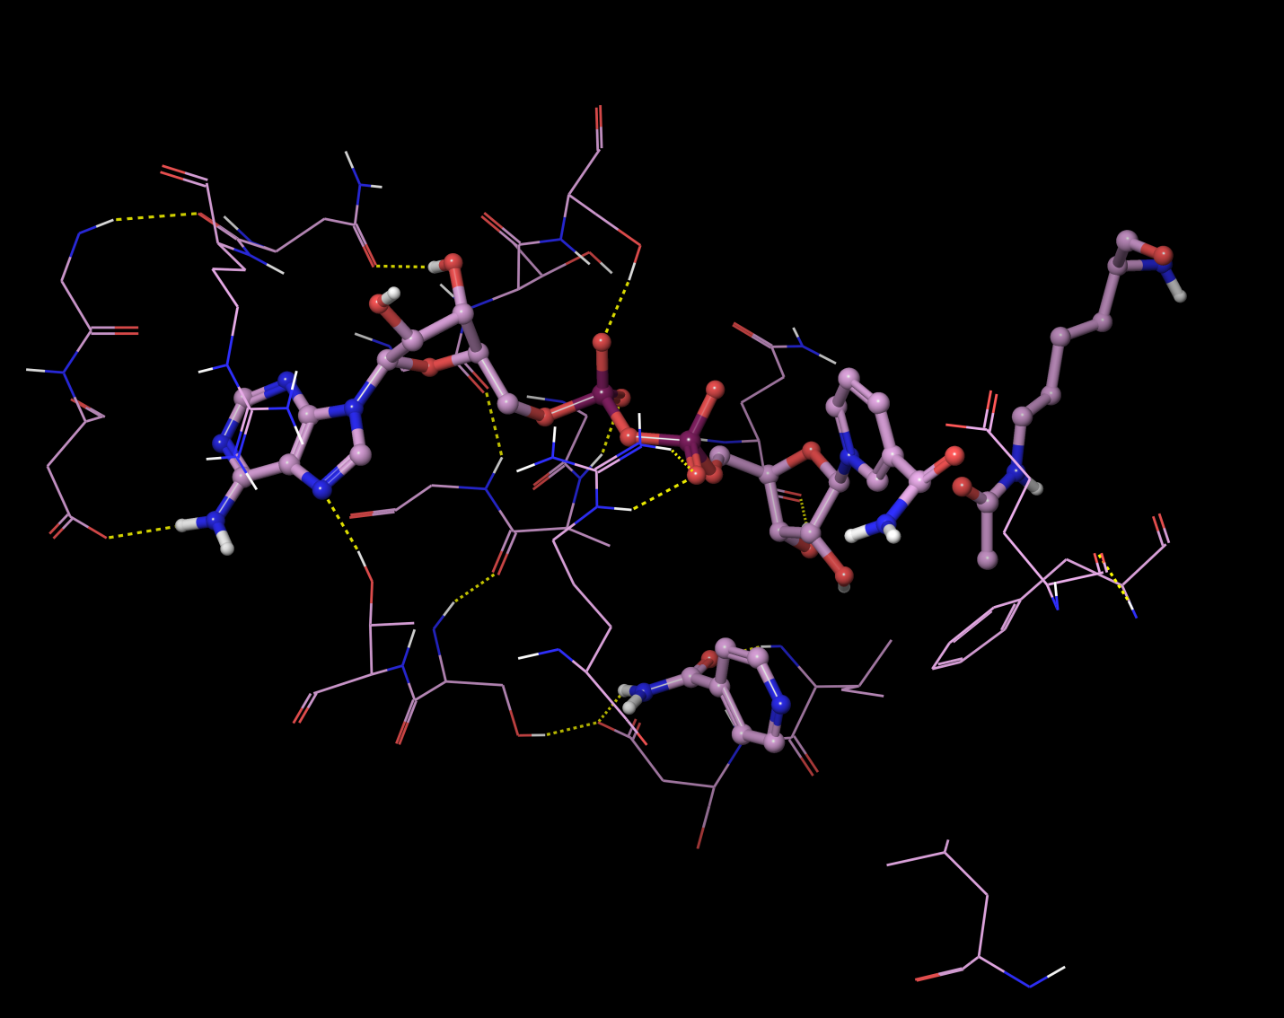
C Pocket
B Pocket
A Pocket
Figure 3a: Observation of A, B and C pockets from the MD averaged structure.

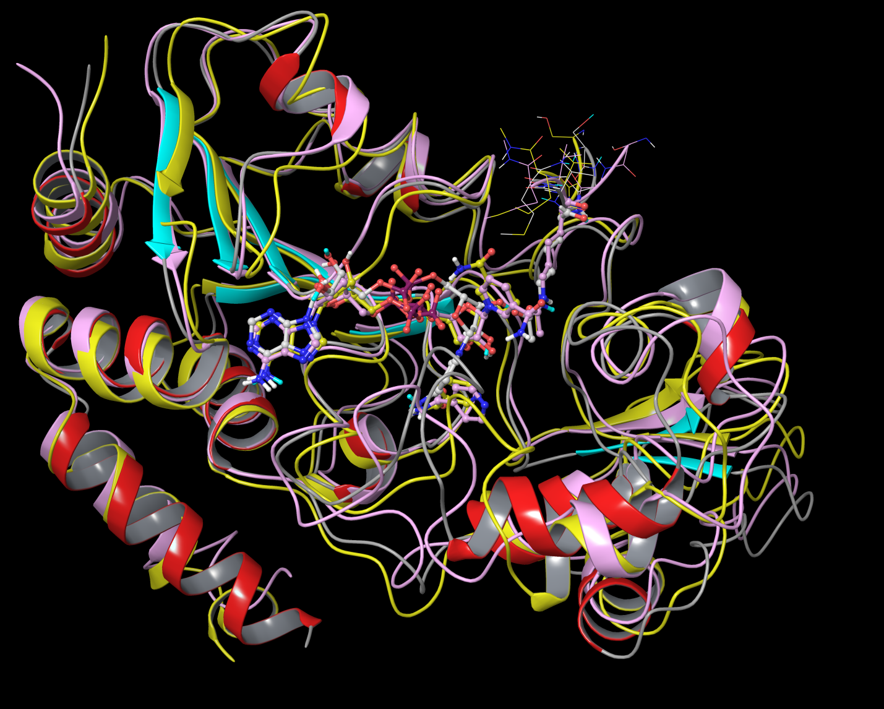
Figure 4: Alignment of complex with NAM (SIRT3/Ac-ACS2/NAD+/NAM, yellow) and isoNAM(SIRT3/Ac-ACS2/NAD+/isoNAM, plum) from MD averaged structures (10 frames from last 10ps) with respect to crystal (pdbID:4FVT) structure.
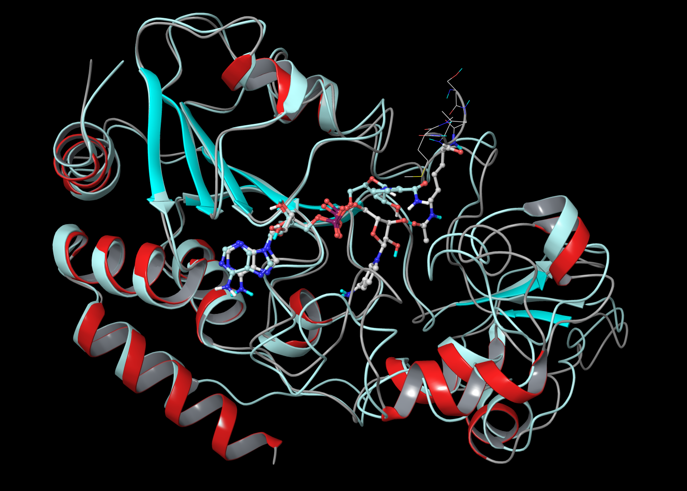
Figure 5: Alignment of binary complex (SIRT3 /NAD+) from MD averaged structure (10 frames from last 10ps) with respect to crystal (pdbID:4FVT) structure. Ribbon representation of crystal structure is colored by secondary structure (sheets in cyan, helixes in red and coils in gray), MD averaged structure in light blue color. Carbon atoms in crystal structure are in white, and are in light blue for MD averaged structure. Alignment was made using residues 139-151, 313-378, which forms the stable A binding pocket in Rossmann fold domain (RMSD of backbone of these residues between crystal structure and MD averaged structure is 0.73 Angstrom). RMSD of NAD+ itself (heavy atoms only) after alignment of MD averaged structure with respect to NAD+ from 1YC2:A is 2.71 Angstrom.
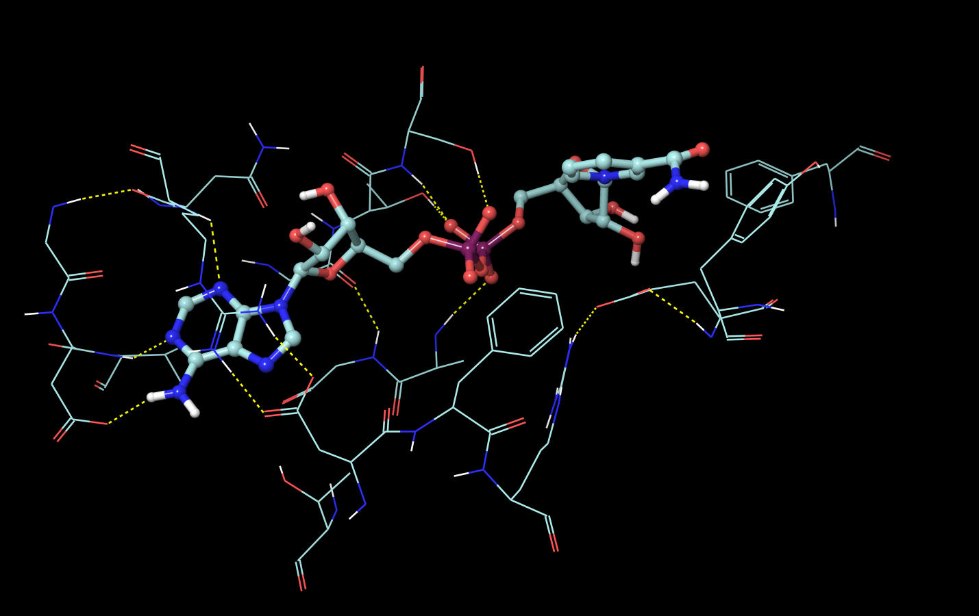
C Pocket
A Pocket
Figure 5a: Presentation of A and C pockets from the MD averaged structure.

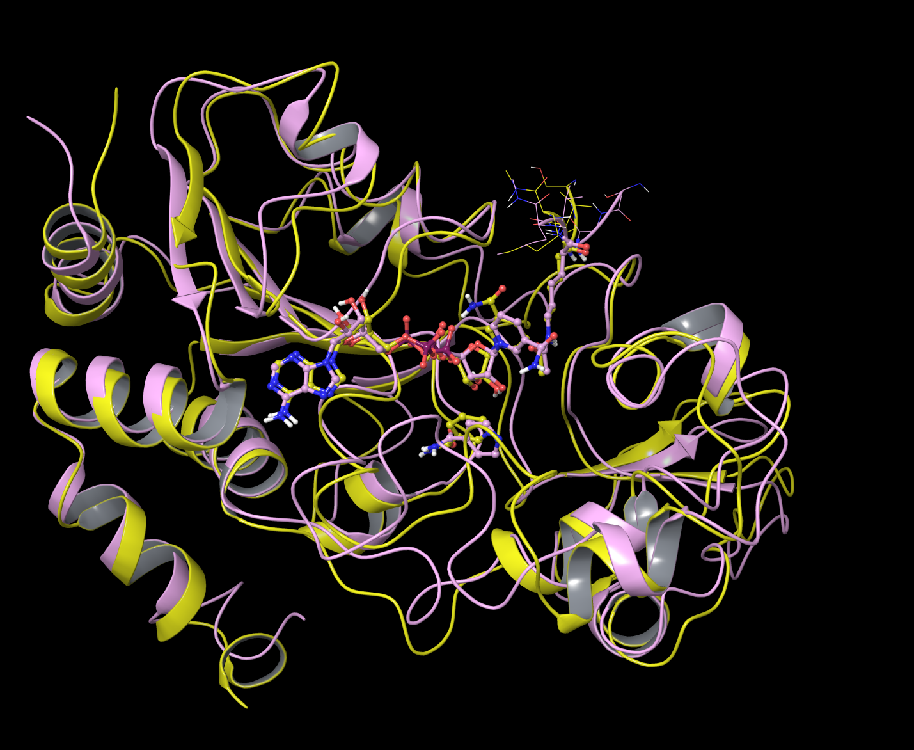
Figure 6: Alignment of complex with NAM (SIRT3/Ac-ACS2/NAD+/NAM, yellow) and isoNAM(SIRT3/Ac-ACS2/NAD+/isoNAM, plum) from MD averaged structures (10 frames from last 10ps). Alignment was made using residues 139-151, 313-378, which forms the stable A binding pocket in Rossmann fold domain with respect to crystal (pdbID:4FVT) structure.
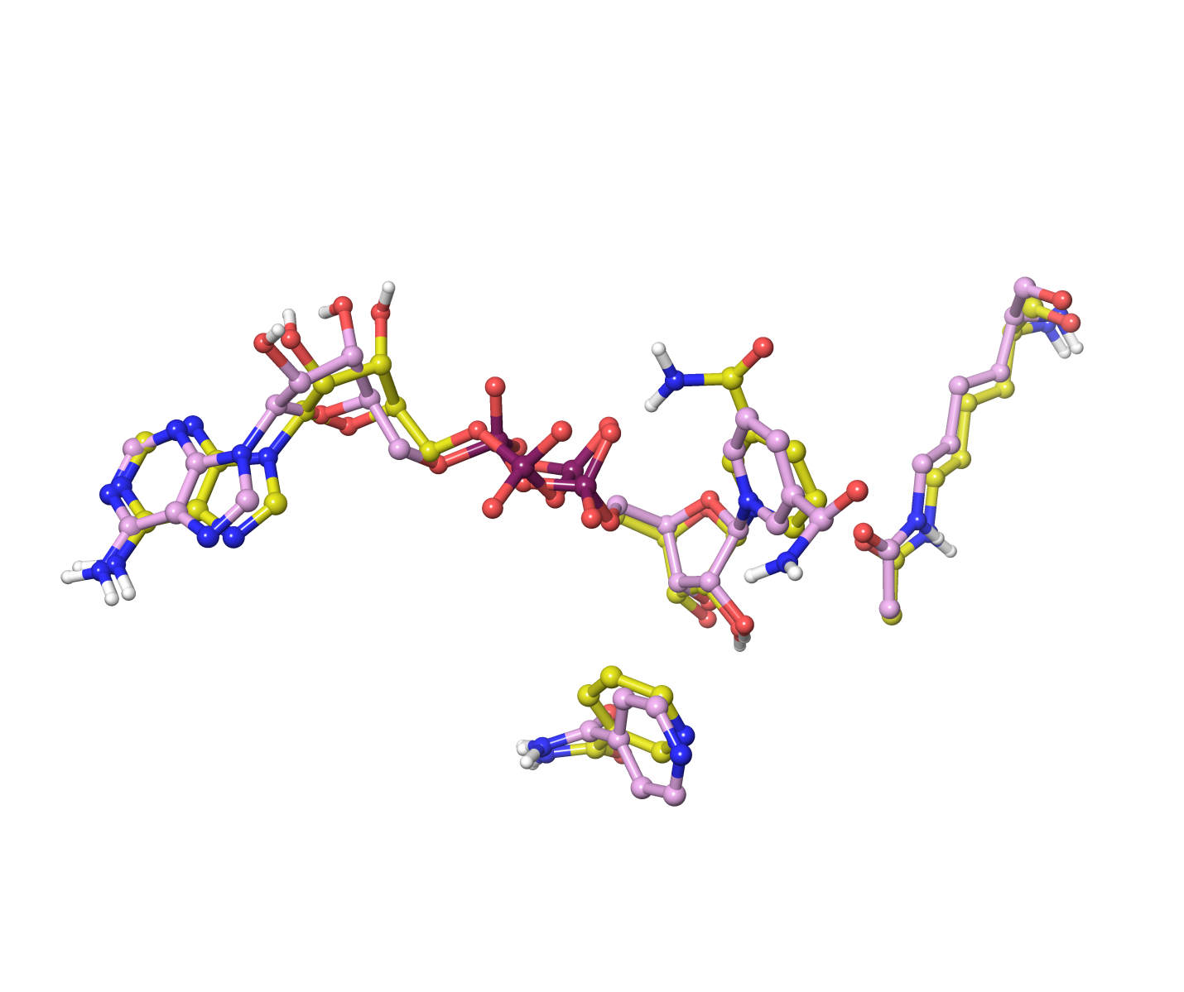
Figure 6: After alignment of residues 139-151, 313-378 in Rossmann fold domain, the display of NAD+, acetylated lysine, NAM (carbon in yellow) and isoNAM (carbon in plum) shows close resemblance between NAM and isoNAM binding from MD averaged structures (10 frames from last 10ps). The MM-GBSA calculations suggest that NAM binds slightly stronger to the C pocket than isoNAM prior to enzymatic reaction (-19.82 kcal/mol vs -15.68 kcal/mol in MM-GBSA scores).

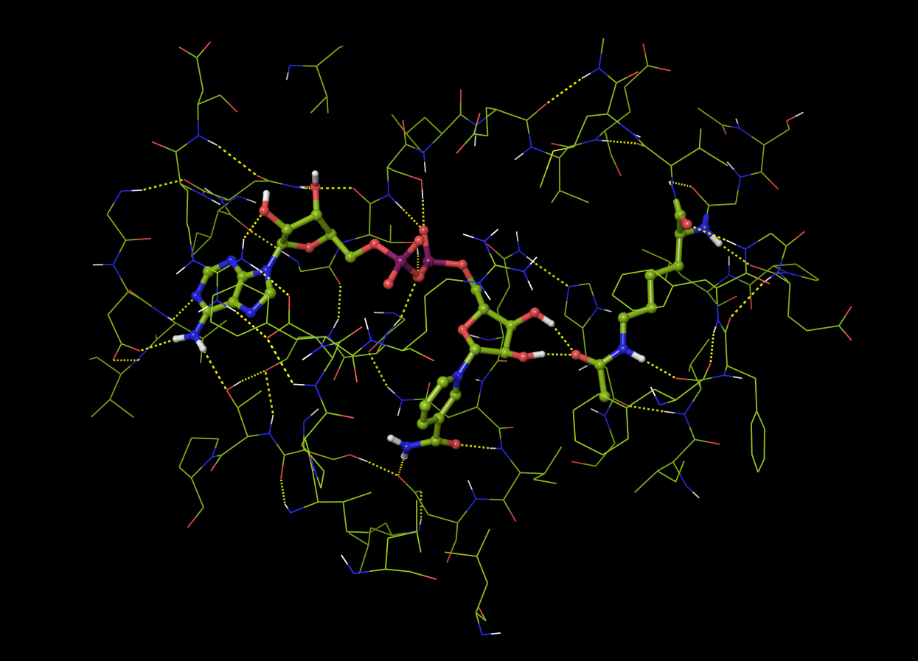 (a)
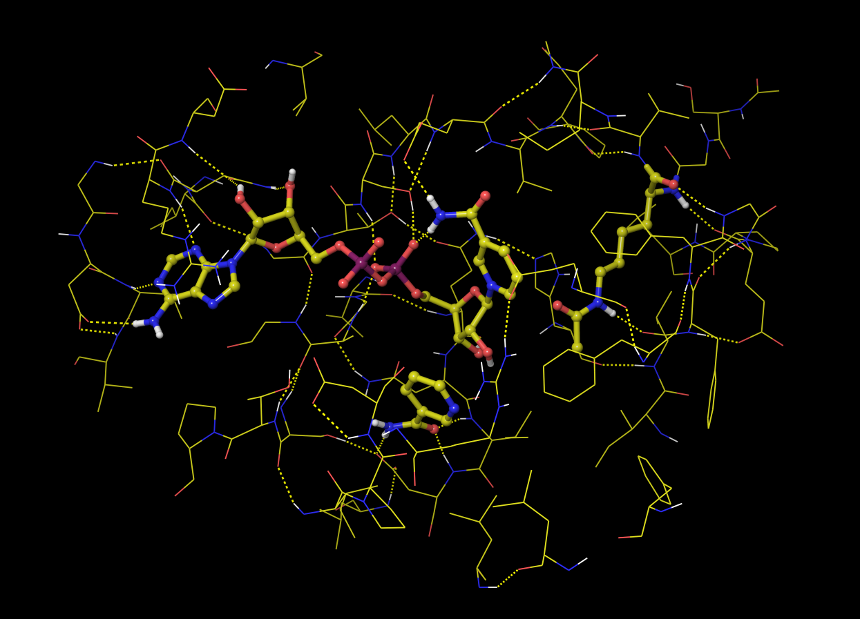 (b)
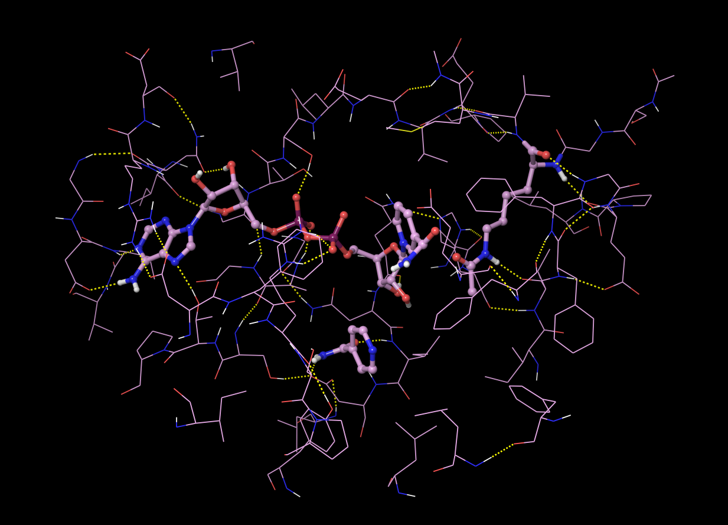 (c)
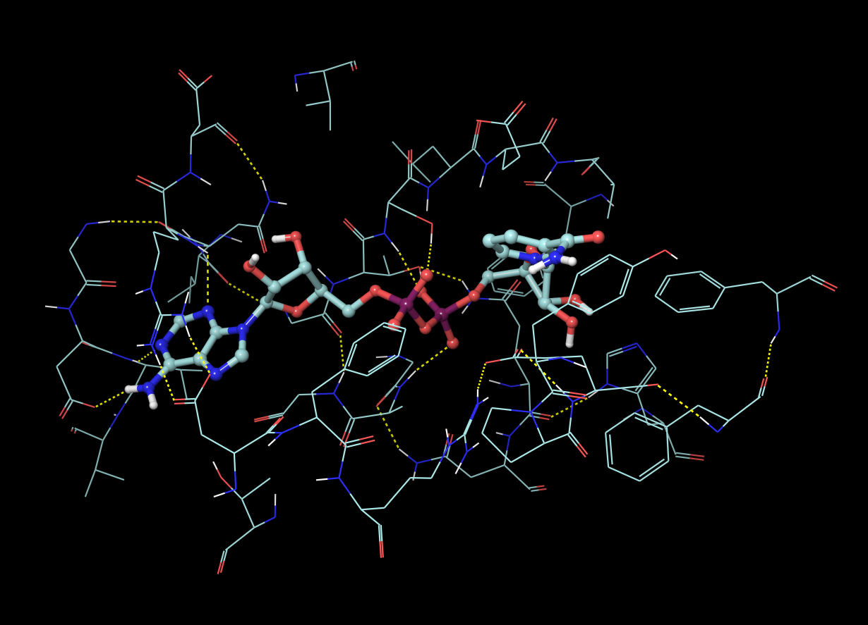 (d)
Figure 7. Binding of NAD+, NAM, isoNAM in (a) ternary complex (SIRT3/Ac-CS2/NAD+); (b) complex with NAM (SIRT3/Ac-CS2/NAD+/NAM); (c) complex with isoNAM (SIRT3/Ac-CS2/NAD+/isoNAM); (d) binary complex (SIRT3/NAD+).

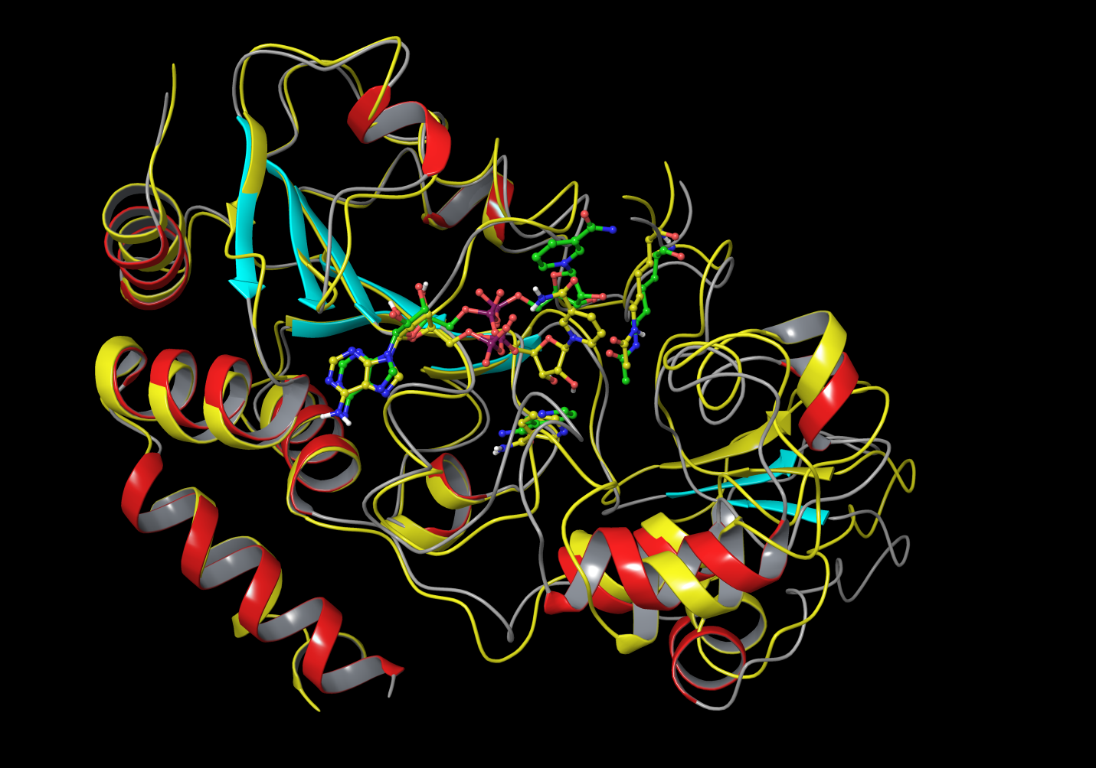
Figure 8: Alignment of complex with NAM (SIRT3/Ac-ACS2/NAD+/NAM, yellow) from MD averaged structures (10 frames from last 10ps) with respect to starting structure (SIRT3/Ac-CS2 from 4FVT, NAD+ in AB pose and NAM in C pocket taken from 1YC2:A after alignment).

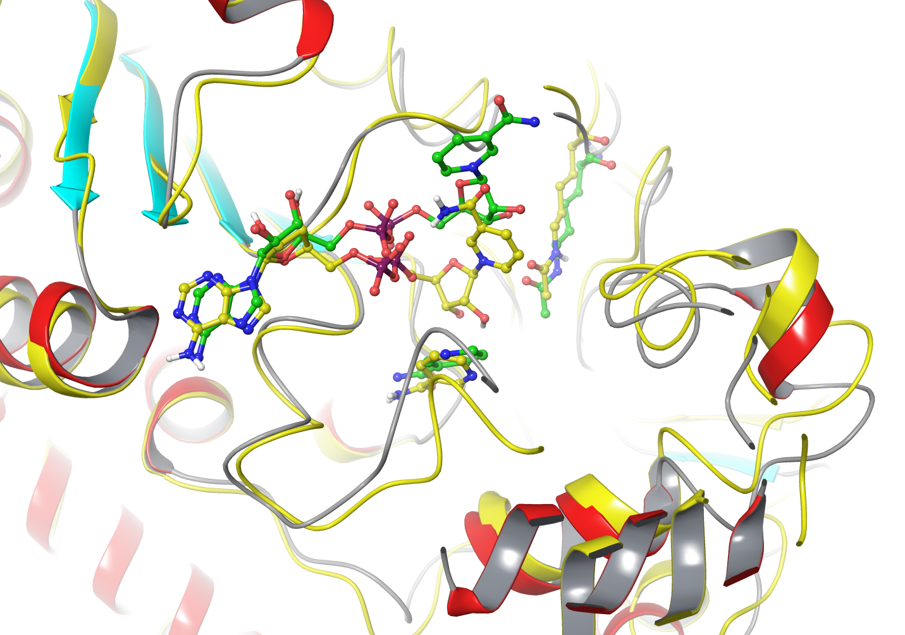
Figure 8a: A close-up view of binding sites in complex with NAM (SIRT3/Ac-ACS2/NAD+/NAM, yellow) from MD averaged structures (10 frames from last 10ps) with respect to starting structure (SIRT3/Ac-CS2 from 4FVT, NAD+ in AB pose and NAM in C pocket taken from 1YC2:A after alignment).

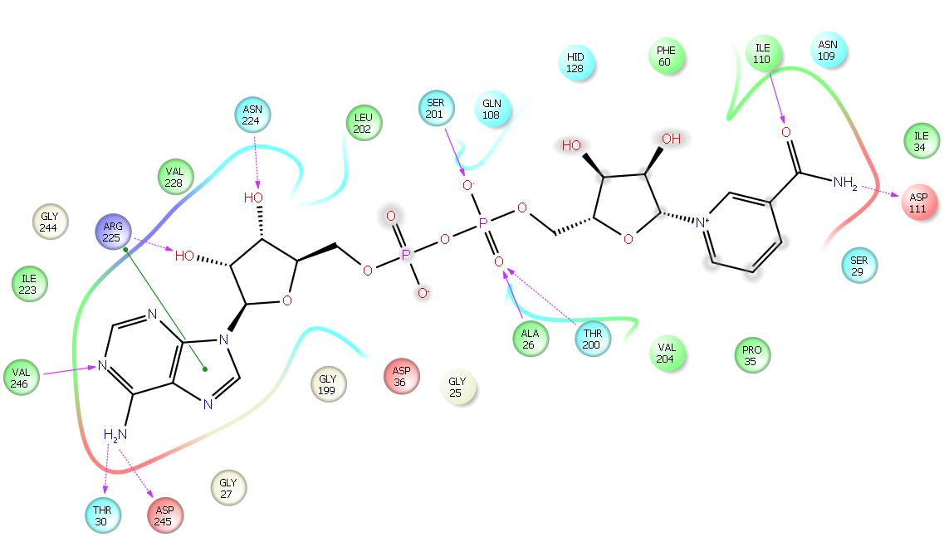(a)
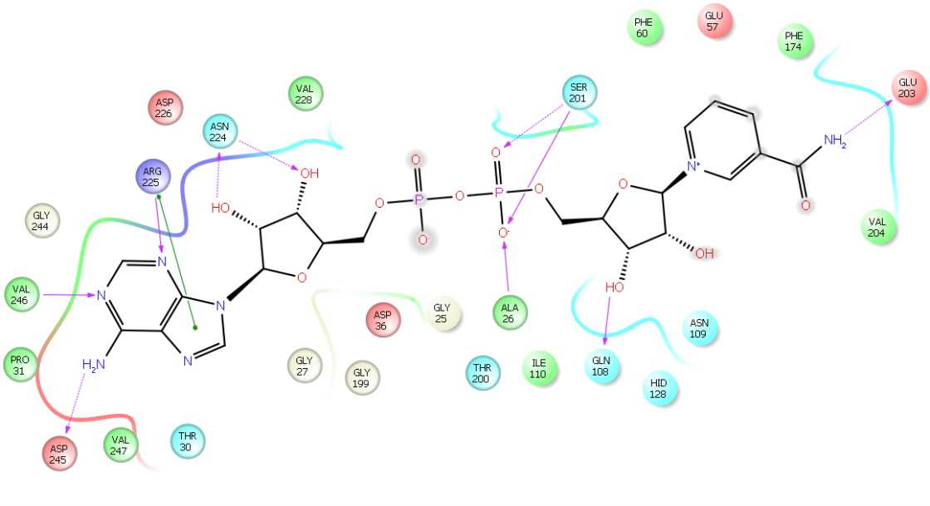 (b)
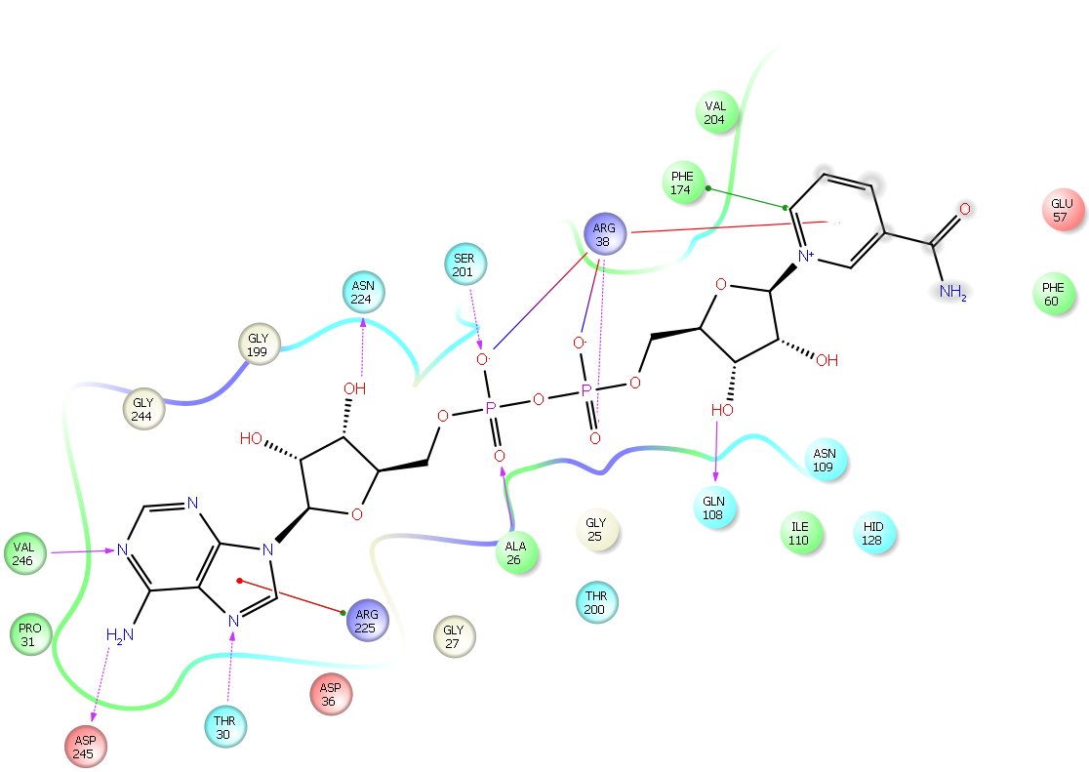 (c)
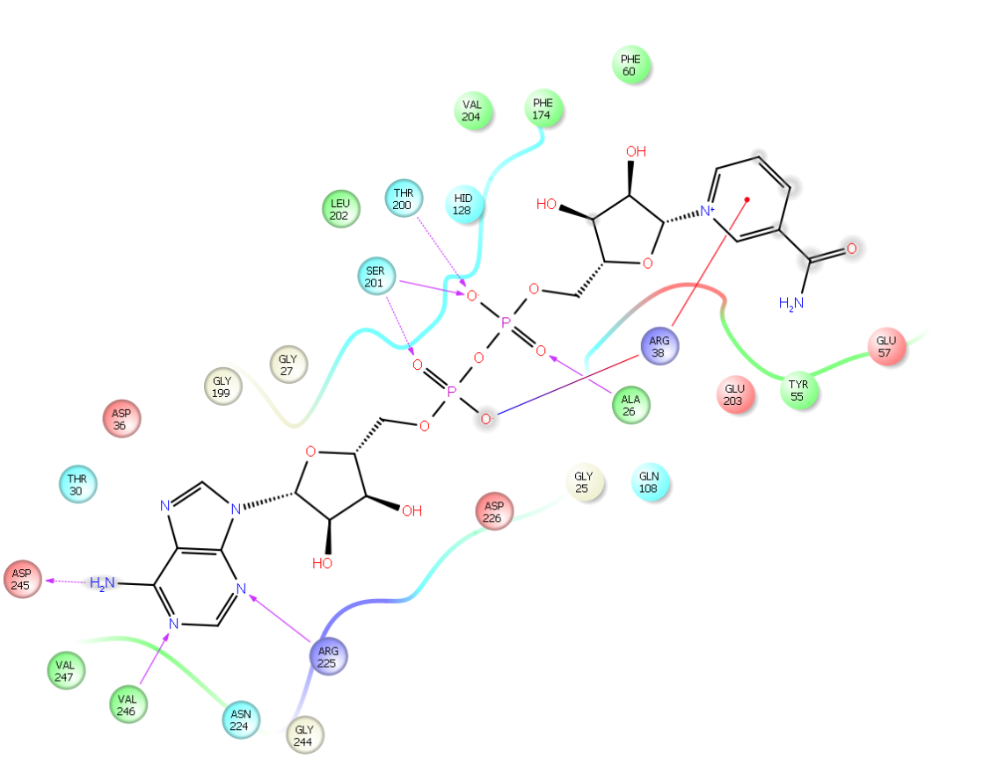 (d)
Figure 9. SIRT3-NAD+ interaction diagrams of MD averaged structures (10 frames from last 10ps) (a) ternary complex (SIRT3/Ac-CS2/NAD+); (b) complex with NAM; (c) complex with isoNAM; (d) binary complex of SIRT3 and NAD+.

