PL(01/30/14): Some updates from SIRT3/NAD+ MD simulation:

NAD+ doesn't bound tightly to SIRT3, as we can see from MD simulation.

1) Starting from NAD+ in AC pocket (initial structure build from ternary structure of 4FVT), snapshots were taken at 0ns, 10ns, 20ns, 22ns, 24ns, 26ns:

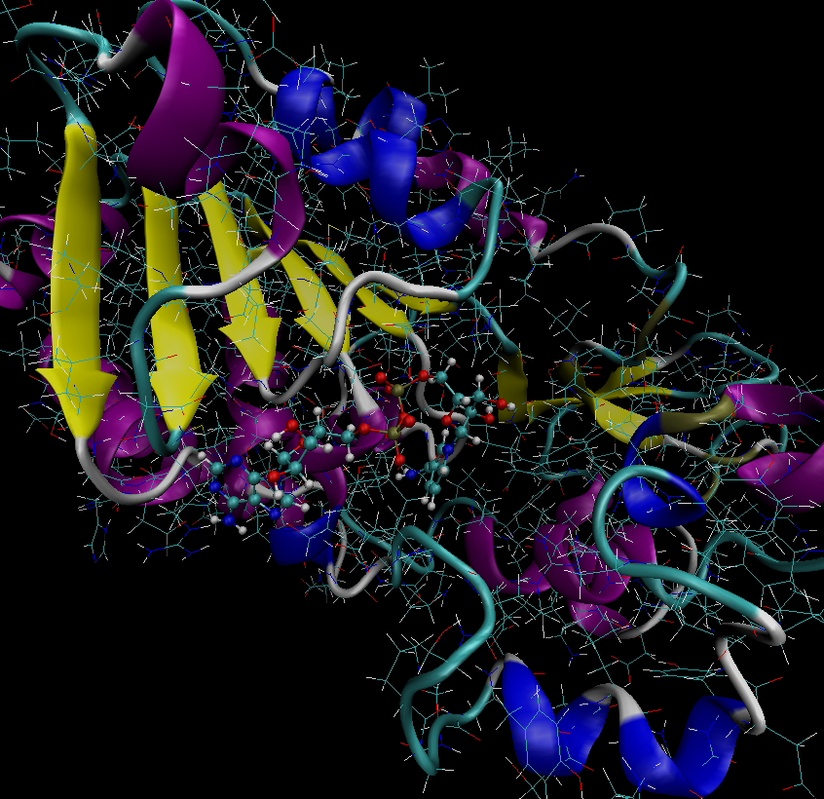 (0 ns)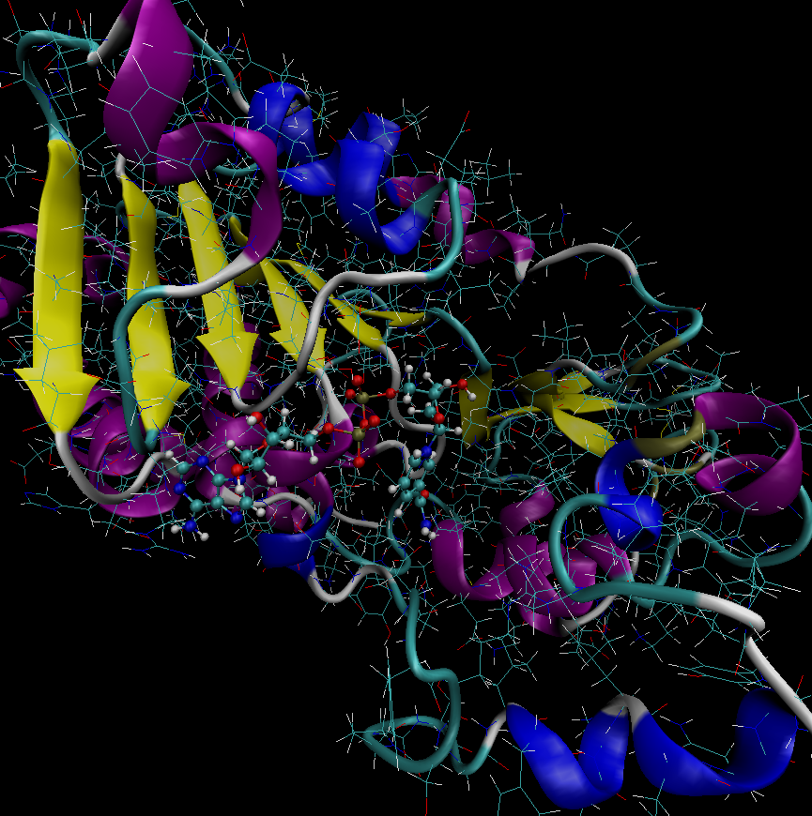 (10 ns)

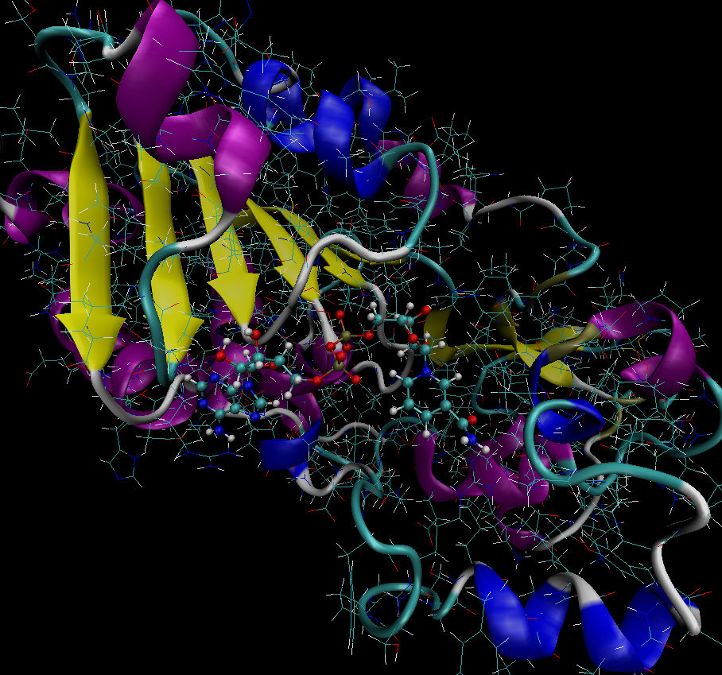 (20 ns)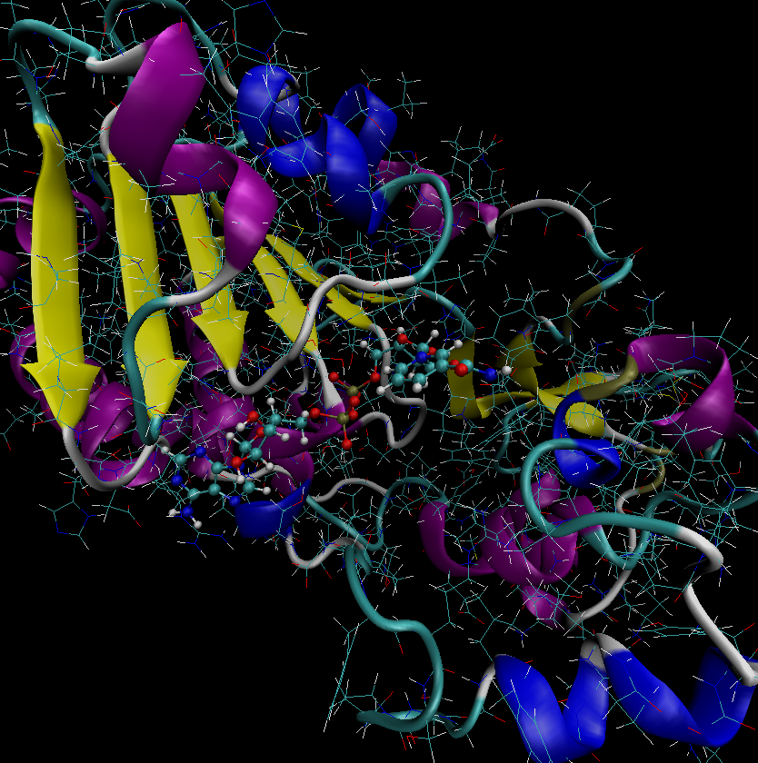 (22 ns)

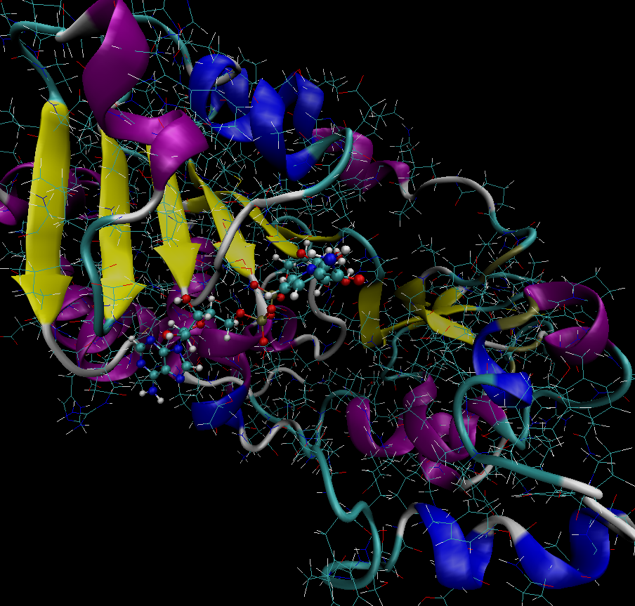 (24 ns)

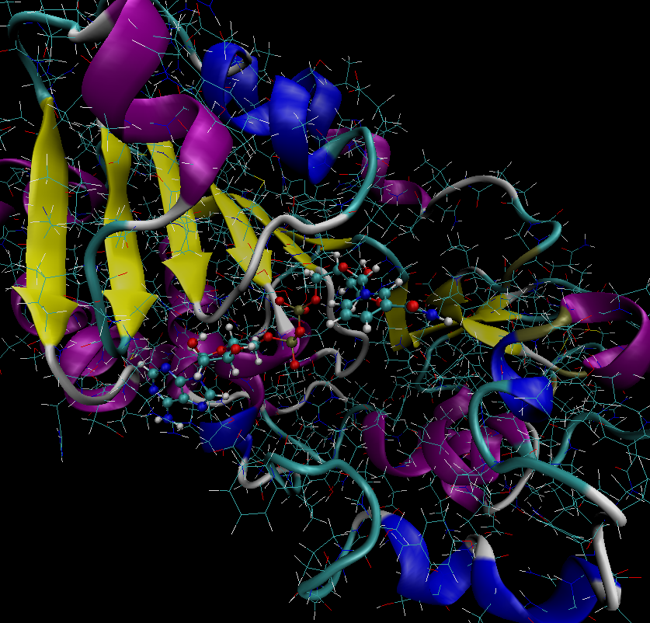 (26 ns)

2) Starting from NAD+ in AB pocket (initial structure build by superimpose NAD+ from 1YC2 (chain A) to SIRT3 taken from 4FVT), snapshots were taken at 0ns, 4ns, 8ns and 12ns.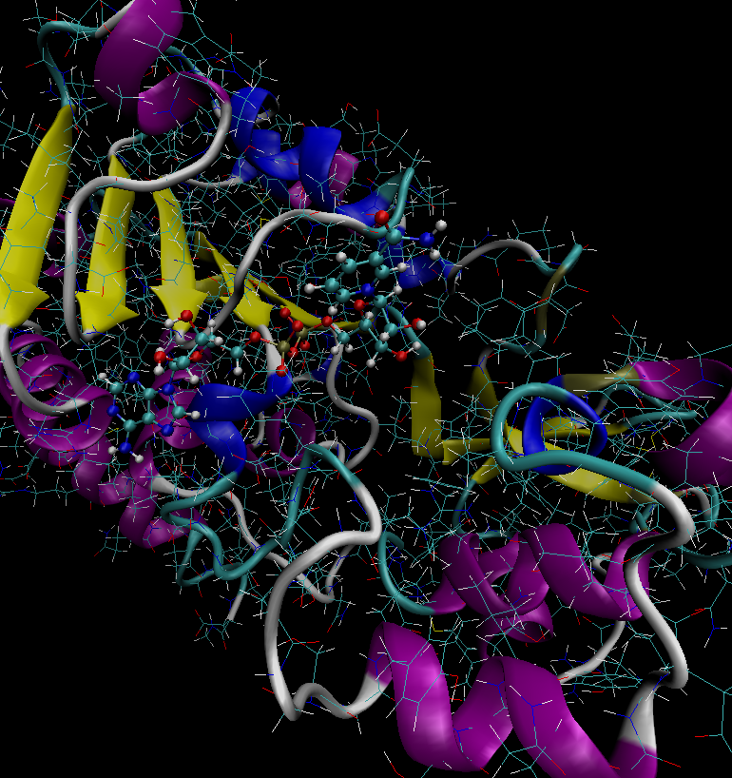 (0 ns)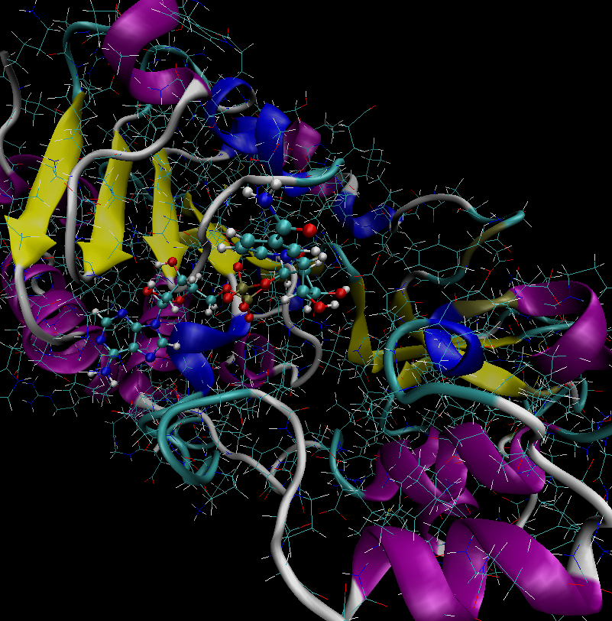 (4 ns)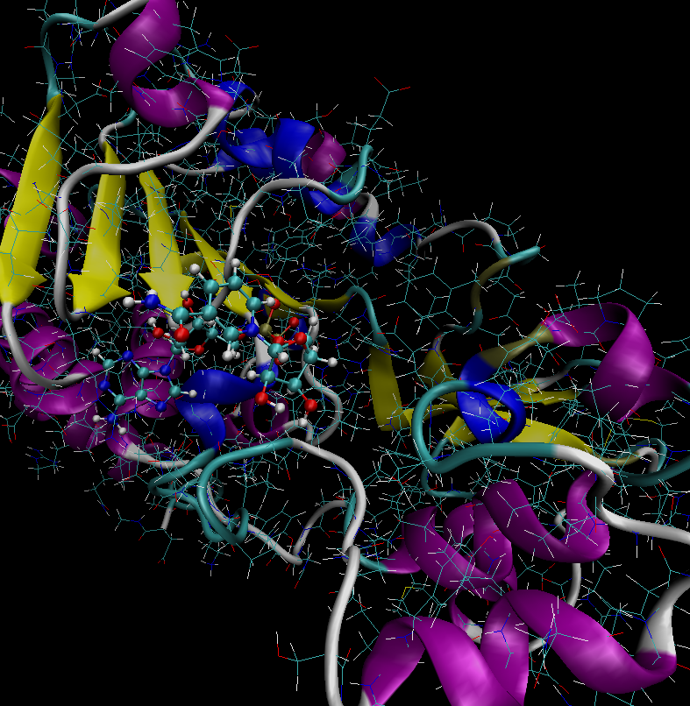 (8 ns) 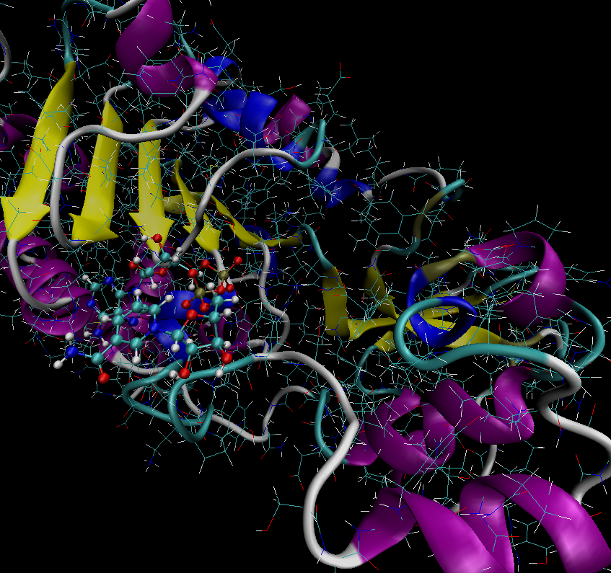 (12 ns)