Date: 4/21/2016

Data for Supplementary information:

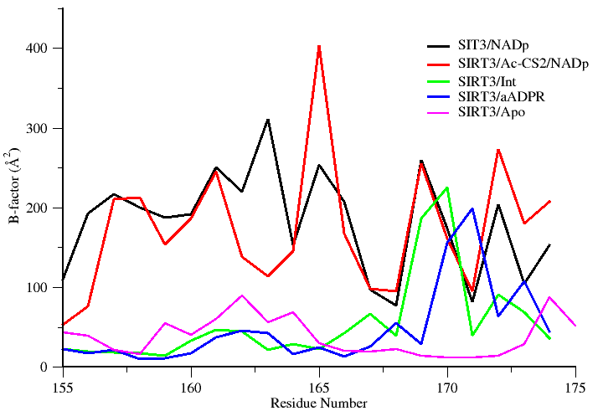

**SI Fig ------:** Plot showing simulated B-factor values for Cα atoms belonging to the co-factor binding loop region of various SIRT3 complexes. Residues (162-170) are known to adapt a helix conformation when bound to substrate.

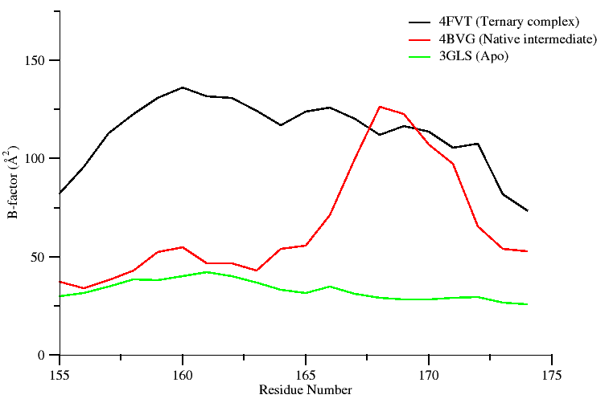

**SI Fig ------:** Plot showing crystallographic B-factor values of the Cα atoms belonging to the co-factor binding loop region of SIRT3 in different states. Residues (162-170) adapt a helix conformation when bound to co-factor.

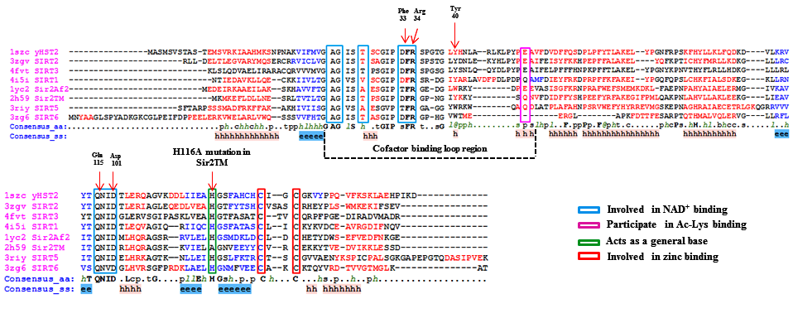

**SI Fig …….:** PROMALS3D based sequence alignment of sirtuin proteins.  Residues shown in the alignment are colored according to their predicted secondary structure elements (red: α-helix, blue: β-strand). The boundaries of the co-factor binding loop region are highlighted using black dotted lines. The consensus sequence (consensus_aa) and consensus predicted secondary structure (consensus_aa) are shown at the bottom of the alignment. Consensus amino acid symbols are represented by: conserved amino acids are in bold and uppercase letters; aliphatic (I, V, L): l; aromatic (Y, H, W, F): @; hydrophobic (W, F, Y, M, L, I, V, A, C, T, H): h; alcohol (S, T): o; polar residues (D, E, H, K, N, Q, R, S, T): p; tiny (A, G, C, S): t; small (A, G, C, S, V, N, D, T, P): s; bulky residues (E, F, I, K, L, M, Q, R, W, Y): b; positively charged (K, R, H): +; negatively charged (D, E): −; charged (D, E, K, R, H): c. The global consensus predicted secondary structure are represented by alpha helix (h) and beta strand (e). Residues important for co-factor binding, substrate binding and catalysis are highlighted in colored boxes.

**SI Table …….: Table showing RMSD comparison between various Sirt3 complexes.**

|  |  |  |
| --- | --- | --- |
| Complex | Global heavy atom RMSD | Co-factor loop RMSD |
| 4FVT (ternary complex) – Xtal vs 4BVG ( native intermediate) Xtal | 0.5 Å | 4.0 Å |
| Sirt3/ADPR complex/NAM modelled from 4FVT (**MD average**)  vs  Sirt3/ADPR complex/NAM modelled from 4FVT but with loop replaced form 4BVG (**MD average**) | 2.2 Å | 5.9Å |
| 4FVT (ternary complex) – Xtal  vs  Sirt3/ADPR complex/NAM modelled from 4FVT (MD average) | 1.9Å | 3.9Å |
| 4FVT (ternary complex) – Xtal  vs  Sirt3/ADPR complex/NAM modelled from 4FVT but with loop replaced form 4BVG (MD average) | 1.1Å | 3.7Å |
| 4BVG (native intermediate) Xtal  vs  Sirt3/ADPR complex/NAM modelled from 4FVT (MD average) | 2.0Å | 6.3Å |
| 4BVG (native intermediate) Xtal  vs  Sirt3/ADPR complex/NAM modelled from 4FVT but with loop replaced form 4BVG (MD average) | 1.0Å | 1.4Å |
| 4FVT (ternary complex) – Xtal  vs  4FVT (ternary complex) – MD averaged | 1.1Å | 2.2Å |
| 4BVG (native intermediate) Xtal  vs  4BVG (native intermediate) MD averaged | 1.6Å | 1.8Å |

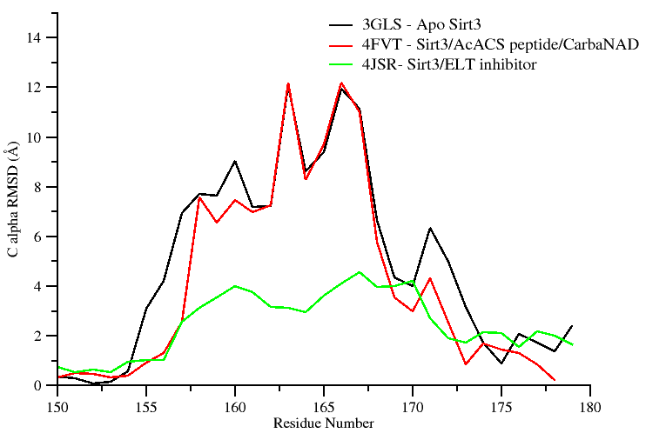 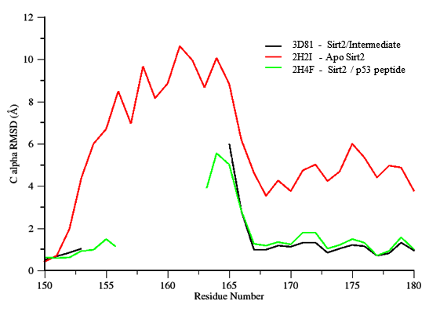

**SI Fig …….:** Shown in the left panel are Sirt3 proteins and their per-residue RMSD values for the cofactor binding loop region computed over all atoms with reference to crystal structure of a Sirt3 intermediate complex (4BVG). The right panel shows RMSD values for Sir2Tm proteins calculated with reference to crystal structure of a Sir2 ternary complex (2H59). Residues (155-178) correspond to the co-factor binding loop region and residues (162-170) form a short alpha helix when bound to co-factors. Unresolved loop region are not plotted in the figure.

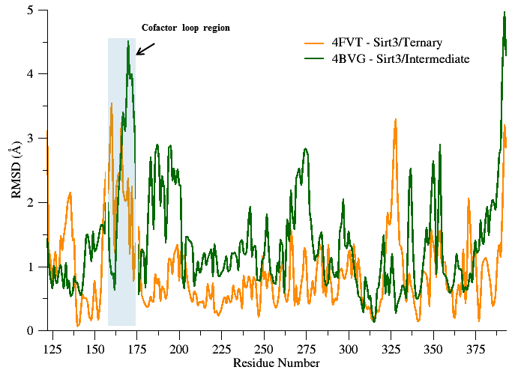

**SI Fig…** – Per residue RMSD plot of the time average MD structure of Sirt3/Ternary and Sirt3/Intermediate complex calculated with respect to their crystal structure.

*Note: If need we can replace it with a separate plot*

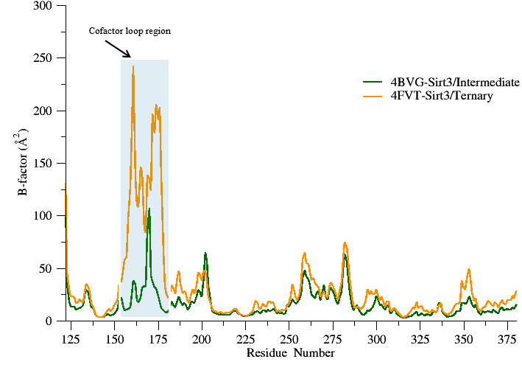

**SI Fig …**: Simulated B factor values for Sirt3/Ternary and Sirt3/Intermediate complexes.

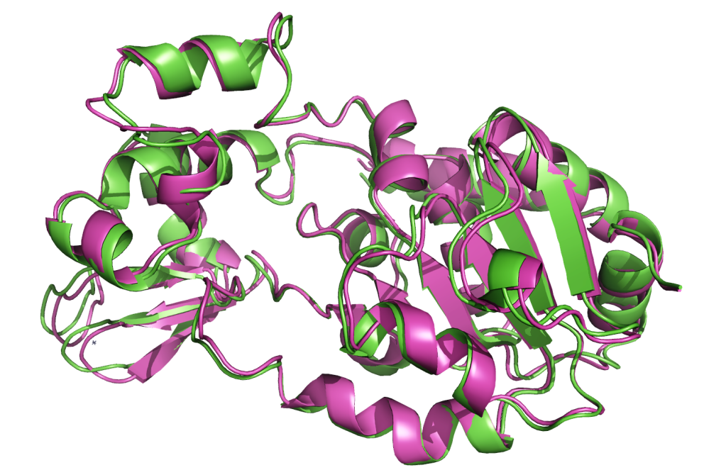

**SI Fig ---:** Time averaged MD structure of apo Sirt3 (Magenta) superimposed onto apo Sirt3 crystal structure 3GLS (Green). Global RMSD = 1.1 Å.

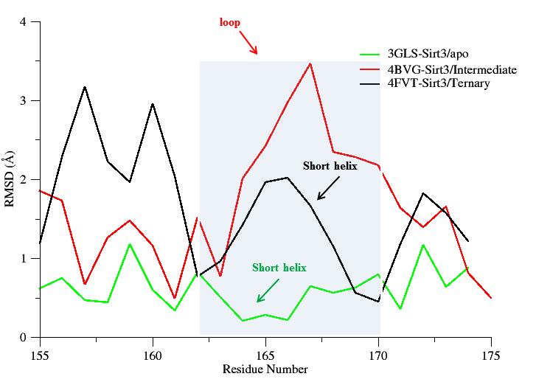

**SI Fig ------:** Per residue RMSD plot of the time average MD structure of Sirt3 apo, Sirt3/Ternary, and Sirt3/Intermediate complex calculated with respect to their crystal structure. Only those residues belonging to the cofactor loop region are shown in the plot for clarity. Residues (162-170) which constitute the short alpha helix region (highlighted in grey) of the cofactor loop region in Sirt3/apo and Sirt3/Ternary complex. In Sirt3/Intermediate complex an order to disorder transition results in the unwinding of the short helix.

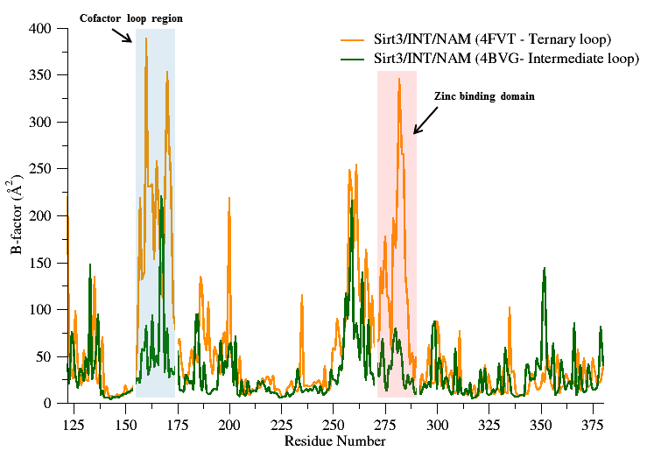

**SI Fig ------:** Simulated B factor values for Sirt3/Int/NAM complexes modeled based on a ternary loop conformation (4FVT) and an intermediate loop conformation (4BVG).