**Mechanism of Human SIRT3 inhibition by Nicotinamide§**

Xiangying Guan1✝, Eric Knoll1✝, Raj Chakrabarti2*

1 PMC Advanced Technology, LLC, NJ, USA

2 Department of Chemical Engineering, College of Engineering,

Carnegie Mellon University, PA, USA

✝ Both authors contributed equally to the results of this work.

**§**This work was partially supported by NSF Grant, XXXXX

* To whom correspondence should be addressed:

Raj Chakrabarti, Ph.D.

Associate Professor of Chemical Engineering and

Center for Advanced Process Decision-Making

# Department of Chemical Engineering

College of Engineering

Carnegie Mellon University

# Doherty Hall 3122

5000 Forbes Avenue

Pittsburgh, PA 15213

Phone: (412) 268-8999

Email: rajc@andrew.cmu.edu

Acknowledgments: We thank Dr. Clarence E Schutt for valuable discussions.

**ABSTRACT**

Sirtuins are performing as key regulators of many cellular functions including metabolism, cell growth, apoptosis, and genetic control of ageing related diseases. In mammals there are seven sirtuin analogues, SIRT1 to SIRT7. Among them SIRT3 is unique because it is the only analogue whose increased expression has been found to be associated with extended lifespan of humans. As an NAD+-dependent deacetylase enzyme, SIRT3catalyzes the deaceylation reaction to generate O-acetyl-ADP-ribose, the deacetylated substrate, and nicotinamide (NAM), a form of vitamin B3. We show here that physiological concentration of nicotinamide competitively inhibits human recombinant SIRT3. We discuss the possibility that nicotinamide is a physiologically relevant regulator of human SIRT3 enzyme…….

**INTRODUCTION**

Many sever diseases often occur later in life (e.g., diabetes, neurodegenerative diseases, cancer, cardiovascular disease, proinflammatory diseases, and osteoporosis) indicating that aging is an important risk factor for these conditions. The silent information regulator 2 (Sir2) is one of the proteins which function has been suggested to be related to the aging process and contribute to longevity. In mammals seven sirtuin genes - SIRT1 to SIRT7 – have been identified.

Human sirtuin type 3 (SIRT3), one of the seven mammalian sirtuins so far identified (Frye, 1999; 2000),is a major mitochondrial protein and has an NAD+ -dependent deacetylase activity regulating the globe mitochondrial lysine acetylation. (Onyango, Celic et al. 2002; Lombard, Alt et al. 2007). Given that SIRT3 expression decreased with aging (Lanza et al, 2008), and that mitochondrial reactive oxygen species (ROS) are important in cancer, SIRT3 plays a role in oncogenic transformation. In addition, the tumor suppressor, p53 has been identified as a new target for SIRT3 deacetylation in bladder cancer (Li. et al, 2010).

Although the functions of SIRT3 have not yet been fully understood, as mentioned above, it has been suggested to be associated with various disease states, including cancer and cardiac disorders. Understanding the properties of theinhibitory mechanism will give support to the elucidation of themechanism of SIRT3 mediated deacetylation and allowimprovements in inhibitor selectivity and affinity (Cen, 2010). In this way, its inhibitors are of interest not only as tools for elucidating in detail the biological functions of the enzyme, but also as potential therapeutic agents.

Nicotinamide, a well known sirtuin inhibitor, is a water-soluble vitamin of the B complex, which together with nicotinic acid belongs to vitamin B3 or vitamin PP and it acts as constituent of the enzyme cofactors NAD (nicotinamide adenine dinucleotide) and NADP (nicotinamide adenine dinucleotide phosphate) (pyridine nucleotides). These molecules function as electron carriers in cell metabolism of carbohydrates, fatty acids and amino acids. Nicotinamide has been used to treat pellagra, osteoarthritis and is currently in trials as a therapy to prevent cancer recurrence and insulin-dependent (type I) diabetes. This vitamin is safe even when administered at high dosage (6 g/day) in human (Flodin, 1988; Sereno et al., 2005; Gazanion et al., 2011). Interstingly, NAM is the physiological regulator of human sirtuinsand is a reaction product and endogenous noncompetitive inhibitor of Sir2proteins. Mechanistically, NAM binds to a conserved region in the Sir2 catalytic site and favors a base-exchange reaction instead of deacetylation( Avalos et al, 2004). However, a NAM analogue, isonicotinamide (isoNAM), that competes for free NAM binding but does not react appreciably with the enzyme intermediate, increases the Sir2 activity. NAM inhibition and isoNAM activation of Sir2 deacetylase activity is achieved without affecting substrate binding (Sauve, et al, 2005).

Low levels of NAM have been measured in several rat tissues, probably as a result of its rapid utilization in the synthesis of NAD+ and other pyridine nucleotides (Adams, et al, 2007). However, NAM concentrations as high as 300 uM have been reported in brain f Tg2576 mice, providing evidence that NAM concentrations could be actually a factor regulating sirtuin activities in mammalian cells (Qin, et al, 2006).

The identity of the binding site of the inhibitory NAM molecule has implications for the development of rational activators of Sir2/SIRT1 that exert their effect through reduction of NAM inhibition. However, no studies of nicotinamide inhibition of human SIRT3 have been done yet. Also the role of isoNAM as human SIRT3 modulator need to be investigates. The aim of this study is to identify the critical roles of NAM and isoNAM responsible to inhibit/activate the human SIRT3 activity.

Available experimental evidence such as x-ray structures and kinetic assays are limited in explaining mechanistic details of inhibition by NAM, isoNAM and other inhibitors; computational modeling can further describe the inhibitory mechanism as competitive or noncompetitive. The design of novel high affinity and specificity inhibitors and activators can be aided with docking and computational binding affinity estimates, such as MM-GBSA [docking and MM-GBSA reference].While the employed binding affinity methods do not produce an accurate ∆G of binding, order of magnitude comparisons in MM-GBSA binding affinity estimates often correlate well with a rank ordering of binding affinities when used with accurate substrate or inhibitor bound co-crystallized x-ray structures. Computational studies include docking and binding affinity estimates of the native NAD+ cofactor in the two different binding modes (AB vs. AC pockets) for Sir2 and SIRT3. The models support theexperimental results of the different inhibition modes between Sir2 and SIRT3, where Sir2 has noncompetitive inhibition and SIRT3 has competitive inhibition.

**MATERIALS AND METHODS**

*Chemicals and reagents.* The acetylated substrate peptide based on the sequence of Acetyl-coenzyme A synthetase 2 (AceCS2 638-649, H2N-TRSGK(Ac)VMRRLLR-OH) was synthesized at PEPTIDE 2.0 Inc (Chantilly, VA, USA). Human recombinant SIRT3 was purchased from Creative BioMart (Shirley, NY, USA). Glutamate dehydrogenase from Proteus was purchased from Sigma (St. Louis, MO, USA). PncAnicotinamidase from Salmonella enteric was expressed and purified from Escherichia coli in the lab (see Protein expression and purification for details). Protein was stored in Tris-HCl (50mM, pH 7.5, at 25 °C) containing KCl (100mM) and 20% (v/v) glycerol at -80 °C. Enzyme concentrations were determined using the method of Bradford(Bradford 1976) with bovine serum albumin (BSA) as the standard. All other chemicals used were of the highest purity commercially available and were purchased from Sigma (St. Louis, MO, USA), and The Fisher Scientific (Pittsburgh, PA, USA).

*Protein Expression and Purification.* Salmonella enterica PncA was amplified using primers to add 5’-EcoR1 and 3’-Not1 restriction sites and cloned into plasmid pAB-6xHis-MBP to yield plasmid pPNC1(Garrity, Gardner et al. 2007), which encodes PncA protein with an N-terminal maltose-binding protein-hexahistidine (6xHis-MBP) tag. Plasmid pPNC1 was moved into Escherichia. coli strain BL21(DE3) by chemical transformation. The resulting strain was grown overnight and subcultured 1:100 (v/v) into 2 liters of lysogenic broth containing ampicillin (100 g/ml). The culture was grown shaking at 37 °C to A600 ~0.7, and MBP-H6-PncA synthesis was induced with isopropyl-1-thio--D-galactopyranoside (1mM). The culture was grown overnight at 25 °C. Cells were harvested and MBP-H6-PncA purified as following: Cells expressing MBP-H6-PncA were harvested by centrifugation at 10,500 xg at 4oC for 12 min in a SORVALL Legend x 1R centrifuge with a FiberLite F15-6x100y rotor (Thermo Scientific). Cell pellets were resuspended in buffer A (sodium phosphate buffer (20 mM, pH 7.5, at 24 °C), NaCl (0.5 M), imidazole (20 mM)) and broken by sonication using a CL-18 Sonic Dismembrator (Fisher Scientific) for 3 min (50% duty). Cell debris was removed by centrifugation at 35,000 xg for 30 minutes. MBP-H6-PncA was purified by affinity chromatography using a 5-ml HisTrap HP column. After equilibration with buffer A and loading of cell-free extract, the column was washed with 50 ml of buffer A, followed by 40 ml of 8% buffer B (sodium phosphate buffer (20 mM, pH 7.5, at 24 °C), NaCl (0.5M), imidazole (0.5 M)). A 50-ml linear gradient increased buffer B to 100%. PncA eluted at 30% buffer B and was xxx pure and was stored in tris(hydroxymethyl) amino methane buffer (Tris-HCl, 50mM, pH 7.5, at 25 °C) containing KCl (100 mM) and 50% glycerol (v/v) at -80 °C. MBP-h6-PncA-containing fractions were pooled and H6-rTEV protease added to reach a 1:50 H6-rTEV protease:MBP-H6-PncA ratio. The cleavage reaction mixture was incubated at room temperature for 3 h and dialyzed overnight against two liters of buffer A at 4oC. Tagless PncA protein was resolved from the raction mixture using the 5-ml His Trap HP column, which did not bind tagless PncA. Protein was stored in Tris-HCL (50 mM, pH 7.5 at 25oC) containing KCl (100 mM) and 20% (v/v) glycerol at –80oC

*Measurement of Deacetylation activity using a Fluorolabeled peptide.* The steady state parameters (Km and Kcat) and catalytic efficiency (Kcat/Km) of deacetylase activity of recombinant human SIRT3 was determined using a fluorimetic assay. The deacetylation activity was measured by using the SIRT3 Fluorimetic Drug Discovery Kit (AK 557, Enzo Life Sciences). This assay system allows detection of a fluorescent signal upon deacetylateion of an acetylated substrate peptide, comprising amino acids 317-320 of human p53 (Gln-Pro-Lys-Lys (Ac)), when treated with developer. The Intensity of fluorescence was measured on a fluorometricmicroplate reader (Fluoroskan Ascent® FL, Thermo LabSystems) with excitation set at 355 nm and emission detection set at 460 nm. The initial rate of the NAD+-dependent deacetylation activity of SIRT3 enzyme was measured at different concentrations of nicotinamide adenine dinucleotide. The reactions were carried out at 37oC in a 50 ul reaction volume containing 50 mMTris/Cl (pH=8), 137 mMNaCl, and 100 uMflourolabeled peptide substrate. The enzyme concentration of the SIRT3 was 50ug/ml. Unless otherwise indicated all initial rate measurements were means of three or more replicates, obtained with single incubation times, at which point 5% or less of the substrate initially present had been deacetylated. The raw data were fitted to the Michaelis-Menten equation by using GraphPad Prism (GraphPad Software, Inc, CA) to obtain the kinetic constants.

*Measurement of IC50 values for SIRT3 inhibitor: Nicotinamide.* This assay was also used to measure the inhibition by nicotinamide, isonicotinamide and combination of both. Reactions were performed in the presence of 100 uM NAD+, 100 uM of substrate peptide, and either nicotinamide (0, 12.5, 25, 50, 100, 200, 500 uM) or 50 uM of nicotinamide with isonicotinamide (0, 0.05, 0.1, 1, 5, and 10 mM). The initial rates were measured at different concentrations of nicotinamide and isonicotinamide, and the reaction conditions were the same as above. The data were fitted to Equation 1 by using Prism to calculate the IC50 values:

vI= v0 (1-[1/(IC50+I)]) (1)

Where v0 is the initial rate of the uninhibited reaction and vI is the initial rate of the reaction at concentration I of inhibitor.

*Measurement of Deacetylation activity using an enzyme coupled continuous assay.* SIRT3 activity was measured continuously using a Multiskan Ascent microplate reader (LabSystems; Franklin, MA, USA). Typical assay mixtures contained 20 to 800 M AcH3, 20 to 1000 M NAD+, 0.2 mMNAD(P)H, 1 mMdithiothreitol (DTT), 3.3 mM-ketoglutarate, 1 to 2 M MBP–PncA (nicotinamidase), 2 units of glutamate dehydrogenase from proteus (with 1 unit defined by the manufacturer as reducing 1.0 mol of -ketoglutarate to glutamate per minute), and 0.2 to 1 M Sirt3 in 20 mM potassium phosphate at pH 7.5. Nicotinamideinhibition reactions contained 80 M NAD+ and 100 M AcH3, with inhibitor concentrations varying from 12.5 to 300 M with 0.5 M SIRT3 for the positive control and no SIRT3 for the negative control. SIRT3 reactions were carried out in a final volume of 300 l per well in a clear, flat-bottomed, 96-well plate. All assay components except SIRT3 or NAD+ were preincu- bated at 25 oC for 5 min or until absorbance at 340 nm stabilized, and the reaction was initiated by the addition of SIRT3 or NAD+. The rates were analyzed continuously for 10, 20, 30, or 60 min by measuring NAD(P)H consumption at 340 nm. Alternatively, NAD(P)H was quantified by its intrinsic fluorescence with excitation at approximately 340 nm and emission at 460 nm in a solid black, flat-bottomed, 96-well plate. Rates were determined from the slopes of the initial linear portion of each curve using an extinction coefficient for NAD(P)H of 6.22 mM-1cm-1 and a pathlength of 0.9 cm for 300 l reactions. The background rates of reactions lacking either SIRT3 or NAD+ resulting from the spontaneous formation of nicotinamide or ammonia were subtracted from the initial velocities of the SIRT3-catalyzed reactions.

*In Silico Docking and Binding affinity estimation:*

In addition to the experimental assays, computational simulations elucidated the mechanism of SIRT3 compared to Sir2 through protein-ligand docking and a subsequent binding affinity estimation. These techniques allow for an approximation of binding affinity of the native NAD+ substrate and multiple known inhibitors. The Schrodinger suite of software, and in particular the docking program Glide[1] along with the MM-GBSA protocol [1] in the suite were used for the binding affinity estimates.

Although protein-ligand docking with Glide rank orders the resulting poses and outputs a docking score for each pose, these outputs are not reliable estimates for the binding affinity. Docking programs such as AUTODOCK[2], DOCK[3], and Glide were designed to distinguish actives from inactives when screening large databases of potential ligands to a given protein active site. The computational simulations in this study attempted to differentiate between the Sir2 and SIRT3 nicotinamide inhibition mechanism, for which subtle variations in absolute binding energy between the various binding modes of the native NAD+ cofactor needed to be estimated. While other groups have reported correlating docking scores [4] to or developing a custom scoring function [5] for binding affinity, these approaches are limited to cogeneric series of ligands for which dozens of experimentally determined binding affinities are used as a training set. These methods are not applicable, as we are concerned with a possible subtle difference between two binding modes of the native cofactor, NAD+ and two inhibitors.

MM-GBSA enhances docking scores by adding an estimation of the missing energy contributions of the solvent through the generalized Born implicit solvent model. MM-GBSA can be applied to the single protein-ligand minimized structure obtained directly from each Glide docking pose with implicit water, or to an ensemble of poses obtained after averaging over multiple MD snapshots. Correlations to free energy of binding for multiple test systems were found to be good for the single structure approach.[1] Because the computationally more intensive combined MD MM-GBSA approach added little additional accuracy [4], we employed the simpler single structure method.

The single structure procedure does not mean that only one pose per protein-ligand docked complex is used. Rather, the docking algorithm, Glide, outputs multiple poses for each ligand, each with a slightly different conformation docked into the protein. All of these structures, even lower ranking ones, are re-scored with the MM-GBSA function, which may rearrange the original GlideScore rank order among poses for each ligand and among multiple ligands. This possible reordering is justified because the MM-GBSA method incorporates implicitly modeled solvent effects that are an important energy contribution completely missing from the docking scores [verify that GlideScore has no solvent contributions]. The scoring functions in Glide and other docking programs are optimized to minimize the RMSD difference between predicted and x-ray determined structures for a large database of co-crystallized protein-ligand structures [FIND REFERENCE FOR THIS], rather than optimized to predict binding affinity. Thus using the standard scoring functions to predict poses, then subsequently re-scoring those poses with MM-GBSA offers better correlation to actual binding affinities.

The first step in determining the MM-GBSA estimate for binding affinity between NAD+ binding in the AB vs. AC pockets for Sir2 and SIRT3 is to accurately dock this ligand in the two poses. While PDB structures are available for NAD+ co-crystallized in the AB and AC pockets of Sir2 (Sir2Af2, PDB:1YC2 chain A and B, respectively [note: verify which is A which is B]), no co-crystallized structures with NAD+ are publicly available for SIRT3.

Next, the docked poses were minimized using the local optimization feature in Prime, and the energies were calculated using the OPLS-AA force field and the GBSA continuum model. The binding free energy ∆Gbind is estimated as

∆Gbind = ∆EMM ∆GSOLV + ∆GSA

where ∆**E**MM is the difference in energy between the complex structure and the sum of the energies of the ligand and unliganded protein, using the OPLS force field, ∆**G**solv is the difference in the GBSA solvation energy of the complex and the sum of the solvation energies for the ligand and unliganded protein, and ∆**G**SA is the difference in the surface area energy for the complex and the sum of the surface area energies for the ligand and uncomplexed protein.

Estimating binding affinity with MM-GBSA involved starting with the crystal structure, prepping the x-ray structure for docking, docking the NAD+ in to either the AB or AC pockets with Glide or Induced Fit, then calculating the MM-GBSA energy. Multiple starting structures of SIRT3 (3GLT) and Sir2 (1YC2) with NAD+ co-crystallized in either the AB or AC pockets of the protein [6] were prepared with the Schrodinger protein preparation protocol. Bond orders were assigned, missing hydrogens added, zero-order bonds to the zinc atoms created, missing side chains were filled in with the PRIME algorithm[2], and protein chain termini are capped. Protonation states for the ligands were generated with Epik [8] for a pH range of 7.0 +/- 3.0. H-bond assignment was done using PROPKA at pH 7.0 and included sampling all water orientations, as well as using crystal symmetry information. A final restrained minimization was performed with heavy atoms converged to RMSD 0.30 Å with the OPLS 2005 forcefield.

Grids for docking were calculated with the grid box centered on the known NAD+ binding site, with partial charges for this ligand taken from the above mentioned semi-empirical Epik calculation. For some docking simulations which had difficulty reproducing the expected binding mode, such as the SIRT3 AB pocket docking, optional ligand positional constraints, H-bond or metal constraints, hydrophobic constraints, and excluded volumes were added.

Using the previously setup grid, Glide was run in both SP (standard precision) and XP (extra precision) modes. The XP mode output a handful of highly scored poses, which were re-ranked using MM-GBSA. The SP mode output up to 1024 more lower scored poses which were also re-reranked, allowing for a more comprehensive sampling of poses with scores slightly higeher in energy. Since Glide does not allow for receptor flexibility in docking, van der Waals (vdW) radius scaling softens the potential for nonpolar atoms in the receptor. The vdW radius was initially set at 0.85 (no scaling) with a partial charge cutoff of 0.15, then decreased to 0.50 in cases, such as SIRT3 AB pocket, where the ligand could not dock properly due to steric obstructions. Partial charges for the ligand were determined by the semi-emperical method, PROPKA, while partial charges on the protein default to the values in the OPLS 2005 force field. Glide constraints, which are receptor-ligand interactions that are believed to be important to the binding mode, were added for certain simulations, as specified later.

Most of the docking simulations used traditional docking, which is useful when the receptor structure does not change upon docking. A number of simulations used the Induced Fit protocol [9], which adds flexibility to the receptor. This protocol iteratively uses Glide and Prime to exhaustively consider possible binding modes and the associated conformational changes within receptor active site. Traditional Glide does not enumerate changes to the side chains or backbone of the receptor.

The overall Induced Fit protocol involves four iterative steps. First docking with a soft core potential produces an ensemble of ligand poses, some of which are hopefully reasonably close to the true structure. Next, the protein side chains are sampled for each of the poses from step one using the PRIME algorithm. The third step refines the ligand conformation to minimize the ligand interaction with the protein conformation from step 2. The final step involves re-scoring the ligand pose and receptor reconfiguration from steps 1 to 3 with terms accounting for the docking energy, and the receptor strain and solvation terms.

Traditional docking for Sir2 and SIRT3 is not sufficient when the starting crystal structure is not from a co-crystallized structure with NAD+ in the desired binding mode because a loop as well as side chains move upon binding of NAD+ and upon NAD+ changing from the AC to the AB binding pocket. [show picture NAD+ AB / AC for Sir2Af2: note, the B pocket is very open in Sir2Af2, unlike in SIRT3; thus Sir2Af2 can do traditional docking, except for Arg36 which must move out of B pocket]

Unlike with traditional docking, Induced Fit has limited constraints available, such as requiring certain receptor hydrogen bond partners participate in docking. Excluded volumes and ligand positional or torsional constraints are currently not implemented in the Schrodinger protocol. As in traditional docking, a receptor region around the AB and AC binding pockets of around 18 Å a side is defined, and the ligand is docked flexibly, or, alternatively, rigidly in the expected conformation seen in the co-crystallized structures of NAD+ in the AB or AC pockets of Sir2Af2 (1YC2). Specified side chains are temporarily mutated to alanine to accommodate the ligand and improve side chain flexibility. In particular, Arg36 on Sir2Af2 (1YC2) sterically hinder the B pocket. Glu323, Arg158, and MET644 from Chain B (the acetyl-lysine peptide substrate) obstruct the B pocket of SIRT3 from the PDB structure 3GLT, as shown in illustration 5. Unlike for Sir2 which has co-crystallized structures with NAD+, 3GLT with the trapped thio-acetyl ADPR intermediate is the closest available to a co-crystallized structure of NAD+ either in the AB or AC pockets.

**RESULTS**

NAM inhibition at physiological concentration, Ki (Note: i=[I]/(Ki+[I]), IC50 is the substrate concentration observed at 50 % inhibition)

NAM is a known inhibitor of the deacetylationacetivity of sirtuins, but the inhibition mechanism of NAM toward its substrates for human SIRT3 has not been determined before. The inhibition of nicotinamideand isonicotinamidein hSIRT3 deacetylation was tested in the presence of different concentrations of NAM with 90 minutes incubation of 1mM NAD+ at 37 oC with IC50 of 36.7uM and 13.8 mM, respectively. Their IC50 in hSIRT1 were also measured using current method. The IC50 of NAM is 68.1 uM and of isoNAM is 12.2 mM. They are in good agreement with reported data.

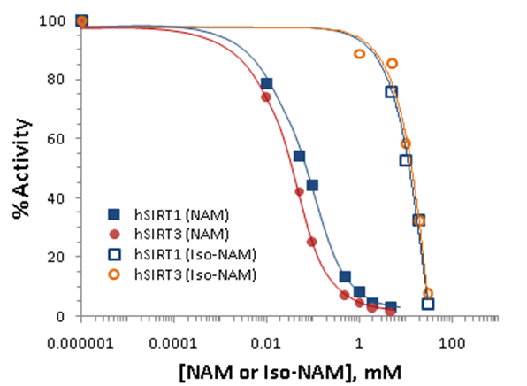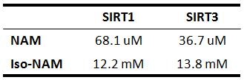

Figure 1. Nicotinamide inhibition assays showing percent change in deacetylation activity as a function of nicotinamide concentration. Data for the hSIRT1 enzyme are indicated with close square and a blue curve; data for the hSIRT3 are indicated with filled circles and a red line. The IC50 for the hSIRT3 enzyme is 36.7 uM, and that of the hSIRT1 enzyme is 68.1 uM.

Nicotinamide is a noncompetitive inhibitor of recombinant human SIRT1 and competitive inhibitor of recombinant human SIRT3 in vitro.

To gain more insight into the effects of nicotinamide on hSIRT3 activity, the in vitro hSIRT3 deacetylated activity was measured in the presence of varying amounts of nicotinamide. We utilized a novel deacetylated activity assay that generates a fluorescent signal upon deacetylation of a peptide substrate. When incubated with acetylated substrate and NAD+, recombinant human SIRT3 gives a strong fluorescent signal 10-fold greater than no enzyme and no NAD+controls (data not shown). Using this assay, we tested the ability of nicotinamide to inhibit deacetylation in the presence of varying concentrations of NAD+. To evaluate the reliability of the method, the in vitro hSIRT1 deactylated activity was measured as well. A double reciprocal Lineweaver-Burk plot of the data (Fig. 2A) shows that nicotinamide is a strong noncompetitive inhibitor of this reaction. We next tested whether the inhibitory effects of nicotinamide could be extended to inhibit human SIRT3 in vitro. Using recombinant hSIRT3, we monitored deacetylation of substrate in the presence of varying amounts of nicotinamide and NAD+. Differ to hSIRT1, interestingly, a Lineweaver-Burk plot of the data shows that nicotinamide inhibits SIRT3 in a competitive manner (Fig.2B). These results imply that nicotinamide does not inhibit hSIRT1 deacetylation by competing with NAD+ for binding to the enzyme, but does inhibit hSIRT3 deacetylation by competing with NAD+ for binding to the enzyme.

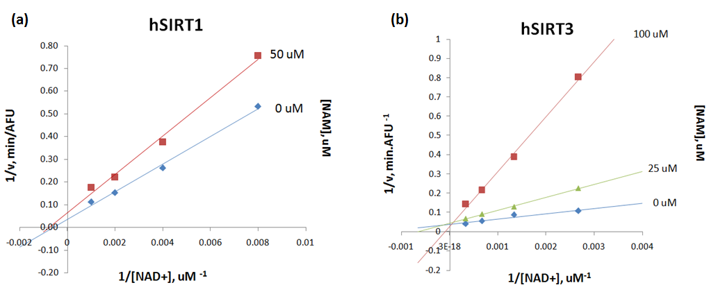

Figure 2. (A) Recombinant human SIRT1 was incubated with 50 uM of SIRT1 substrate for 0, 10, 20, 30, 60, 120, 180, and 240 min at 37oC in the presence of 125, 250, 500, 1000 uM NAD+ and 0, 50, 100, and 300 uMnicotinamide. (B) Recombinant human SIRT3 was incubated with 100 uM of acetylated substrate for 40 min at 37oC in the presence of 100, 375, 750, 1500, 3000 uM NAD+ and 0, 25, 100, and 200 uMnicotinamide. Reactions were terminated by the addition of developer and samples were analyzed by flourometry (excitation set at 355 nm and emission at 460 nm). Experiments were performed in triplicate. Data are shown as a Lineweaver-Burk double-reciprocal plot of arbitrary fluorescence units (AFU) min-1 versus 1/[NAD+] uM-1.

Human SIRT3 inhibition effect by nicotinamide in the presence of isonicotinamide.Isonicotinamide was reported as an activator of Sir2 activity (Sauve, Moir et al. 2005). shown to directly compete with nicotinamide for binding. Nicotinamide is a potent inhibitor of the Sir2 reaction because of its ability to rebind with the enzyme and react with a high-energy intermediate, preventing deacetylation and regenerating starting materials (Jackson, Schmidt et al. 2003; Sauve and Schramm 2003). The basis for the observed activation is the relief of the inherent nicotinamide inhibition by competition with isonicotinamide, which does not readily react with the enzyme intermediate. Does the aforementioned rule of isoNAM fit on hSIRT3? The hSIRT3 inhibition effect by NAM was studied in the presence of different concentration of isoNAM. Figure 3 shows that in the presence of isonicotinamide (50 uM and 500 uM), hSIRT3 inhibition of NAM was slightly decreased.

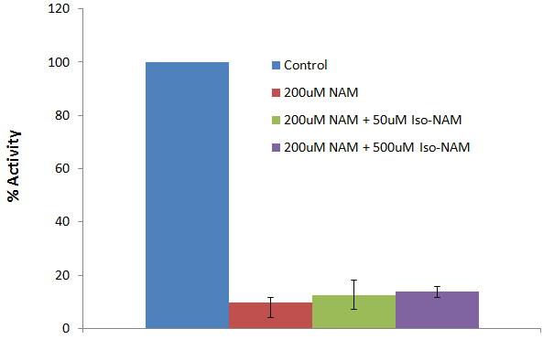

Figure 3. Recombinant human SIRT3 was incubated with 50, and 500 uM of isoNAM for 40 min at 37oC in the presence of 500 uM NAD+, 50 uM of Acetylated substrate, and 200 uMnicotinamide. Reactions were terminated by the addition of developer and samples were analyzed by flourometry (excitation set at 355 nm and emission at 460 nm). Experiments were performed in triplicate.

Although the IC50 for isonicotinamide was about three orders of magnitude worse than nicotinamide binding, in vivo yeast studies showed that millimolar levels of isonicotinamide increased Sir2- dependent silencing of the telomeric URA3 gene. These results suggest that the development of higher affinity nicotinamide antagonists may provide a means to upregulate cellular sirtuins. However, great care will be needed to avoid crossreactivity with other nicotinamide utilizing enzymes, in particular, those involved in NAD+ salvage and synthesis.

Measurement of IC50 values for SIRT3 inhibitors.Few groups have identified synthetic compounds that inhibit Sir2-like proteins using high-throughput phenotypic screens of small molecule libraries.(Bedalov, Gatbonton et al. 2001; Grozinger, Chao et al. 2001) None of these compounds, however, has been examined for its ability to inhibit hSIRT3 activity. To compare the efficacy of inhibition of these compounds to that of nicotinamide we measured recombinant hSIRT3 activity in the presence of 50 uM of each of these inhibitors. We also included nicotinic acid and the class I/II HDAC inhibitor TSA for comparison. In support of our in vivo results, nicotinic acid had no effect on the activity of hSIRT3 in vitro, whereas nicotinamide inhibited SIRT3 with an IC50: 36.7uM, a value that was equal to, or lower than, that of all the other inhibitors tested (Fig. 4).

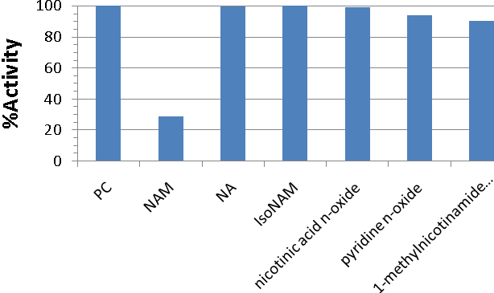

Figure 4. deacetylation reactions were performed in triplicate with 2.5 _g of SIRT1, 25 uM substrate peptide, 1 mM NAD+, and 50 uMnicotinamide, nicotinic acid, isonicotinamide, nicotinic acid n-oxide, pyridine n-oxide, 1-methyl nicotinamide chloride, and matched controls. Reactions were carried out at 37 °C for 90 min and fluorescence was measured (excitation set at 355 nm and emission at 460 nm).

General description of the enzyme-coupled assay.Sirtuins catalyze protein deacetylation using NAD+ as a co-substrateand generate the reaction products nicotinamide, deacetylatedprotein, and OAADPr. Here, we also applieda spectrophotometric assay that continuously measures nicotinamideformation. The rate of nicotinamide formation is measuredusing a coupled enzyme system with nicotinamidase and glutamatedehydrogenase. Nicotinamidase hydrolyzes nicotinamide tonicotinic acid and ammonia. Glutamate dehydrogenase then convertsammonia, -ketoglutarate, and NAD(P)H to glutamate andNAD(P)+. NAD(P)H oxidation/consumption is measured spectrophotometricallyat 340 nm.

Enzyme linearity.The utility of the coupled assay was initially tested by measuringNADPH consumption at 340 nm due to Sirt3-dependent nicotinamideformation at a variety of SIRT3 concentrations. Fig. 5Ashows the kinetic traces of the nicotinamidase/glutamate dehydrogenase

enzyme-coupled SIRT3 reactions. When the reaction wasinitiated by SIRT3 addition, robust steady-state initial velocitieswere measured; only low background rates were observed in theabsence of SIRT3. After initiation with SIRT3, a lag phase of approximatelyxxx min was observed and was likely due to the necessarybuildup of nicotinamide from the SIRT3 reaction before a linear responseis achieved from the coupled enzyme system. Short lagphases in the kinetic traces are common in enzyme-coupled reactions. The initial velocities were calculated from the linearportion of the curves.

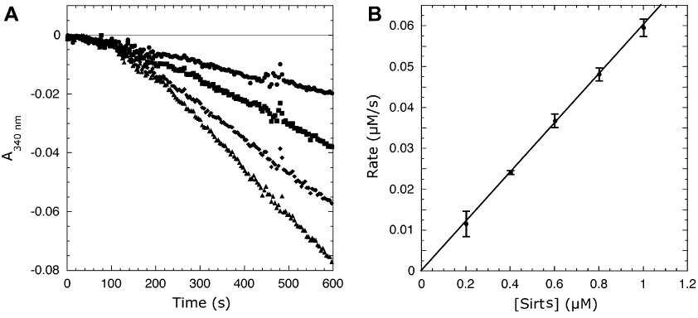

*Example of Fig. 5.* (A) Representative kinetic traces at increasing Sirt* concentrations. (B) Linear dependence of coupled assay on SIRT* concentration

To verify the accuracy of the coupled assay and that the observedrates are not limited by the coupled reaction, initial velocities weremeasured with increasing Sirt3 concentrations. Fig. 5B demonstratesa linear relationship between the NADPH consumption rateand Sirt3 concentration; that is, the observed rate depends only onSIRT3 activity, not nicotinamidase or glutamate dehydrogenase. Tofurther demonstrate that the coupled assay does not limit theobserved rate, concentrations of the coupled reaction components(i.e., a-ketoglutarate, nicotinamidase, and glutamate dehydrogenase)were decreased two- to fourfold and the reactions wererepeated. Decreasing a-ketoglutarate concentrations from xxx toxxxmM, glutamate dehydrogenase levels two-fold, or nicotinamidaseconcentrations from xxxto xxxuM did not significantly affect theobserved rates, indicatingthat the original conditions were sufficient and that the coupledreaction does not limit the observed initial rates.

Determination of SIRT3 saturation kinetics.Having demonstrated that SIRT3 activity could be measuredaccurately, therelevant steady-state rate constants were measured. First, we measured the abilityof a 12-mer acetyl-lysine peptide based on the N-terminal tail ofacetyl-CoA synthetase 2to saturate SIRT3-catalyzedreactions.

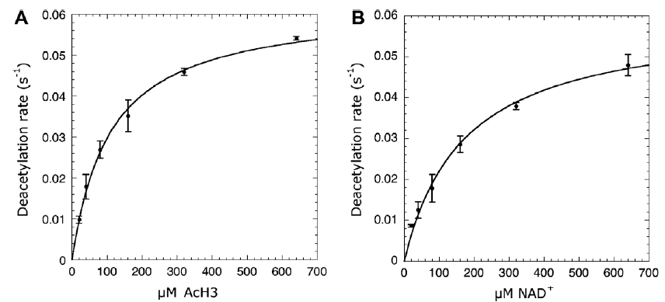

*Example of Fig. 6.*Steady-state kinetics of Sirt* varying substrate peptide (A) or NAD+ (B) concentrations.

The concentration of substrate peptide was varied at saturatingNAD+ concentrations, and the initial velocities were determinedby measuring the continuous consumption of NADPH at 340 nm.Background rates in the absence of substrate peptide were subtracted fromthe rates determined in the presence of substrate peptide. The data were fittedto the Michaelis–Menten equation to yield kcat and Km values ofxxx and xxx, compared with corresponding values that we obtained with the Fluorolabeled assay. We also measuredthe ability of NAD+ to saturate Sirt3activity. NAD+concentrations were varied, and the resulting initial velocitieswere fitted to the Michaelis–Menten equation (Fig. 6B), yieldingkcat and Km values of xxxand xxx, respectively. These measured steady-state kinetic parameters revealexcellent agreement between the coupled and Flurecsence assays.

Evaluation of sirtuin inhibitors.The coupled assay was evaluated further for use in the analysisof sirtuin inhibitors. Using substrate peptide and NAD+ concentrations belowtheir respective Km values, the potency of nicotinamide as a SIRT3inhibitor was determined. With the coupled assay using absorbancedetection, NAM inhibited Sirt3 with an IC50 value ofxxx (Fig. 7). This IC50 value is consistent withthe value of 36.7M determined by Fluorecent assay(Figure 1 right).

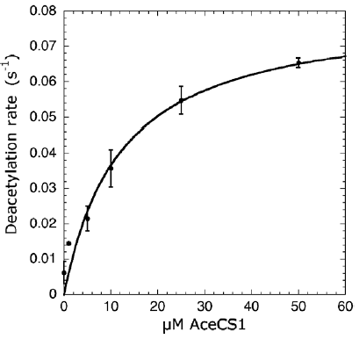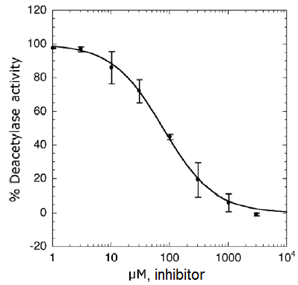

*Example of Fig. 7* (left) Steady-state kinetics of Sirt* varying concentrations of native AceCS1. (right)Inhibition of Sirt* by ADP-ribose determined by the coupled assay.

It is important to use proper controls to ensure that the couplingenzymes are not inhibited by the addition of the small-moleculeeffectors being evaluated. A simple control would be to add astandard concentration of nicotinamide to the assay mixture andto assess whether the compound yields a lower rate comparedwith the mock-treated sample (e.g., DMSO).

Simulation Result

MM-GBSA predicted binding affinities for Sir2 support the non-competitive nicotinamide inhibitor experimental results. In non-competitive inhibition mechanistic models, when the inhibitor, such as nicotinamide, occupies the C pocket preventing NAD+ from occupying the productive AC pocket binding mode, NAD+ can equally bind to the AB pockets and wait for the noncompetitive inhibitor to leave. Binding affinity estimates of NAD+ binding in the two different modes are about equal, supporting the non-competitive mechanistic model.

Both in-place and cross docking estimates predicted approximately equal binding affinity for the AC or AB pocket mode. Cross docking validated the method with Sir2 (Sir2Af2, PDB:1YC2), in which NAD+ was docked into the AC pocket starting with the x-ray structure with the NAD+ originally in the AB pocket, and vice versa. These results were compared with the in-place MM-GBSA binding affinity estimate, in which the co-crystallized structure is used in-place for scoring without any docking, ligand or protein movement. As hypothesized for noncompetitive inhibition, the MM-GBSA predicted in place ∆Gbinding is very similar for NAD+ in the AC pocket (-92.6) and the AB pocket (-95.2). Like the in place predicted binding, the cross-docked predicted ∆Gbinding are similar at -xxx (find these results) and -yyy. Note that the units are proportional to kcal/mol, but have not been normalized to experimental binding affinities for this system. [should I normalize?]

Cross docking into the AC pocket worked well with no constraints, as shown in illustration 1. The above reported Sir2 cross-docking poses were degenerate for NAD+ binding in the AB pocket. Illustration 2 shows the acceptable results within about 2 ?RMSD from the known crystal structure when using Glide XP with only one constraint: an exclusion volume in the C pocket necessary to prevent re-docking to the starting structure. Illustrations 3 and 4, the protein-ligand interaction diagrams, show the adenine diphosphate side of the NAD+ held firmly in place by 11 intermolecular hydrogen bonds between the ligand and the protein in the A pocket for Sir2 either in the AB or AC pockets. Figure 4 shows that the C pocket is not exposed to solvent, and the docked structure is not degenerate. Illustration 3 shows no hydrogen bonds in the B pocket with the outer half of the pocket exposed to solvent allowing the nicotinamide to move. The amide hydrogen of the nicotinamide end of NAD+ in the AB pocket of the Sir2Af2 (1YC2) cocrystallized structure makes a hydrogen bond to the phosphotidyl oxygen. This intermolecular H-bond is never seen in the docking possibly because the energy is truly degenerate in this case where most of the nicotinamide is exposed to solvent., or a systematic bias against ligand intermolecular H-bonds. In addition, the nicotinamide in the B pocket must move to the C pocket, and this degenerate flexibility in solvent could facilitate this motion.

***Above Figure:*** *the two top ranked Glide XP docked results of NAD+ docked to the SIRT3 AC pocket (orange), with the co-crystallized comparison structure from 2H4F (Sir2Tm) in green. The NAD+ in the AC pocket conformation is shown in red. GlideScores ranged from -15.0 to -17.5.*

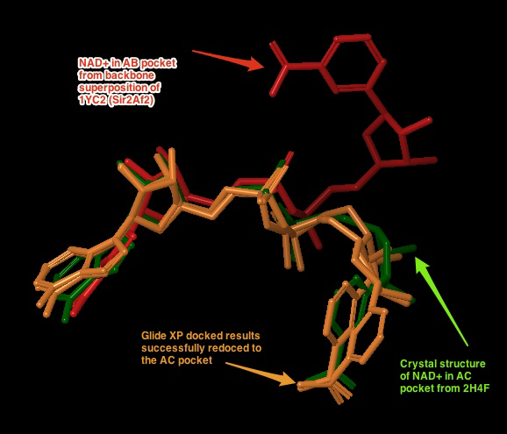

Illustration

***Above Figure:*** *Cross docking of NAD+ into the AB pocket of the crystal structure of 1YC2 with NAD+ originally in the AC pocket. The red pose is from the AB pocket co-crystallized structure. The blue are the degenerate top ranked and only output from Glide XP with an excluded volume in the C pocket and a completely flexible ligand. The RMSD of the closest structure is 1.98 Å, and the GlideScores for all 5 degenerate structures ranged from -9.9 to -12.2.*

Illustration

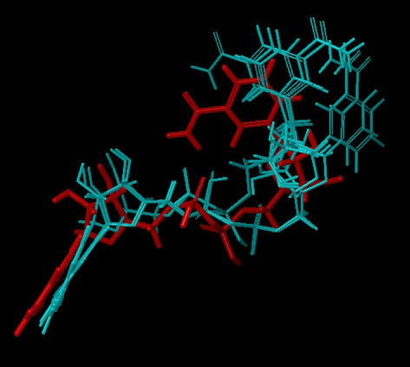

***Sir2Af2 (1YC2 chain A) NAD+ in AB pocket******Above figure:****Intermolecular protein-ligand diagram of Sir2Af2 (1YC2 chain A) with NAD+ in the AB pocket. In this flattened 2D reppresentation of the protein-ligand interactions, residues are represented as colored spheres, where: red=acidic, green=hydrophobic, blue=polar, light gray=(Gly,water), dark gray=metal atoms. Solid pink lines are H-bonds to the protein backbone; dotted pink are H-bonds to the side chains; green are pi-pi stacking interactions; orange are pi-cation interactions. Protein and water residues within 3.0 Å of the NAD+ are shown. The lack of a protein "pocket" line around the nicotinamide end and the grey spheres around those atoms indicate that the nicotinamide end is exposed to solvent. The B pocket (show as a yellow circle) is a crevice open to solvent, while the C-pocket (lower yellow circle) is protected by a loop from the solvent (shown in the next diagram). The C-pocket is empty or collapsed in this structure. Also note that there are no H-bonds or other specific intermolecular interactions between the protein and the nicotinamide end of NAD+. Images produced in Maestro.*

Illustration

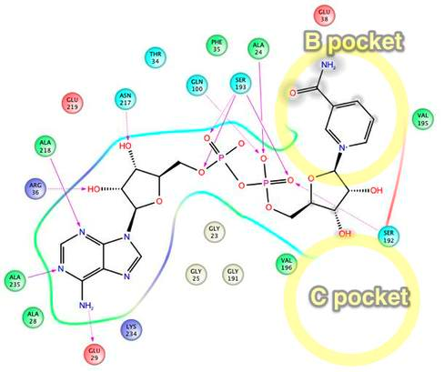

***Sir2Af2 (1YC2 chain B) NAD+ in AC pocket******Above figure:****Intermolecular protein-ligand diagram of Sir2Af2 (1YC2 chain B) with NAD+ in the AC pocket. Protein and water residues within 3.0 Å of the NAD+ are shown. Unlike in the AB pocket, the NAD+ molecule is completely surrounded by protein residues in the entire A and C pockets. The nicotinamide is not exposed to solvent, unlike in the B pocket. The approximate location of the B pocket is shown due to distortions created by transforming the 3D protein-ligand picture into a simple 2D diagram. There is a backbone H-bond between the protein ILE102 and the nicotinamide end of NAD+.*

Illustration

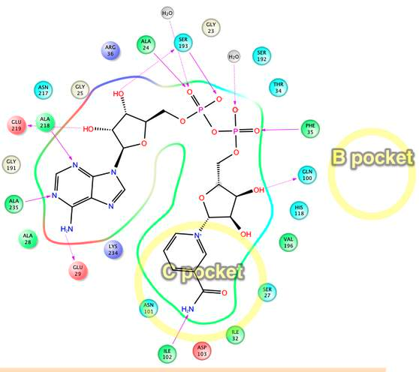

Induced Fit

While traditional and Induced Fit docking succeeded in placing NAD+ into the AC pockets of SIRT3 without the use of constraints or reduced vdW radius, all docking attempts, with or without Induced Fit, failed to dock NAD+ into the AB pocket when starting with the best available crystal structure for SIRT3 (3GLT). The top ranked docked poses for the AC productive pocket had RMSD of 2.1 and 2.0 [verify these numbers!] with respect to the backbone aligned co-crystallized structure of 1YC2 with NAD+ in the AC pockets. We conjecture that AB pocket docking did not work for SIRT3 because the side chains and backbone movements could not sufficiently open up the B pocket for the nicotinamide end of NAD+, as shown in illustration 5.

***Above figure:*** *Steric clashes between NAD+ in the AB conformation and SIRT3 (from the thio-acetyl ADPR intermediate).  This is a top view of the NAD+, where the B pocket is oriented on top of the C pocket within the axis perpendicular to the figure. The steric clashes are labeled in aqua, and the B pocket is labeled with the yellow oval.  Comparable Sir2Af2 residues within 6 ?of the nicotinamide in the B pocket are in red.  The Sir2Af2 structure is from the NAD+ co-crystallized PDB file 1YC2 chain A with NAD+ in the AB pockets.  This structure is aligned to the SIRT3 protein backbone from 3GLT.  3GLT has the thio-acetyl ADPR intermediate, which has the nicotinamide cleaved off.  The depicted NAD+ cofactor is from the Sir2Af2 co-crystallized structure. Note that Sir2 does not obstruct the B pocket.  For example, the ARG 36 in Sir2Af2 is moved back and its side chain rotated out of the way in comparison to SIRT3 ARG 158.  While SIRT3 has GLU 323 which obstructs the nicotinamide, Sir2Af2 has a Val 195 pushed farther back leaving room for the nicotinamide.  There are no steric clashes with peptide substrate residues, like there is with the SIRT3 MET.*

Illustration

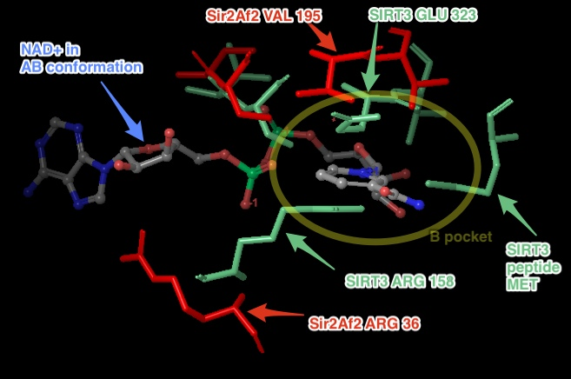

On the experimental side related to the unsuccessful docking attempts, crystallographers failed multiple different protocols to co-crystallize NAD+ into either the SIRT3 productive or unproductive binding pocket, with or without the acetyl-lysine substrate[10]. While NAD+ has been observed to bind in the productive (AC) binding site for Sir2Af2 and Sir2Af1 and in the non-productive (AB) binding site for Sir2Af2, Sir2Af1 in the absence of the peptide substrate [5], [6], NAD+ cannot bind to SIRT3 efficiently in the absence of this peptide [10]. In addition, the experimental assays presented here show that SIRT3 inhibition by nicotinamide, which binds in the C pocket blocking the productive conformation of NAD+, is competitive, as compared to noncompetitive for Sir2. These results suggest that in SIRT3, unlike in Sir2, NAD+ either cannot adopt the comparable AB pocket non-productive conformation or this conformation is much higher in energy than the productive AC binding mode. We hypothesized that the MM-GBSA predicted binding affinity of NAD+ docked into the AB pocket would be significantly higher in energy than NAD+ docked into the AC pocket. As with the experimental crystallography, we were unable to dock NAD+ into the non-productive AB pocket.

Multiple docking methods were attempted, including variations of Glide and Induced fit. Various protocols included: using multiple excluded volumes in the C pocket and surrounding (but not in) the B pocket to direct the nicotinamide end to the B pocket; rigidly docking an ensemble of low energy poses close to the AB pocket conformation seen in Sir2 with traditional docking and a softcore potential of 0.5, and Induced Fit with the above mentioned amino acids mutated to Ala to make room in the B pocket; creating torsional constraints to impose an AB-like conformation on the flexible ligand; increasing the number of output poses above 1000 and accepting higher energy levels to look for higher energy poses; energy minimizing of the SIRT3 protein with NAD+ frozen in the AB conformation from Sir2Af2 aligned to SIRT3 to push the side chains and backbone out of the way, then subsequently using Induced Fit.

Failure to dock into the AB pocket supports, but not strongly, that this non-productive binding is much higher in energy or prohibited. Future simulations to obtain more reliable estimates of binding affinity differences between the AB and AC pockets could involve more sophisticated molecular dynamics techniques. Accurate computational affinity predictions using more sophisticated simulations beyond docking are known to be challenging.[9]. MM-GBSA method provides a fast and simpler first estimation to more accurately rank order the raw protein-ligand docking results.[10], [11], but the underlying docking protocol did not work for SIRT3 AB pocket docking. More computationally intensive molecular dynamics based simulations such as linear interaction energy (LIE), thermodynamic integration (TI) or free energy perturbation (FEP) have been shown to be more accurate[9] and include more degrees of freedom to dock to the AB pocket.

***Above Figure:****The best docking starting structure for SIRT3 is 3GLT, which has the thio-intermediate of the acetyl-lysine peptide. The nicotinamide has been cleaved and a bond to the thioacetyl is trapped. SIRT3, 3GLT with the trapped thio-acetyl lysine ADPR intermediate.  The B and C pockets are unoccupied because of the intermediate . H-bonds between the ADPR and the protein residues within 3 ?of the ligand are shown here.*

Illustration

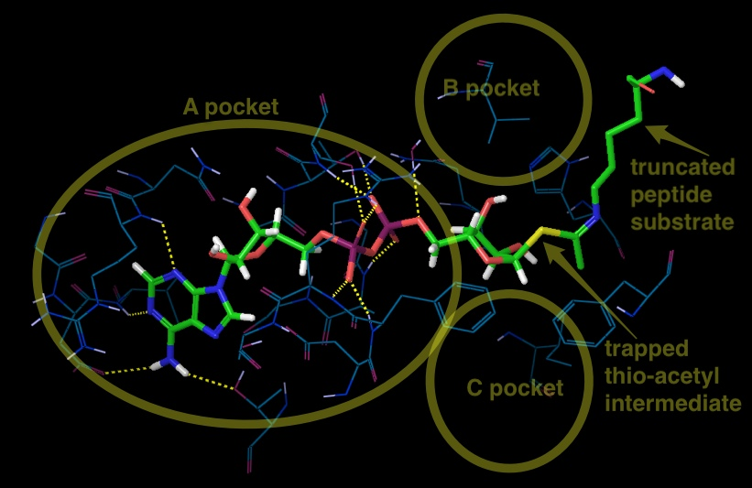

**DISCUSSION**

SIRT3 is a member of the sirtuin family of protein deacetylases that is preferentially localized to mitochondria. Prominent among the proteins targeted by SIRT3 are enzymes involved in energy metabolism processes, including the respiratory chain, tricarboxylic acid cycle, fatty acid β-oxidation and ketogenesis (Giralt et al, 2012). Through these actions, SIRT3 controls the flow of mitochondrial oxidative pathways and, consequently, the rate of production of reactive oxygen species (ROS). The involvement of SIRT3 in processes closely associated with human pathologies, from the metabolic syndrome to cancer, as well as in many other aging-related diseases (cardiac dysfunction and neural degeneration), raises the enormous interests in SIRT3 function and regulation in the context of biomedical research. As with other sirtuins, SIRT3 holds great promise as a ‘druggable protein’, i.e. a protein target capable of binding drug-like molecules. In this scenario, SIRT3 and its subsequent biological effects may be modulated by small molecules or nutrient pharmaceuticals (nutriceuticals) that influence the deacetylase activity of SIRT3.

Whether SIRT3 serves as a tumor promoter or suppressor has been wildly discussed. On one hand, increased levels of SIRT3 associated with node-positive breast cancer versus non-malignant breast tissue (Ashraf et al, 2006) as well as with oral squamlors cell carcinoma, suggesting that SIRT3 could function as a tumor promoter. On the other hand, SIRT3 expression is decreased in many different types of human cancers, and heterozygous loss of SIRT3 occurs in 40% of human breast malignancies(Bell et al, 2011; Chen et al, 2005; Qiu et al, 2010; Fineley et al, 2011; Haigis et al, 2012). Much work will be needed to pinpoint the precise molecular mechanisms governing SIRT3 functions in cancer. But one thing is sure: these proteins clearly link DNA repair and metabolism, two hallmarks of cancer. As such, it is tempting to envision that modulators of SIRT3 activity could provide future beneficial alternatives against this devastating disease.

Other than cancer, SIRT3 plays a role in the emerging cardiac pathologies associated with diabetes, obesity, and cardiac ischemia (Lu et al, 2009; Schwartz et al, 2008; Neubauer 2007; Pound et al, 2009; Nakagawa et al, 2005; Sundaresan et al, 2008). Direct investigations have shown that SIRT3 plays an important ameliorative role in preventing pathology form pressure overload and aging-associated decline in cardiac function. Whether the direct pharmacological modulation of SIRT3 may confer greater benefit compared with the disappointing results to date of other antioxidant approaches in cardiac disease is an intriguing concept, although direct pharmacological activators of SIRT3 have not been developed at current time.

The inhibition of enzyme activity is one of the major regulatory devices of living cells, and one of the most important diagnostic procedures of the enzymologist. Inhibition studies often tell us something about the specificity of an enzyme, the physical and chemical architecture of the active site, and the kinetic mechanism of the reaction. In our everyday life enzyme inhibitors can be found masquerading as drugs, antibiotics, preservatives, poisons, and toxins.

Most drugs that function through enzyme inhibition interact with their target enzyme through simple, reversible binding mechanisms. Three potential modes of inhibitor interactions with enzymes are defined as (see Figure below): (A) competitive inhibitors that bind exclusively to the free enzyme form; (B) noncompetitive inhibitors that bind with some affinity to both the free enzyme and to the enzyme-substrate complex (ES complex); (C) uncompetitive inhibitors that bind exclusively to the ES complex or subsequent species.

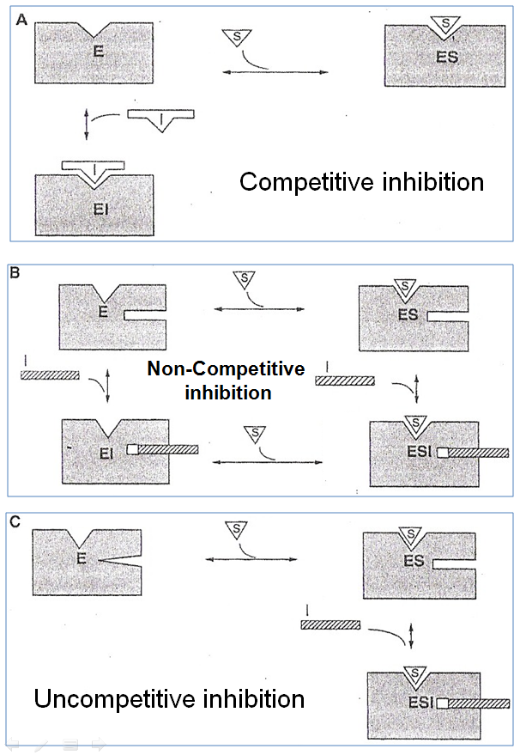

An inhibitor that binds exclusively to the free enzyme is said to be **competitive** because the binding of the inhibitor and the substrate to the enzyme are mutually exclusive; hence these inhibitors compete with the substrate for the pool of free enzyme molecules.Because competitive inhibitors bind to the free enzyme to the exclusion of substrate binding, it is easy to assume that this results from a direct competition of the two ligands (substrate and inhibitor) for a common binding pocket (i.e., the active site) on the enzyme molecule. In the presence of competitive inhibitor, the Vmax remains unchanged but the apparent Km for the substrate increased. *There are a very large number of drugs in clinical use today that function as competitive enzyme inhibitors.*

A **noncompetitive** inhibitor is one that displays binding affinity for both the free enzyme and the enzyme-substrate complex or subsequent species. In the presence of noncompetitive inhibitor, the Vmax, decreases but has no effect on the Km value. The degree of inhibition in the presence of a non-competitive inhibitor depends only upon [I] and Ki. The inhibited velocity (vi) is always a constant fraction of v0, regardless of the substrate concentration or the value of Km. An increase in [S] causes both v0 and vi to increase by the same factor. A diagnostic signature of noncompetitive inhibition is that the double reciprocal plot displays a nest of lines that intersect at a point other than the y-axis. *Relative to competitive inhibitors, there are fewer examples of noncompetitive inhibitors in clinical use as drugs today. This reflects the historic approaches to drug discovery that have been largely focused on active-site directed inhibitors. With a greater emphasis on compound library screening as a mechanism of lead identification, more examples of noncompetitive inhibitors are likely to emerge, especially if attention is paid to designing screening assays that balance the opportunities for identifying the greatest diversity of inhibitor modalities*.

An inhibitor that binds exclusively to the ES complex, or a subsequent species, with little or no affinity for the free enzyme is referred to as **uncompetitive**. Inhibitors of this modality require the prior formation of the ES complex for binding and inhibition. Anuncompetitive inhibitor decreases Vmax and Km value to the same extent. The degree of inhibition depends on the substrate concentration, but, unlike competitive inhibition, the degree of inhibition increases as [S] increase. As with noncompetitive inhibitors, uncompetitive inhibition cannot be overcome by high substrate concentrations; in fact the affinity of uncompetitive inhibitors is greatest at saturating concentrations of substrate. Depending on the physiological conditions experienced by the target enzyme, this inability of high-substrate concentrations to overcome noncompetitive and uncompetitive inhibitors may offer some clinical advantage to these inhibition modalities.

Human SIRT3 crystal structure has been solved in 2009, promoting us to use computer-based design methods to identify novel inhibitors or to establish structure-activity relationships for known inhibitors. Ligand docking methods have provided insights into the binding mode of Sir2 inhibitors.

Nicotinamide is the physiological sirtuin inhibitor. The IC50 values of nicotinamide inhibition of bacterial, yeast, mouse, human SIRT1, SIRT2 and SIRT3 were 26, 120, 160, 50, 100, 36.7*uM, respectively (Sauve et al, 2003; Schmidt et al, 2004; Tervo et al, 2004; *current work 2012). Nuclear nicotinamide levels has been estimated to be 10-150 uM (Sauve et al, 2005), which most likely make NAM as Sirtuin activity regulator *in vivo*. Early studies reported nicotinamide bind an allosteric site (Bitterman et al, 2002), however more recent work (Jackson et al, 2003; Sauve et al, 2006) observed that NAM inhibition depends on its ability to condense with the high-energy enzyme: ADP ribose:acetyl-lysine intermediate to reverse the reaction, reforming NAD+. And NAM non-competitively inhibits deacetylation reaction of sirtuins with a single binding pocket C (Avalos et al, 2005), the same site which binds the nicotinamide of NAD+. The structural evidences indicates that tight binding at the C pocket and the subsequent attack of NAM on the O-alkylamidate intermediate to regenerate NAD and acetylated peptide are involved into NAM inhibition of sirtuin deacetylation. If a small molecule could compete with free NAM binding without reacting appreciably with the enzyme intermediate, it would be predicted to have a stimulatory effect on the overall deacetylation rate in the presence of nicotinamide. Taking into account of the above criteria, isoNAM, the NAM analog, was found as a Sir2 activator (Sauve et al, 2005). Because of the requirement of high millimolar concentrations of isoNAM (up to 100mM) for a detectable effect (Sauve et al, 2005; *current work), it is necessary to improve this strategy to provide better affinity and specificity.

A mechanistically understood SIRT3 activator, in contrast, is isonicotinamide. Nicotinamide is the first product of the Sir2 catalyzed reaction, released from NAD+ during formation of the alkylimidate intermediate. Rebinding of nicotinamide to the Sir2/intermediate complex can promote the reverse reaction to reform the substrates, and thus inhibits the deacetylation reaction((Sauve 2010). Sir2 thus appear to be affected by physiological nicotinamide concentrations, assumed to be up to 0.1mM, and a role of nicotinamide as endogenous Sir2 regulators supported by in vivo studies in yeast, flies, and mammalian cells ((Anderson, Bitterman et al. 2003; Sauve 2010). Isonicotinamide can compete with nicotinamide for binding but cannot initiate the reverse reaction, thereby leading to apparent activation through relief of nicotinamide inhibition ((Sauve, Moir et al. 2005; Cen, Youn et al. 2011). Assuming that all Sirtuins are equally inhibited by nicotinamide, isonicotinamide would be a general Sirtuin 揳ctivator.?However, data from Steegborn’s lab suggest that some Sirtuins show nicotinamide insensitive eacetylase activity (unpublished), indicating that nicotinamide and isonicotinamide employ isoform discriminating binding sites or modulation mechanisms. Structural and further biochemical studies on these compounds and mechanisms might enable the development of isoform selective modulators.

## Eric part-----

In summary, SIRT3 is the major sirtuin deacetylase in mitochondria, where bioenergetics, oxidative stress, and apoptosis are controlled. In order to have better understanding of the basic cell biology processes as well as a pharmacological and/or nutritional target for intervention, the extensive efforts for development of SIRT3 modulators are needed.

Experimental results reported here indicate that NAM, a noncompetitive inhibitor of Sir2 and SIRT1, competitively inhibits hSIRT3 by competing the binding site at C pocket with NAD+, which reveals a different strategy for SIRT3 inhibitor design. Molecular docking is performed in current study. X-ray crystal structures of Sir2Af2 and human SIRT3 are employed as the starting point for docking analysis. In addition, incorporation of protein flexibility and backbone conformation change upon ligand association are taking into consideration. Simulation data show that ………………………………………… Computer-assisted drug design coupled with experimental confirmation has become an attractive alternative to the tradition *in vitro* and *in vivo* screenings. Taken together, we anticipate that the structural elucidation of the NAM inhibitory for hSIRT3 enzymes reported here will provide the direction for designing a new generation of SIRT3 modulator.

**RFERENCES**

Frye, R. A. Characterization of five human cDNAs with homology to the yeast SIR2 gene: Sir2-like proteins (sirtuins) metabolize NAD and may have protein ADP-ribosyltransferase activity. *Biochem. Biophys. Res. Commun.* **1999**, *260*, 273-279.

Frye, R. A. Phylogenetic classification of prokaryotic and eukaryotic Sir2-like proteins.*Biochem. Biophys. Res. Commun.* **2000**, *273*, 793-798.

Lanza, I.R.; Short, D.K.; Short, K.R.; Raghavakaimal, S.; Basu, R.; Joyner, M.J.; McConnell, J.P.; Nair, K.S. Endurance exercise as a countermeasure for aging. *Diabetes*, **2008**, *57* (11), 2933-2942.

Li, S.; Banck, M.; Mujtaba, S.; Zhou, M.M.; Sugrue, M.M.; Walsh, M.J. p53-induced growth arrest is regulated by the mitochondrial SirT3 deacetylase. *PLoS. One*, **2010**, *5* (5), e10486.

Cen, Y. Sirtuins inhibitors: the approach to affinity and selectivity. *Biochim.Biophys. Acta*, **2010**, *1804* (8), 1635-1644.

Lara, E.; Mai, A.; Calvanese, V.; Altucci, L.; Lopez-Nieva, P.; Martinez-Chantar, M.L.; Varela-Rey, M.; Rotili, D.; Nebbioso, A.; Ropero, S.; Montoya, G.; Oyarzabal, J.; Velasco, S.; Serrano, M.; Witt, M.; Villar-Garea, A.; Imhof, A.; Mato, J.M.; Esteller, M.; Fraga, M.F. Salermide, a Sirtuin inhibitor with a strong cancer-specific proapoptotic effect. *Oncogene,* **2009**, *28* (6), 781-791.

Lin SJ, Ford E, Haigis M, et al. Calorie restriction extends yeast life span by lowering the level of NADH. *Genes Dev***2004**, 18: 12-6.

Avalos JL, Bever KM, Wolberger C. Structural basis for the mechanism and regulation of Sir2 enzymes. *Mol Cell***2004**, 13: 639-648.

Sauve AA, Moir RD, Schramm VL, Willis IM. Chemical activation of Sir2-dependent silencing by felief of nicotinamide inhibition.*Mol Cell***2005**, 17:595-601.

Adams JD Jr, Klaidman LK, Sirtuins, nicotinamide and aging: a critical review. *Lett Drug Design Discov***2007**, 4: 44-48.

Qin W, Yang T, Ho L et al .Neuronal SIRT1 activation as a novel mechanism underlying the prevention of Alzheimer disease amyloid neuropathology by calorie restriction.*J BiolChem***2006**, 281: 21745-21754.

Ashraf, N., Zino, S., Macintyre, A., Kingsmore, D., Payne, A. P., George, W.D. and Shiels, P.G. (2006) Altered sirtuin expression is associated with node-positive breast cancer. Br. J. Cancer 95, 1056-1061.

Bell, E.L.,Emerling,B.M.,Ricoult,S. J.H.,andGuarente,L.(2011).SirT3 suppresses hypoxia inducible factor 1α and tumor growth by inhibiting mitochondrial ROS production. *Oncogene* 30, 2986–2996.

Chen, W.Y.,Wang,D.H.,Yen,R. C., Luo,J.,Gu,W.,andBaylin,S. B.(2005).TumorsuppressorHIC1 directlyregulatesSIRT1tomod- ulatep53-dependentDNA-damage responses. *Cell* 123, 437–448.

Finley,L.W.S.,Carracedo,A.,Lee, J.,Souza,A.,Egia,A.,Zhang,J., Teruya-Feldstein,J.,Moreira,P.I., Cardoso,S.M.,Clish,C.B.,Pan- dolfi, P.P.,andHaigis,M.C. (2011). SIRT3opposesreprogram- ming ofcancercellmetabolism throughHIF1α destabilization. *Can-cer Cell* 19, 416–428.

Giralt A and Villarroya F. SIRT3, a pivotal actor in mitochondrial functions: metabolism, cell death and aging. Biochem J (2012) 444, 1-10.

Haigis MC, Deng CX, Finley LWS et al. SIRT3 is a mitochondrial tumor suppressor: a scientific tale that connects Aberrant cellular ROS, the Warburg effect, and carcinogenesis. Cancer Research (2012) 72: 2468-2472.

Kim,H.-S.,Patel,K.,Muldoon-Jacobs, K., Bisht,K.S.,Aykin-Burns,N., Pennington,J.D.,vanderMeer, R., Nguyen,P.,Savage,J.,Owens, K. M.,Vassilopoulos,A.,Ozden,O., Park,S.-H.,Singh,K.K.,Abdulka- dir,S.A.,Spitz,D.R.,Deng,C.- X., and Gius,D.(2010).SIRT3isa mitochondria-localizedtumorsup- pressorrequiredformaintenanceof mitochondrialintegrityandmetab- olism duringstress. *Cancer Cell* 17, 41–52.

Lu Z, Bourdi M, Li JH, Aponte AM, Chen Y, Lombard DB, Gucek M, Pohl LR, and Sack MN. (2011) SIRT3-dependent deacetylation exacerbates acetaminophen hepatotoxicity. EMBO Rep 12:840 - 846.

Lu Z, Scott I, Webster BR, Sack MN. The emerging characterization of lysine residue deacetylation on the modulation of mitochondrial function and cardiovascular biology. *Circ Res* 105: 830–841, 2009.

Neubauer S. The failing heart—an engine out of fuel. *N Engl J Med* 356: 1140–1151, 2007.

Nakagawa T, Shimizu S, Watanabe T, Yamaguchi O, Otsu K,Yamagata H, Inohara H, Kubo T, Tsujimoto Y. Cyclophilin D-dependent mitochondrial permeability transition regulates some necrotic but not apoptotic cell death. *Nature* 434: 652–658, 2005.

*Guan X; Knoll E; Chakrabarti R. (2012) Mechanism of human SIRT3 inhibition by Nicotinamide. Unpublished work.

Avalos JL, Bever KM, Wolberger C: Mechanism of sirtuin inhibition by nicotinamide: altering the NAD(+) cosubstrate specificity of a Sir2 enzyme. Mol Cell 2005, 17:855-868.

Sauve AA; Schramm VL. (2003) Sir2 regulation by nicotinamide results from switching between base exchange and deacetylation chemistry. Biochemistry 42: 9249-9256.

M.T. Schmidt, B.C. Smith, M.D. Jackson, J.M. Denu, Coenzyme specificity of Sir2 protein deacetylases, J. Biol. Chem. 279 (38) (2004) 40122–40129.

A.J. Tervo, S. Kyrylenko, P. Niskanen, A. Salminen, J. Leppanen, T.H. Nyronen, T. Jarvinen, A. Poso, An in silico approach to discovering novel inhibitors of human sirtuin type 2, J. Med. Chem. 47 (25) (2004) 6292–6298.

Jackson MD, Schmidt MT, Oppenheimer NJ, Denu JM: Mechanism of nicotinamide inhibition and transglycosidation by Sir2 histone/protein deacetylases. J Biol Chem 2003, 278:50985-50998.

Sundaresan NR, Samant SA, Pillai VB, Rajamohan SB, Gupta MP.SIRT3 is a stress-responsive deacetylase in cardiomyocytes that protects cells from stress-mediated cell death by deacetylation of Ku70. *Mol Cell Biol* 28: 6384–6401, 2008.

Pound KM, Sorokina N, Ballal K, Berkich DA, Fasano M, Lanoue KF, Taegtmeyer H, O’Donnell JM, Lewandowski ED. Substrate-enzyme competition attenuates upregulated anaplerotic flux through malic enzyme in hypertrophied rat heart and restores triacylglyceride content: attenuating upregulated anaplerosis in hypertrophy. *Circ Res* 104: 805–812, 2009.

Qiu, X.,Brown,K.,Hirschey,M.D., Verdin,E.,andChen,D.(2010). Calorierestrictionreducesoxida- tivestressbySIRT3-mediatedSOD2 activation. *CellMetab.* 12, 662–667.

Schwer B, Eckersdorff M, Li Y, Silva JC, Fermin D, Kurtev MV, Giallourakis C, Comb MJ, Alt FW, and Lombard DB(2009) Calorie Restriction Alters Mitochondrial Protein Acetylation. Aging cell 5:604-606.

Schwartz DR, Sack MN. Targeting the mitochondria to augment myocardial protection. *Curr Opin Pharmacol* 8: 160–165, 2008.

Tao,R.,Coleman,M.C.,Pennington, J.D.,Ozden,O.,Park,S.-H.,Jiang, H., Kim,H.-S.,Flynn,C.R.,Hill, S., HayesMcDonald,W.,Olivier,A. K., Spitz,D.R.,andGius,D.(2010). Sirt3-ediated deacetylation of evolutionarily conserved lysine122 regulates MnSOD activity in response to stress. *Mol.Cell* 40, 893–904.)

[1] G. Rastelli, A. D. Rio, G. Degliesposti, and M. Sgobba, “Fast and accurate predictions of binding free energies using MM-PBSA and MM-GBSA,” *Journal of Computational Chemistry*, vol. 31, no. 4, pp. 797–810, 2010.

[2] D. S. Goodsell, G. M. Morris, and A. J. Olson, “Automated docking of flexible ligands: applications of AutoDock,” *J. Mol. Recognit.*, vol. 9, no. 1, pp. 1–5, Feb. 1996.

[3] D. T. Moustakas, P. T. Lang, S. Pegg, E. Pettersen, I. D. Kuntz, N. Brooijmans, and R. C. Rizzo, “Development and validation of a modular, extensible docking program: DOCK 5,” *J. Comput. Aided Mol. Des.*, vol. 20, no. 10–11, pp. 601–619, Nov. 2006.

[4] R. Kim and J. Skolnick, “Assessment of programs for ligand binding affinity prediction,” *Journal of Computational Chemistry*, vol. 29, no. 8, pp. 1316–1331, 2008.

[5] S. Henrich, I. Feierberg, T. Wang, N. Blomberg, and R. C. Wade, “Comparative binding energy analysis for binding affinity and target selectivity prediction,” *Proteins: Structure, Function, and Bioinformatics*, vol. 78, no. 1, pp. 135–153, 2010.

[6] J. L. Avalos, K. M. Bever, and C. Wolberger, “Mechanism of Sirtuin Inhibition by Nicotinamide: Altering the NAD+ Cosubstrate Specificity of a Sir2 Enzyme,” *Molecular Cell*, vol. 17, pp. 855–868, Mar. 2005.

[7] *Prime, version 3.1, Schrödinger, LLC, New York, NY, 2012.* Schrödinger, LLC.

[8] J. Shelley, A. Cholleti, L. Frye, J. Greenwood, M. Timlin, and M. Uchimaya, “Epik: a software program for pKa prediction and protonation state generation for drug-like molecules,” *Journal of Computer-Aided Molecular Design*, vol. 21, no. 12, pp. 681–691, 2007.

[9] W. Sherman, T. Day, M. P. Jacobson, R. A. Friesner, and R. Farid, “Novel Procedure for Modeling Ligand/Receptor Induced Fit Effects,” *Journal of Medicinal Chemistry*, vol. 49, no. 2, pp. 534–553, 2006.

[10] L. Jin, W. Wei, Y. Jiang, H. Peng, J. Cai, C. Mao, H. Dai, W. Choy, J. E. Bemis, M. R. Jirousek, J. C. Milne, C. H. Westphal, and R. B. Perni, “Crystal Structures of Human SIRT3 Displaying Substrate-induced Conformational Changes,” *Journal of Biological Chemistry*, vol. 284, pp. 24394–24405, Jun. 2009.

[11] J.-H. Chang, “Structural Basis for the NAD-dependent Deacetylase Mechanism of Sir2,” *Journal of Biological Chemistry*, vol. 277, pp. 34489–34498, Jun. 2002.

[12] J. Michel and J. Essex, “Prediction of protein–ligand binding affinity by free energy simulations: assumptions, pitfalls and expectations,” *Journal of Computer-Aided Molecular Design*, vol. 24, no. 8, pp. 639–658, 2010.

[13] P. D. Lyne, M. L. Lamb, and J. C. Saeh, “Accurate Prediction of the Relative Potencies of Members of a Series of Kinase Inhibitors Using Molecular Docking and MM-GBSA Scoring,” *J. Med. Chem.*, vol. 49, no. 16, pp. 4805–4808, 2006.

[14] J. M. Hayes, V. T. Skamnaki, G. Archontis, C. Lamprakis, J. Sarrou, N. Bischler, A.-L. Skaltsounis, S. E. Zographos, and N. G. Oikonomakos, “Kinetics, in silico docking, molecular dynamics, and MM-GBSA binding studies on prototype indirubins, KT5720, and staurosporine as phosphorylase kinase ATP-binding site inhibitors: The role of water molecules examined,” *Proteins: Structure, Function, and Bioinformatics*, vol. 79, no. 3, pp. 703–719, 2011.