1. More Docking results (more inhibitors, receptors, induced fit)

|  |  |  |  |
| --- | --- | --- | --- |
| Ligand | Receptor | MM-GBSA scores | Glide Score (XP) |
| DHP-1c | SIRT3:ac-Peptide(from 4FVT) | -79.054743 | -5.288631 |
| DHP-1d | SIRT3:ac-Peptide(from 4FVT) | -67.262835 | -4.613234 |
| DHP-1b | SIRT3:ac-Peptide(from 4FVT) | -76.015906 | -2.117807 |
| DHP-1a | SIRT3:ac-Peptide(from 4FVT) | -76.104804 | -1.390832 |
|  |  |  |  |
| DHP-1c | SIRT3(from 4BVH) | -49.761182 | -8.060841 |
| DHP-1b | SIRT3(from 4BVH) | -57.11277 | -7.756798 |
| DHP-1d | SIRT3(from 4BVH) | -52.199778 | -6.983156 |
| DHP-1a | SIRT3(from 4BVH) | -44.563101 | -6.276144 |
|  |  |  |  |
| DHP-1b | SIRT3(from 4BN5) | -73.321258 | -9.291359 |
| DHP-1c | SIRT3(from 4BN5) | -69.275284 | -8.134838 |
| DHP-1a | SIRT3(from 4BN5) | -68.652436 | -7.854865 |
| DHP-1d | SIRT3(from 4BN5) | -82.207429 | -7.826902 |
|  |  |  |  |
| DHP-1a | SIRT3(from 4JSR) | -76.373909 | -8.369315 |
| DHP-1d | SIRT3(from 4JSR) | -64.798252 | -7.631151 |
| DHP-1c | SIRT3(from 4JSR) | -70.454133 | -7.45589 |
| DHP-1b | SIRT3(from 4JSR) | -80.388479 | -6.967164 |
|  |  |  |  |
| DHP-1c | SIRT3(from 4FVT) | -88.97926 | -7.451651 |
| DHP-1b | SIRT3(from 4FVT) | -77.625507 | -7.38527 |
| DHP-1a | SIRT3(from 4FVT) | -80.881088 | -6.741127 |
| DHP-1d | SIRT3(from 4FVT) | -59.410078 | -5.907016 |
|  |  |  |  |
| DHP-1d | SIRT3(from 4FVT) Induced Fit |  | -10.712468 |
| DHP-1b | SIRT3(from 4FVT) Induced Fit |  | -10.342806 |
| DHP-1c | SIRT3(from 4FVT) Induced Fit |  | -9.890372 |
| DHP-1a | SIRT3(from 4FVT) Induced Fit |  | -9.192057 |
|  |  |  |  |
| DHP-1c | SIRT3:ac-Peptide(from 4FVT) Induced Fit |  | -10.985114 |
| DHP-1b | SIRT3:ac-Peptide(from 4FVT) Induced Fit |  | -10.489428 |
| DHP-1d | SIRT3:ac-Peptide(from 4FVT) Induced Fit |  | -10.332505 |
| DHP-1a | SIRT3:ac-Peptide(from 4FVT) Induced Fit |  | -9.009854 |

1. Some selected structures from the above docking results

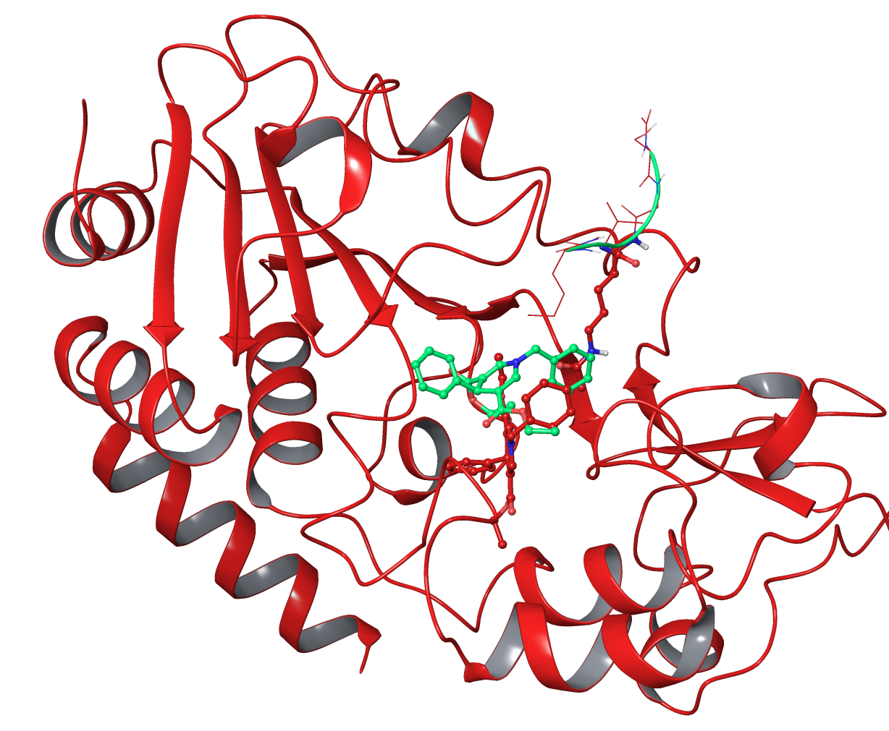

Comparison DHP-1c in SIRT3 (in green) and SIRT3:ac-peptide (in red) (both taken from 4FVT)

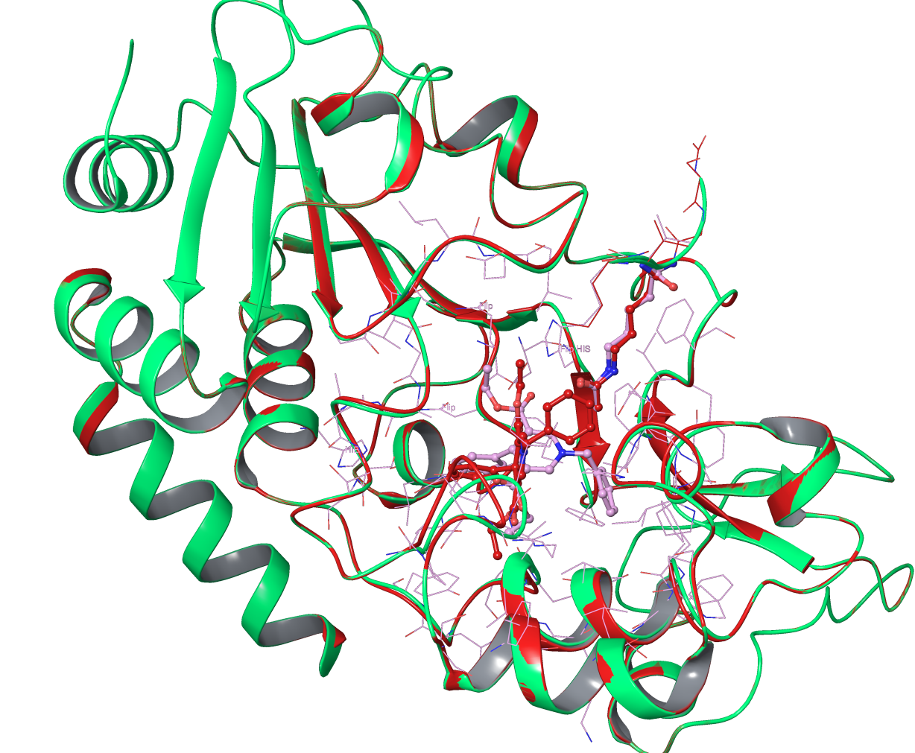

Comparison of DHP-1c in SIRT3:ac-peptide with induced Fit (pink, SIRT3 in green) and with Glide XP (red, SIRT3 in red)

1. SIRT2 structures 4L3O (released 2014) can be modified to represent SIRT2:ac-peptide complex and suitable for docking studies. SIRT2 structure 3ZGV (released 2013) can be modified to represent SIRT2:NAD+ complex and be useful to compare with docking results.