#### RC: in the former picture above, you mention the closed loop conformation and annotate that as SIRT3/NAD/Ex-527. Please confirm that the receptor was obtained from the xtal structure for that complex.

#### RSK: Indeed the receptor structure shown in the figure is the native receptor of the complex.

#### RC -- -- please show for comparison the xtal structure for the coproduct complex with Ex-527. If you can show all of these in representations similar/aligned to those in the paper draft,it would be convenient (though not essential).

#### C:\Users\vramaswamy\AppData\Local\Microsoft\Windows\Temporary Internet Files\Content.Word\comp_final.png

#### RSK: From the above figure, it looks like the cofactor loop closes further upon conversion of the “substrate complex” to “product complex” in the presence of Ex-243 (the shift in the loop conformation is shown as dotted arrow in the figure above). There is no crystal structure of any alkyimidate/bicyclic intermediate structures in the presence of EX-243.

#### Secondly, we do have native crystal structures of sirt3 trapped in a native intermediate state (4BVG), but we don’t have native structures of sirt3 trapped with its reaction product (2’-*O*-AADPR). Going through literatures, I believe a crystal structure of yeast Hst2 bound to the reaction product does exist.

#### RC:- you may also superimpose the xtal structure, if available, of the coproduct complex (no Ex-527) with that of the intermediate complex (4BVG).

#### RSK: There is no xtal structure of native Sirt3 coproduct complex, but a crystal structure of yeast Hst2 bound to the reaction product does exist. Assuming they are structural homologs (yHst2 a being a close homolog of human sirt2), if needed I can carry out structural comparison using yHst2 and Sirt3 and comment if the co-factor loop closes upon transition from intermediate to product in native conditions ( in the absence of inhibitor Ex-527).

#### RC: The paper mentions that NAD resides in nonproductive (perhaps AB) pocket conformation in presence of Ex-243/527. The loop conformation looks quite different from that in 4FVT.

#### RSK: Yes the loop conformation seen in Sirt3/NAD/Ex-527 is different from the loop conformation evident in Sirt3/Ac-ACS peptide/Carba-NAD (PDB id: 4FVT)

#### Sirt3/NAD/Ex-527 complex is termed to be a “nonproductive complex” by Steegborn in his paper because the Nicotinamide moiety of NAD+ occupies the acetyl lysine channel instead of occupying the C pocket as seen in a “productive conformation”. See figure insert, the blown up portion of the image.

#### The same “non-productive” is also evident when “free nicotinamide” is complexed simultaneously with sirt3/ADP-ribose (or) NAD+/NAM.

#### I have also attached a short summary of loop conformations based on my observations and literature reading at the end of this report.

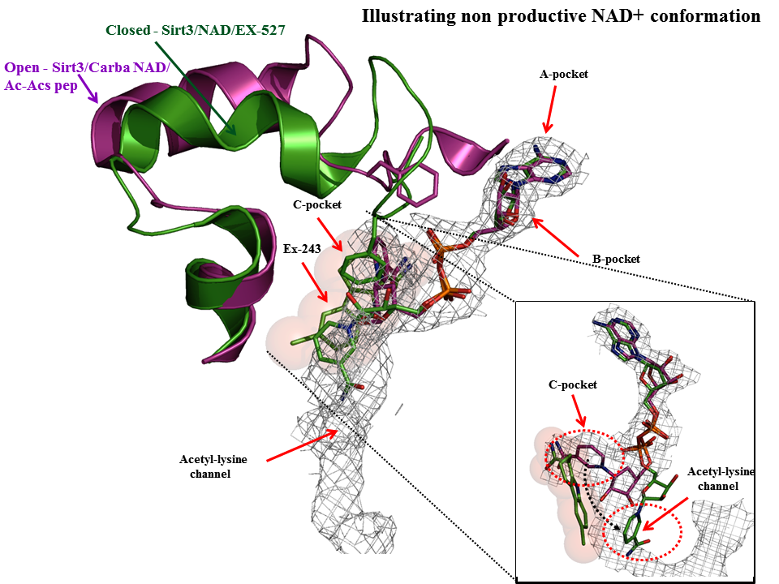

#### RC: finally, please add the coproduct loop conformation (no Ex-527) to the by-residue RMSD plot in the paper from xtal structures, since this complex is important.  If you don't have the coproduct xtal structure, you can use the Ex-527 coproduct complex for this purpose.

#### RSK: A revised figure incorporating the RMSD of the crystal structure of Sirt3/coproduct/Ex- 527 complex is shown below.

#### C:\Users\vramaswamy\AppData\Local\Microsoft\Windows\Temporary Internet Files\Content.Word\RMSD4_revised.png C:\Users\Vijayan\AppData\Local\Microsoft\Windows\INetCache\Content.Word\rmsd1.png

**Figure----.** Shown in the left panel are Sirt3 proteins and their per-residue RMSD values for the cofactor binding loop region computed over all atoms with reference to crystal structure of a Sirt3 intermediate complex (4BVG). The right panel shows RMSD values for Sir2Tm proteins calculated with reference to crystal structure of a Sir2 ternary complex (2H59). Residues (155-178) correspond to the co-factor binding loop region and residues (162-170) form a short alpha helix when bound to co-factors. Unresolved loop region are not plotted in the figure.

*Note: Residues 170-172 are unresolved in PDB entry 4BVH*

#### --------------------------------------------------------------------------------------------------------------------

#### Some general observations on the structural features of the co-factor loop of Sirt3 trapped in action

#### The co-factor loop conformation in apo sirt3 is highly disordered as evident for thermal B factor values.

#### The co-factor loop of Sirt3 when bound to a substrate analogue Carba NAD (or) its natural substrate NAD+ together with the peptide substrate shows that the loop becomes highly ordered.

#### The conformations of the co-factor loop seen in apo sirt3 and sirt3/NAD/Peptide ternary complex are quite similar. It is often described as the open conformation in literatures.

#### Although the global loop conformation are similar in apo sirt3 and sirt3/NAD/Peptide ternary complex, the position of the invariant residue (Phe 157) occupies different position in apo sitrt3 and sirt3 ternary complex.

#### In apo sirt3 structure, Phe 157 is positioned away from the C pocket, on the contrary in sirt3 ternary complex Phe 157 is positioned above the B pocket.

#### In sirt3/native intermediate structure (shown in green), an unwinding of the short helix (order to disorder transition) of the co-factor loop is evident.

#### Literatures entail that an open to closed conformation is not influenced by the cleavage of NAM or the complete product formation but is dependent on the alkylamidate intermediate, as intermediate analogs like S-alkylamidate also bind in a closed conformation.

#### This inference is based on structural studies involving yHst2/2-O-Acetyl ADP Ribose/peptide ternary complex and yHst2/Carba NAD/peptide ternary complex.

#### C:\Users\vramaswamy\AppData\Local\Microsoft\Windows\Temporary Internet Files\Content.Word\seq_final.png

#### This figure shows that catalysis is coordinated through significant conformational changes involving the co-factor binding loop and in particular involving Phe 157. The missing structure here is sirt3 with its product (Sirt3/2’-OacADPr).