|  |  |  |  |  |  |
| --- | --- | --- | --- | --- | --- |
| **Enzyme** | **Substrate** | **Kcat (s-1)** | **Vmax (µM/min)** | **Km (µM)** | **Kcat/Km (M-1s-1)** |
| **WT-b1\***  **(197 µM)** | **CEP** | **39**  **35**  **37** | 2.34  2.1  2.22 | 30.08  31.65  34.85 | **1.3 x 106**  **1.2 x 106**  **1.06 x 106** |
| **AMP** |  |  |  |  |
| **CEF** |  |  |  |  |
| **WT-b2**  **(286 µM)** | **CEP** | **101**  **72** | 6.06  4.34 | 38.58  40.51 | **2.6 x 106**  **1.7 x 106** |
| **AMP** |  |  |  |  |
| **CEF** |  |  |  |  |
| **WT-b3**  **(214 µM)** | **CEP** | **137**  **141**  **104** | **8.25**  **8.5**  **6.24** | **9.95**  **10.15**  **7.52** | **1.37 x 107**  **1.38 x 107**  **1.38 x 107** |
| **AMP** |  |  |  |  |
| **CEF** |  |  |  |  |

CEP = Cephalothin; E concentration = 1 nM

AMP = Ampicillin

CEF = Ceftazidime

**WT-b1* = E was dialyzed at room temperature because cold room failed at night.**

**Enzyme concentration was determined by OD280 and extinction coefficient 71000 M-1cm-1.**

**Kcat = Vmax/Et**

**Lefurgy et al, *Protein Science*, 2007**

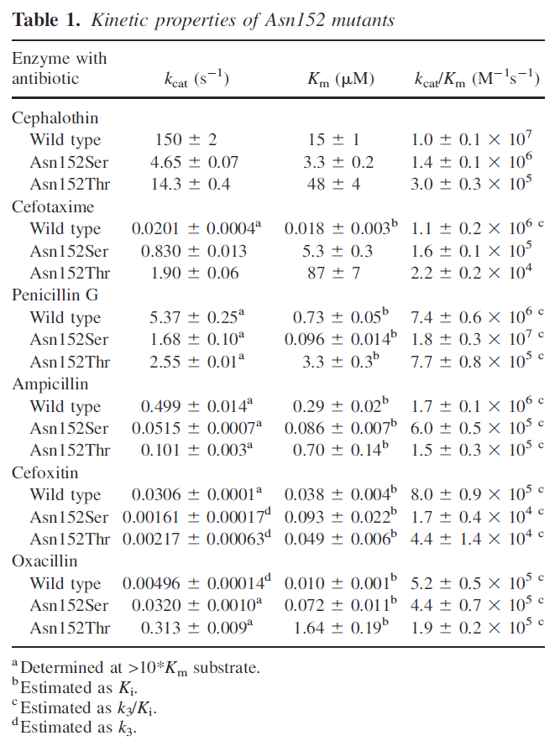

***Goldberg et al., Protein Science 2003***

