Brief report on the application of Schrodinger suite in the discovery of Ex-527 derivatives

Ex-527:

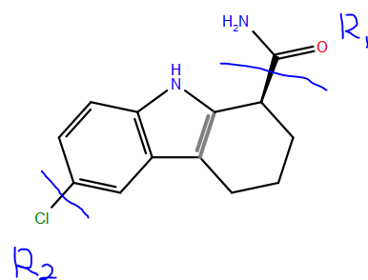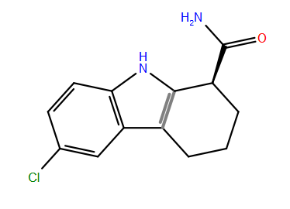

1. Ligand-based core hopping:

Use Ex-527 as template, –(C=O)NH2 and Cl- as R1 and R2 group, and smallest core library (?97 cores?) provided by Schrodinger, a total of 1131 new ligands were generated, see examples below:

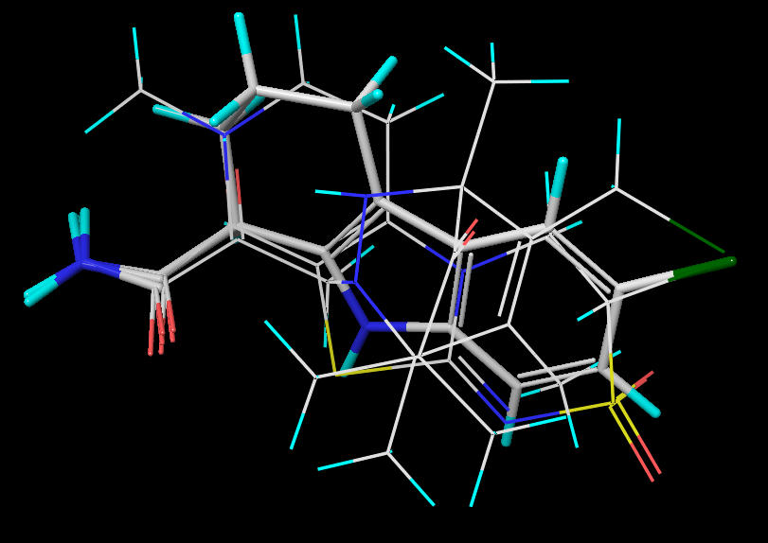

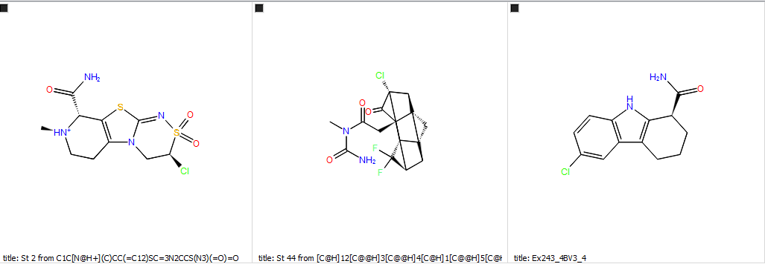

1. Glide docking with the generated ligands in 1).

Using SIRT3 from SIRT3:AADPR:EX-527 crystal structure as receptor, we carried out docking using the generated ligands (no MM-GBSA re-ranking).

See examples of the docked poses below, (only residues near ligands are shown.)

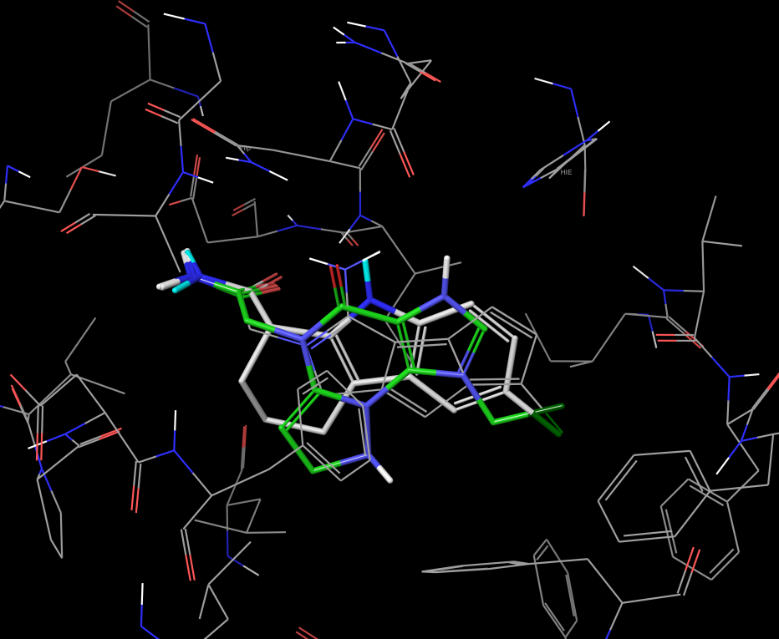

Ex-527 is shown with carbon in green.

1. Test structure-based core hopping using artificial ligand with attempt to re-discover Ex-527.

The artificial ligand is generated by cutting out parts of Ex-527, shown below. 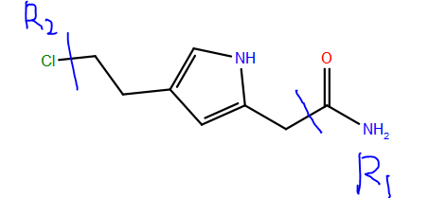

Again, using –(C=O)NH2 and Cl- as R1 and R2 group, a larger core library (?970 cores?), and SIRT3:AADPR as receptor from PDB 4BVH, we obtained 19391 new ligands, and Ex-527 hasn’t been located on the top of the list, but one close in structure is identified. (see comparison below.)

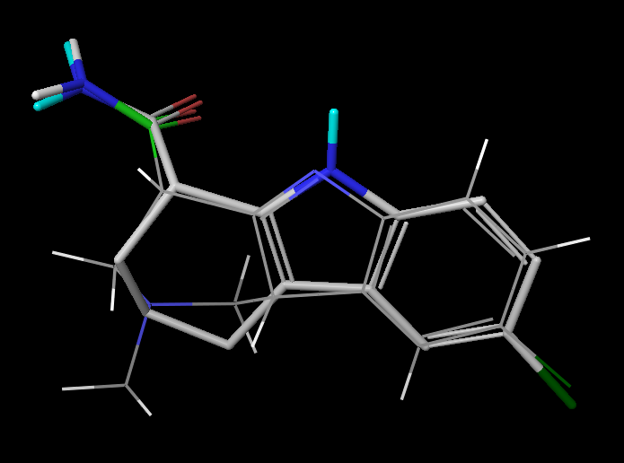

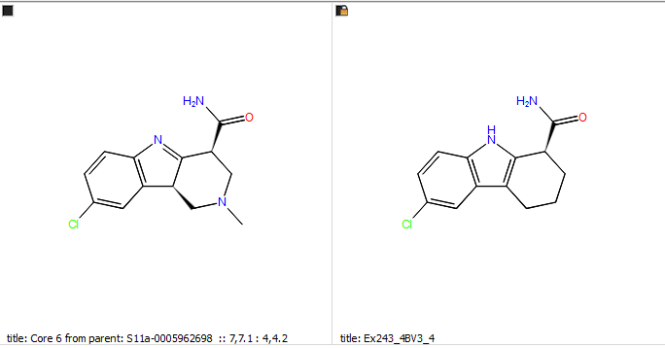

1. Same procedure (structure-based core-hopping) is applied again using the larger core library (?9.7K cores?) and the 40000 ligands was saved (due the limited set on the job panel). Many more new core types are identified.

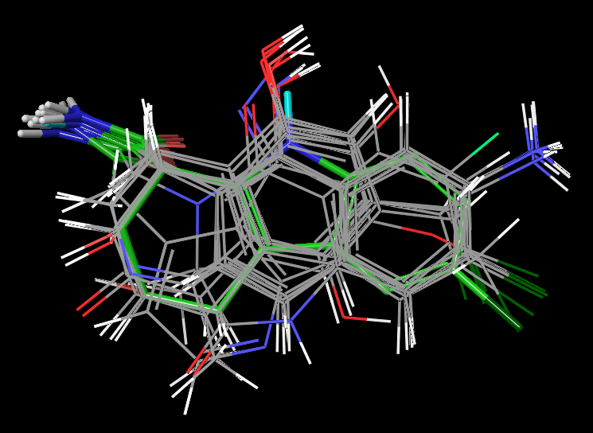

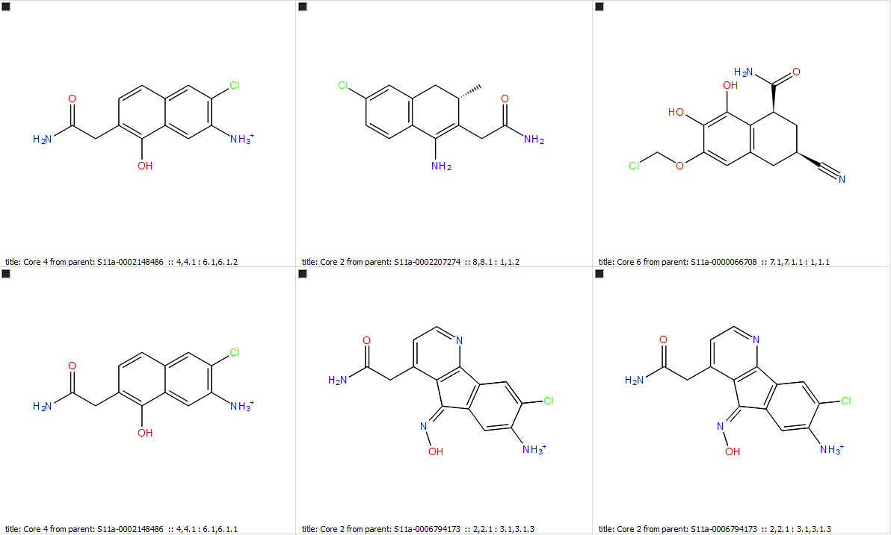

But again Ex-527 hasn’t been located on the top of the list. (I didn’t check them all out because there are too many ligands to explore.) Below is one of the ligands that are structurally similar to Ex-527.

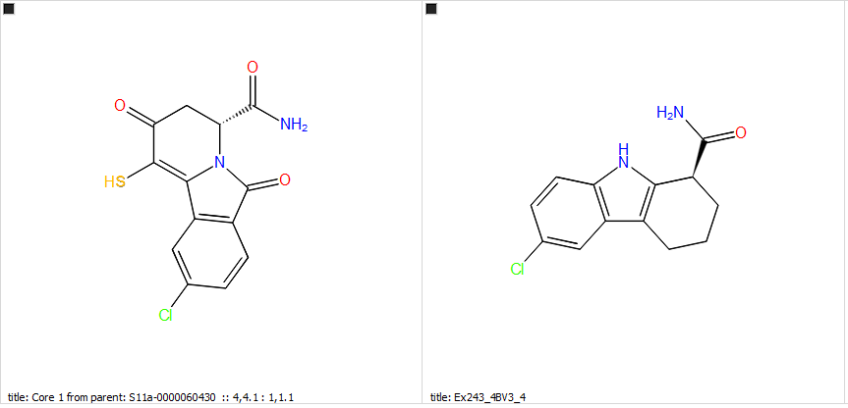

1. Isosteric Matching core-hopping use Phase module, Ex-527 as temperate, –(C=O)NH2 as the preserved group, and relatively large core library (?9.7K cores?) generated 2563 new ligands. Sample ligands are shown below.

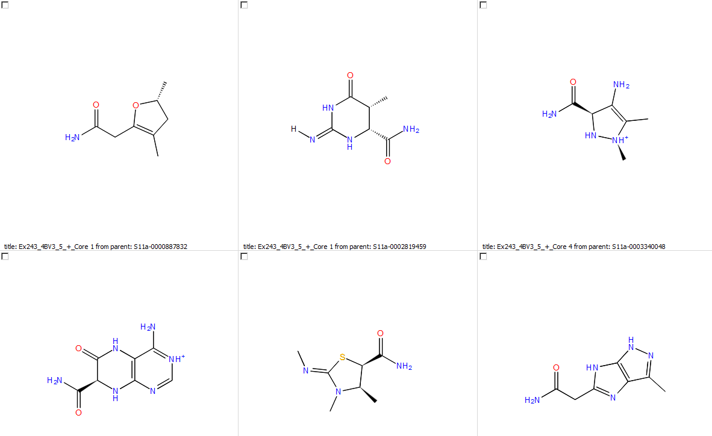

1. The generated ligands from step 5) above were prepared using LigPrep and docked into SIRT3:Intermediate structure (based on pdbID: 4BVG) using the high-throughput virtual screening (coarser approach than Glide SP). See sample output below.

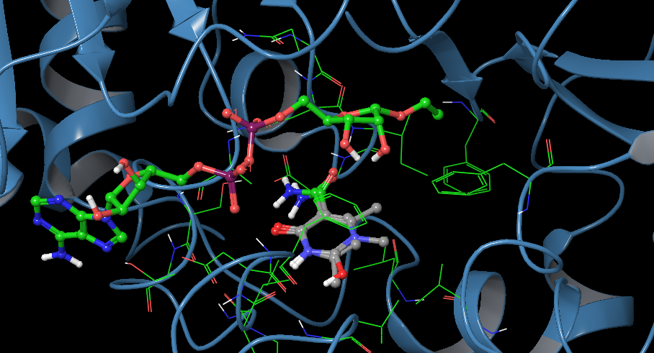

1. Isosteric Matching core-hopping use Phase module, Ex-527 as temperate, –(C=O)NH2 as the preserved group, and the largest core library (?97K cores?) generated 15774 new ligands. Sample ligands are shown below.

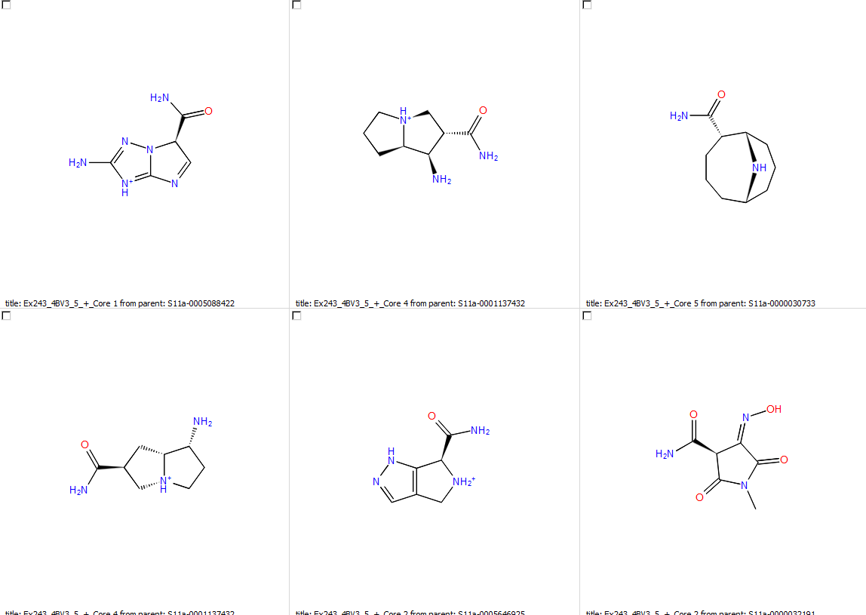

Docking of new set of ligands using high-throughput virtual screening is underway.